Maat Group was formed by a group of accountants back in 2009, Maat provides opportunities for investors to be part of syndicates to purchase commercial property. From the beginning, Maat has developed and recognised the need to provide great returns for investors. In September 2014 Maat started a Financial Services side to the business, concentrating on Personal Risk Insurance.

Maat represents the ethical and moral principle that every Egyptian citizen was expected to follow throughout their daily lives. They were expected to act with honour and truth in matters that involve family, the community, the nation, the environment, and God.

Maat’s objectives are:
- To present well researched and fully documented investment opportunities for investors.
- To assist individuals, families and businesses to plan their insurance for protection from the financial impact of illness, death and accident.

What is Maat’s Business:

Maat provides:

- The research, analysis and documentation for commercial property syndication opportunities.

- The management, accounting and administration for the commercial property syndicates.

- The management expertise for commercial property other than for syndication.

- The planning and presentation of life insurance plans.

- The development of personal financial plans.

Maat builds its business on:

- Personal Relationships
- Transparency
- Professional disclosure and presentation of information
- Putting the clients’ interests first at all times

The commercial property syndicates are offered as either proportionate ownership schemes or company shares.

Each syndicate is governed by an ownership and management deed, the securities act and the companies act.
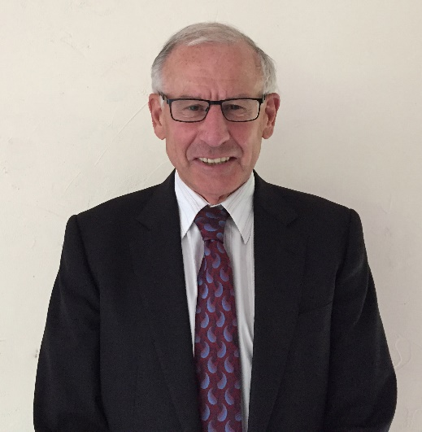
Neil Tuffin CA, GDipBusStds

Authorised Financial Adviser
Neil Tuffin is an Authorised Financial Adviser (under the Financial Advisers Act 2008), a Director of Maat Property Group and WealthNZ Limited, and the proportionate ownership companies managed by Maat.

Email: ntuffin@maat.co.nz
Tel: 021 481 441

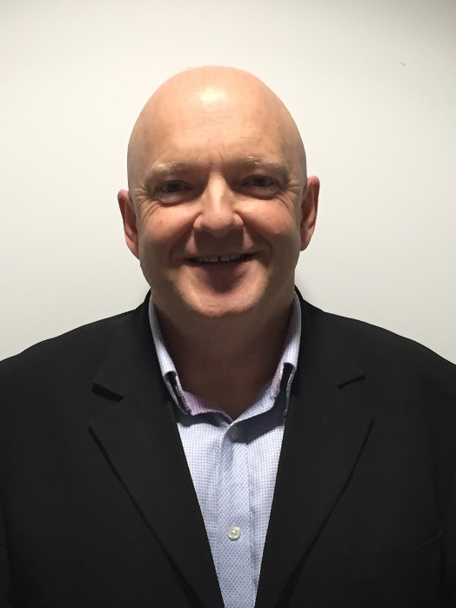

Mark Hughson CA

Director
Mark is a Chartered Accountant operating as the sole practitioner in his Hawera (Taranaki) practice. With a staff of 12, Mark manages his practice and provides strategic advice for a client base which extends across New Zealand. He also makes a significant contribution to the South Taranaki community.
Mark understands the opportunities for investors when investing in carefully selected Commercial Properties and is willing to discuss these benefits with prospective investors.

Email: mark.hughson@hughson.co.nz

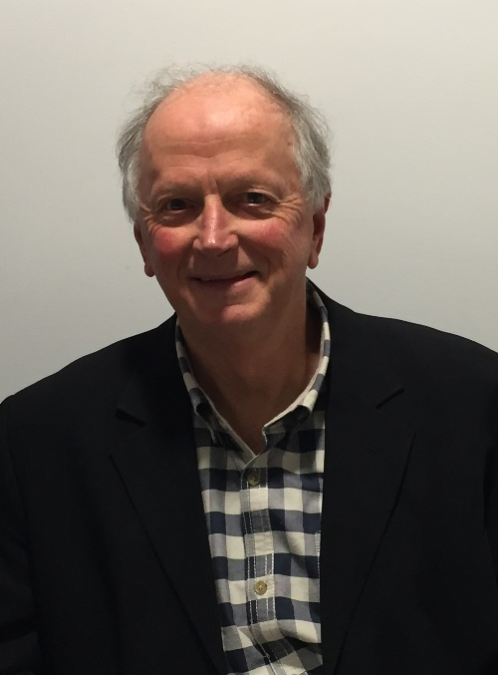

Bruce Ellis CA

Director
Bruce is a Chartered Accountant with a senior role in Capper Macdonald King Limited, a Stratford accounting practice, following a career as a director of a former Stratford accounting practice, Accountants on Broadway. He is a Director and Shareholder of Maat Group and WealthNZ Limited.

Email: bruce.ellis@cmk.co.nz
Tel: 021 081 62137

PERSONAL RISK INSURANCE

We are experts in the field of Personal risk Insurance and pride ourselves on helping clients and their families secure their future. You can rely on the team at Maat Financial Services for sound insurance advice and we will be there right from the application process to the claims process no matter how complex.

The Products we can offer you:

Life Insurance
To provide a lump sum upon death or terminal illness to help repay debt or provide an inheritance, among other things, at the client’s discretion.

Trauma Insurance
To provide a lump sum when a covered condition is suffered to help alleviate its financial impact by financing home modification or specialist equipment, or creating an investment fund, among other things at the client’s discretion.

Total and Permanent Disability Insurance
To provide a lump sum upon Total and Permanent Disability to help reduce debt, create an investment fund, or pay for home modifications, among other things at the client’s discretion.

Medical Insurance
To help fund private hospital treatments, and access to specialists, diagnostic tests, and non-PHARMAC medications outside of the public health system.

Income Protection
To replace a significant portion of lost income when you suffer a total or partial disability.

Mortgage and Rent Protection
Mortgage and Rent Cover pays you a regular monthly payment if you are unable to work because you are sick or injured, or have been made redundant or bankrupt.

Life insurance is not for you. It’s for those you leave behind. What will happen if you or your partner dies? Who will pay the mortgage and the monthly bills?

That’s where life insurance comes in, a policy that pays a cash lump sum so your family can maintain their lifestyle if you become terminally ill or if you die unexpectedly.

Don’t become a statistic. Avoid being one of many kiwis who haven’t got cover or who have insufficient cover in place to protect their family should the unavoidable happen.

Insurance Testimonial
I was apprehensive when contacted about a meeting with a financial advisor however when Paul arrived, I was pleasantly surprised to meet an open, caring and knowledgeable person. Paul went above and beyond in his dealing with my insurance. Follow up was timely, communication was consistent and the outcome was ten times better than expected.

Benefits of using an adviser

Here are just a few of the reasons why you should choose an Insurance Adviser:

- Insurance Advisers work for you, not the insurance company

- Insurance Advisers are not call centres. Making changes, requesting documentation and getting answers can be frustrating with direct insurers (especially if you’re bounced around from person-to-person, or department-to-department. But insurance advisers take the time needed to ensure that you know all of your options, understand them and receive the coverage you need.
- Insurance advisers strive to act in the best interest of their clients. That means building close relationships to understand their needs.

- Insurance advisers have the ability to shop around to various insurance providers. That means that with one call to an insurance adviser, you are guaranteed that best products for the greatest value. Conversely, if you went directly to an insurance company you’d only have access to their products and prices.

- Insurance advisers build long-lasting relationships with their clients. Most people who choose to work with an adviser because they love the relationship and dealing with one person on the consistent basis. Regardless of whether you choose an insurance adviser over a direct insurer, the most important thing is to find a provider you trust and that has your best interests in mind.









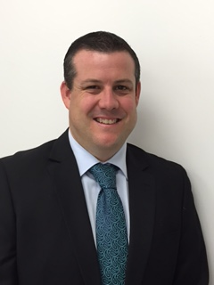
Paul Tuffin (RFA)
Risk Advisor

