
Correct Weight Scales Products & Services
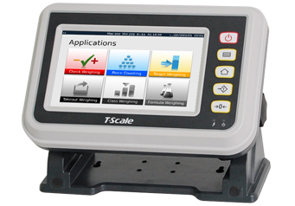
Correct Weight Scales has derived from over 20 years of experience in the Weighing and Packaging Industry.
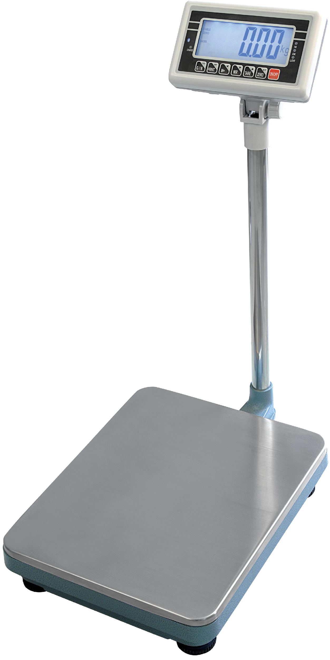
We can assist in helping your business’ weighing applications through the perfect combination of unsurpassed experience and loyal committed customer service that is unfortunately hard to find in this era we live in.
C.W.S offer a comprehensive range of Weighing, Packaging and Filling equipment to suit an array of industry including Industrial, Retail, Bakery, Medical, logistics and Manufacturing just to name a few.
We offer complete solutions to all your Weighing, Packaging and Processing requirements and offer a full-customised design and manufacturing service to adapt to your specific requirements.

We offer a Full Repairs, Calibration, Hire and Preventative Maintenance Agreement Service 24/7 to any type of weighing Equipment in Melbourne and surrounding Areas and have experience with every make and model from Laboratory Balances through to Large Scale Batching Equipment with everything in between.
Contact myself Louis for expert no obligation HIGHLY COMPETITIVE free quotes on ALL Service, Repairs and New Equipment Sales. We look forward to your most valuable enquiry

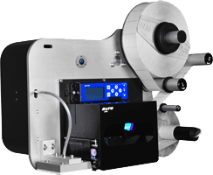
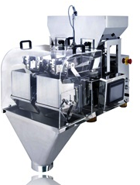
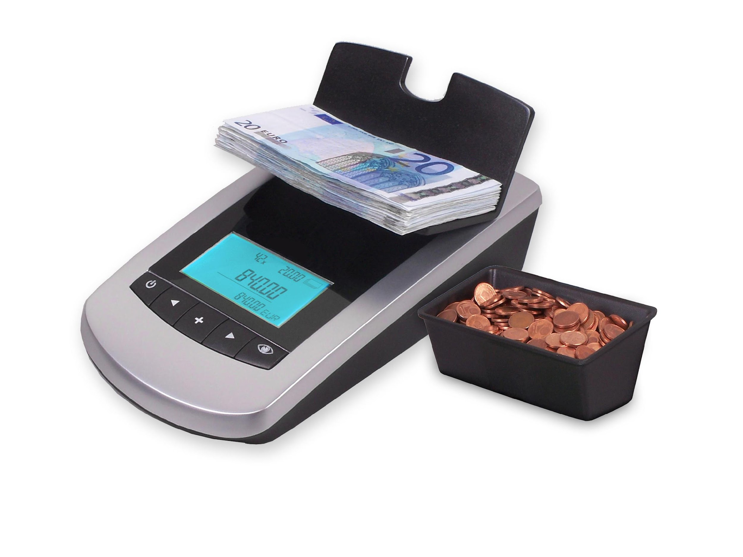
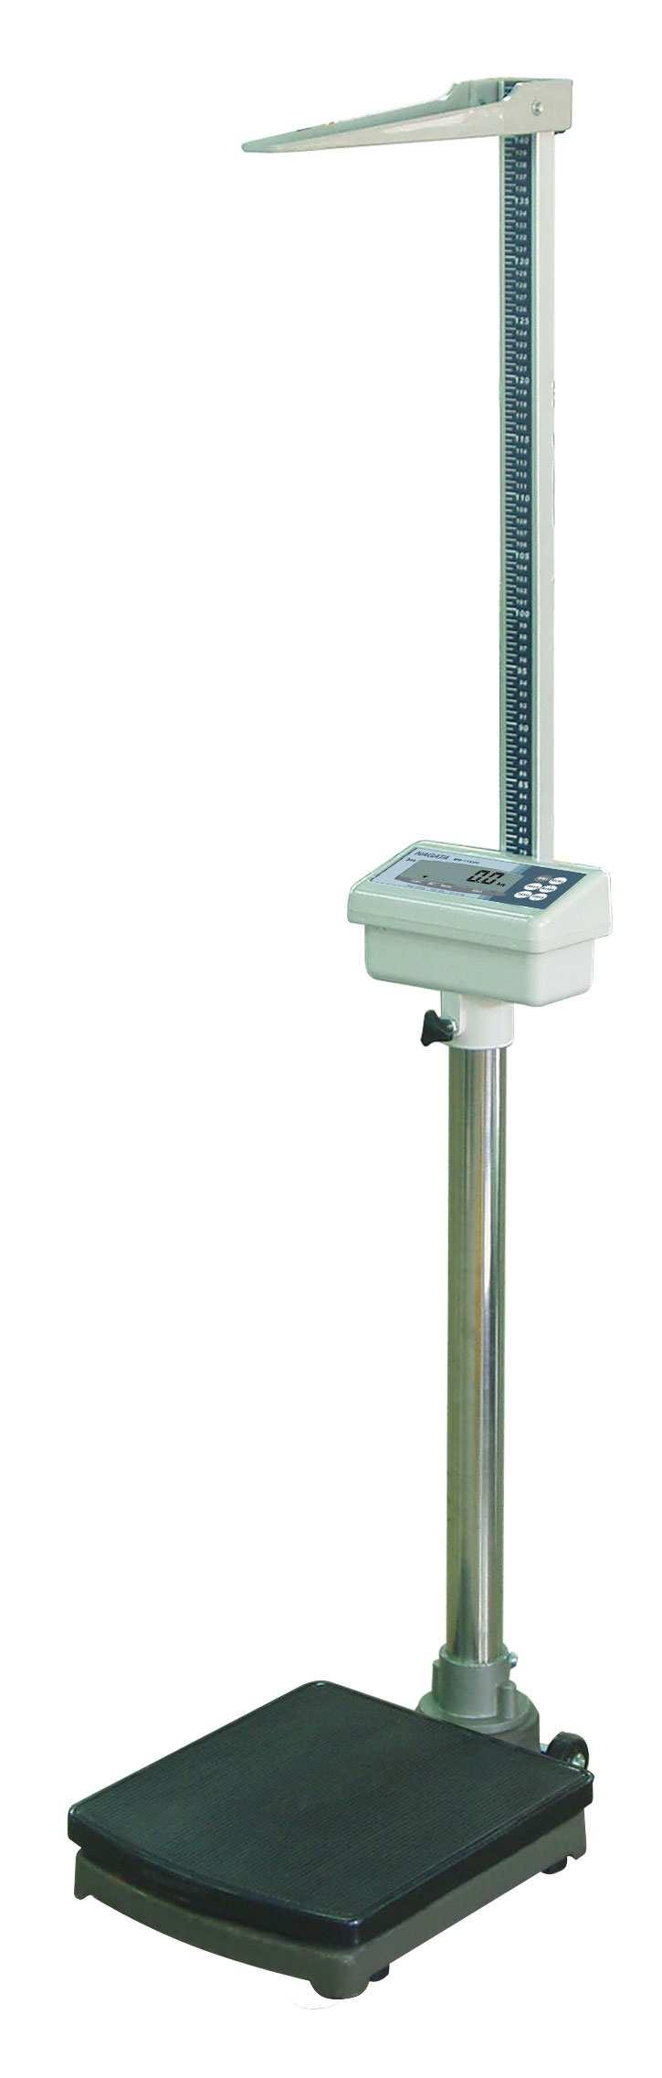
Products
*Electronic Platform Scales Ranging From 30kg-600kg
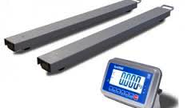
*Printers and Labellers to suit your requirements
*Linear Weighers to suit all Applications
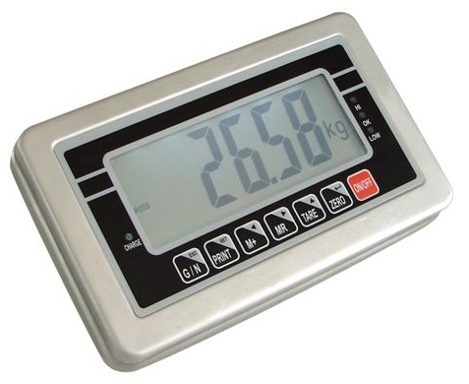
*Electronic Floor Scales Ranging From 1000kg - 3000kg(Trade Approved)
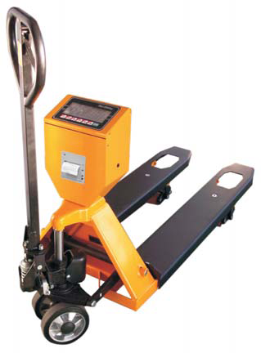
*Full Range of Electronic and Mechanical Hanging and Crane Scales Ranging from10kg -10Tonne
*Vet Scales ranging from 20kg-300kg
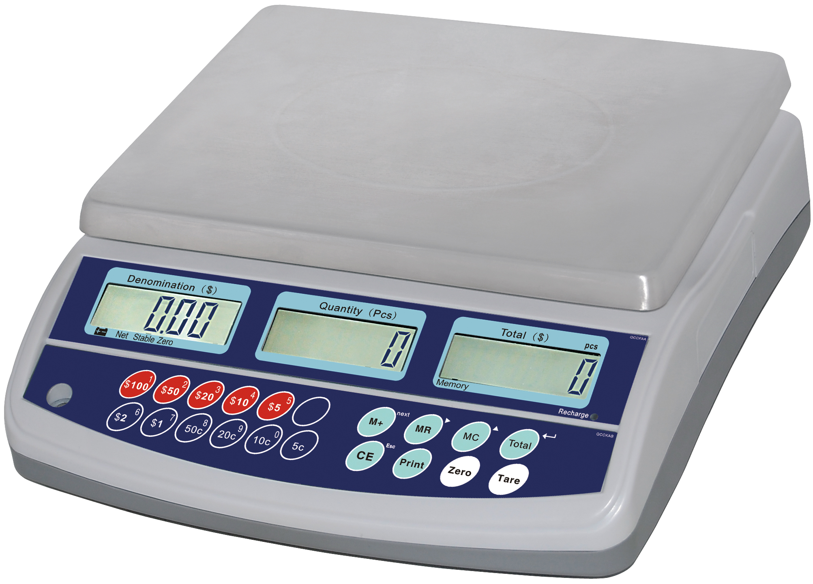
*Electronic Baby Scales
*Pallet Jack Scales to 2000kg
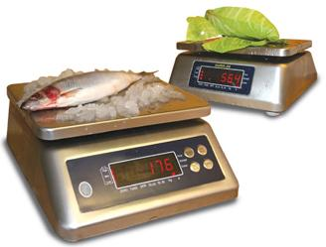
*Full range of TRADE APPROVED SCALES
*Coin and Note Counting Scales
*Shipping/Parcel Scales to suit any application
*High Precision Electronic Balances Ranging From 100-6000g
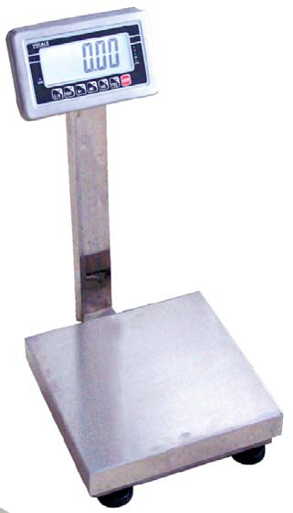
* Full Range of Electronic Weighing Indicators To suit any application
*Full range of Load Cells and Fittings to suit any Application
* REPAIRS ON ALL WEIGHING AND PACKAGING EQUIPMENT ALL MAKES AND MODELS.
ASK ABOUT OUR RANGE OF PACKAGING AND FILLING EQUIPMENT

