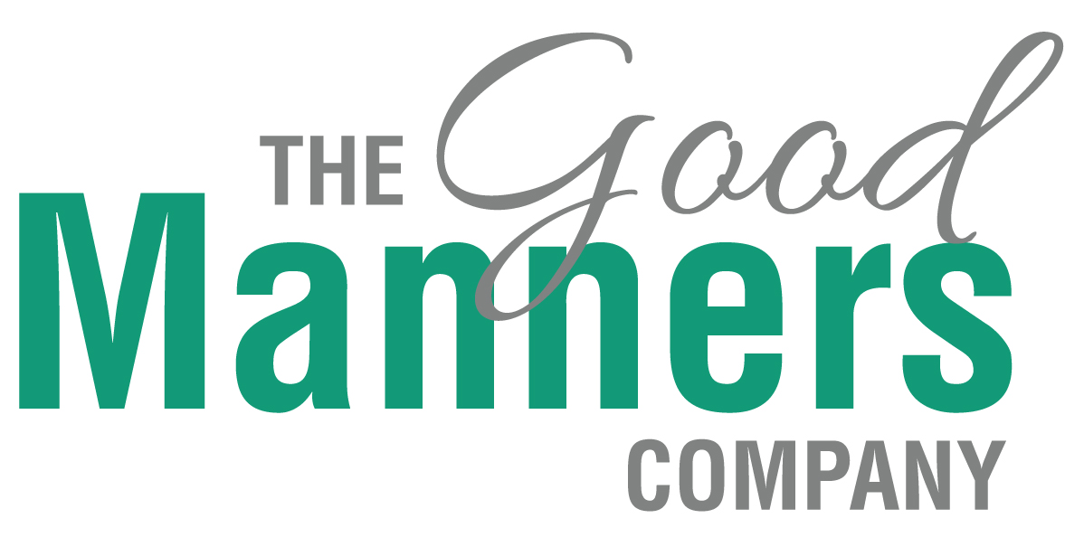
ETIQUETTE AND MANNERS FOR STUDENTS

Are you frustrated by the lack of manners and courtesy shown by students today? Reports show that students are applying for jobs lacking social skills and etiquette, making them unprepared for part time jobs and full time workplaces. The sooner they learn good habits around manners and etiquette, the more well-rounded and prepared they will be for leadership opportunities, employment and forming good relationships.

Topics

- Modern manners for young people
- How to introduce and others yourself correctly
- Job Interview Preparation
- Formal Preparation
- Netiquette, conduct with mobiles, devices and social media
- Table Manners
- Deportment, how to walk, sit, carry yourself with poise and confidence
- Dating Etiquette

Sample one hour agenda


Introduction
What are good vs bad manners?
Why it is important today?

The Rules
Appropriate conduct for young ladies and gentlemen


The First Impression
How to make a good first impression
Speaking clearly
What to wear, where and when, dressing appropriately for the occasion
What not to wear, where and when incl job interviews

Introductions
How to introduce yourself correctly
How to introduce one person to another

Handshaking skills
Putting it all together
Role plays

Prices from $500 for 1 hour to $1500 for day

What’s Included.
- handout to take home to parents
- classroom poster
- copy of “Etiquette Secrets” book for School

Who is The Good Manners Company?

The Good Manners Company was founded in 2007 by Anna Musson, Author of “Etiquette Secrets” and Etiquette Expert for Sunrise, The Project and Sky Business. Anna Musson has become one of Australia’s most recognised and popular etiquette commentators. We work with Australia’s top 200 companies, our sporting professionals and our goal is to support parents and teachers ensure our emerging leaders have the social skills to match their education.
Anna Musson – Founder and Principal

Rachel Smeallie brings a wealth of experience of etiquette and good manners through her long association with The Good Manners Company as a colours consultant and schools specialist.
Rachel is a qualified workplace trainer, with experience in delivering training packages and conducting assessments.
Rachel Smeallie – Schools & Colours Consultant

How does this benefit your school?
Teaching manners to school students is mostly taught at home, however as teens shift focus from parents and teachers, to peers, engaging a third party to speak about manners and etiquette is a wonderful way to support both home and school values, for a great outcome for the student, the school and parents. We want to partner with you to get the best outcome for students and families.

How does it work?
Sessions start from 1 hour to full day workshops for group sizes from 10-100 students. We come to your school and speak to your students on a
- leadership day
- personal development day
- year /school assesmbly
- leadership camp

What is the cost?
One hour session: $500
Two hour session: $750
Half day workshop: $1000
Full day workshop: $1500

How do I obtain more information or book?

Contact Rachel Smeallie
Ph: 0403 235 723
Email: rachel@goodmanners.com.au
Or go to www.goodmanners.com.au

or Anna Musson
Ph 0412 007 173
Email: anna@goodmanners.com.au
www.goodmanners.com.au

