Welda Consults, LLC
The Best of the Best!

Educational Consulting:
The Best of the Best!

weldaconsults.com
Raise test scores

Lower discipline referrals

Help teachers feel more successful
LIMITED TIME!
Get a half-day free when you book 2 or more days.
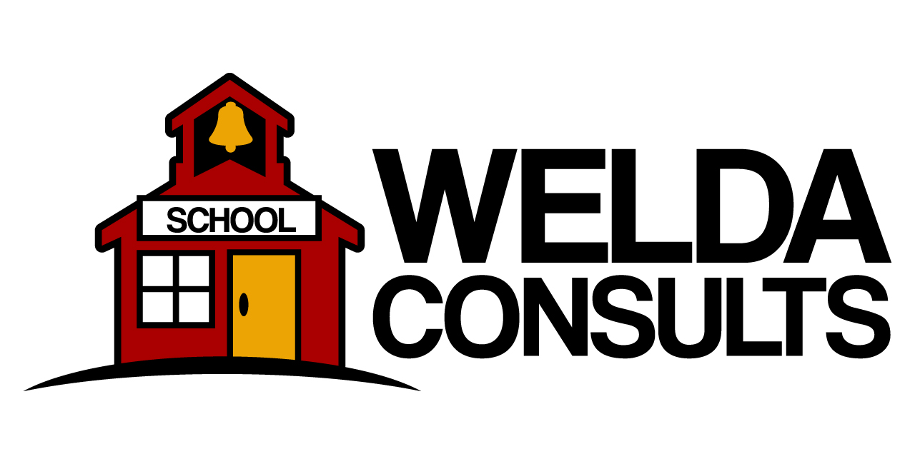
Welda Consults
Coaching and training in:
Classroom Management
State Standards Implementation
Differentiated Instruction
Data-Driven Instruction
School Climate and Safety
Professional Learning Communities
Customized sessions are also available!
21403 N. 133rd Drive
Sun City West, AZ 85375
(608) 320-0069
welda@weldaconsults.com

608.320.0069

There are very few students in the middle of the continuum of learners. Differentiated instruction is a must in order to reach all learners.
Research and data on almost any classroom shows that there is usually just a handful of students who fall in the middle of the performance range. So, differentiating instruction is a necessity to meet all students where they are.
Attendees have said:
“Welda’s knowledge and experience with differentiation strategies, enthusiasm for the subject matter, and techniques for engaging students is without parallel.”

“Welda Consults offers workshop participants interactive, relevant instruction. Teachers leave the workshops with a foundational understanding of learning styles and tools to help all learners grow.”

Lower discipline referrals!
Contact Welda Consults today!
608-320-0069

Welda Consults

Raise test scores!

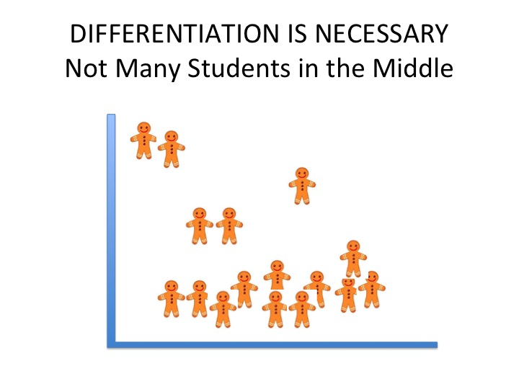

Do you want to lower the number of discipline referrals and raise student test scores?
In just 2-4 days spaced throughout the school year, our instructional coaching and training can provide you a guaranteed, one-stop solution for reducing your discipline referrals, raising your test scores, and providing best practice instruction.

