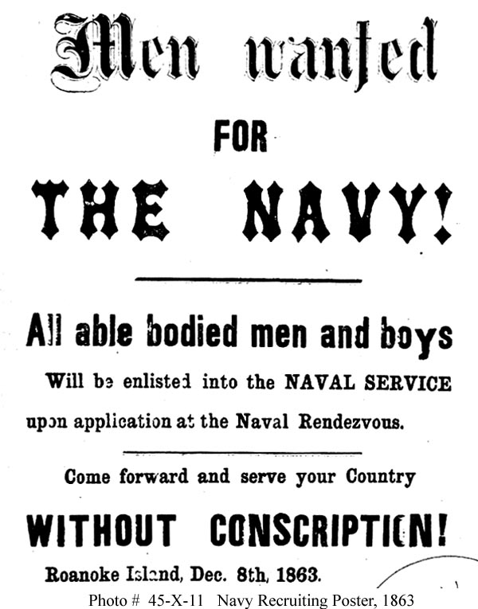

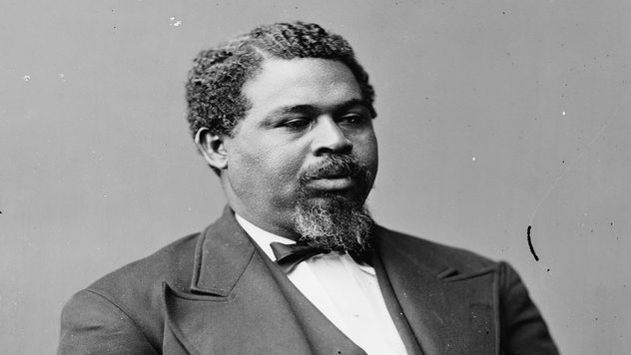
Robert Smalls

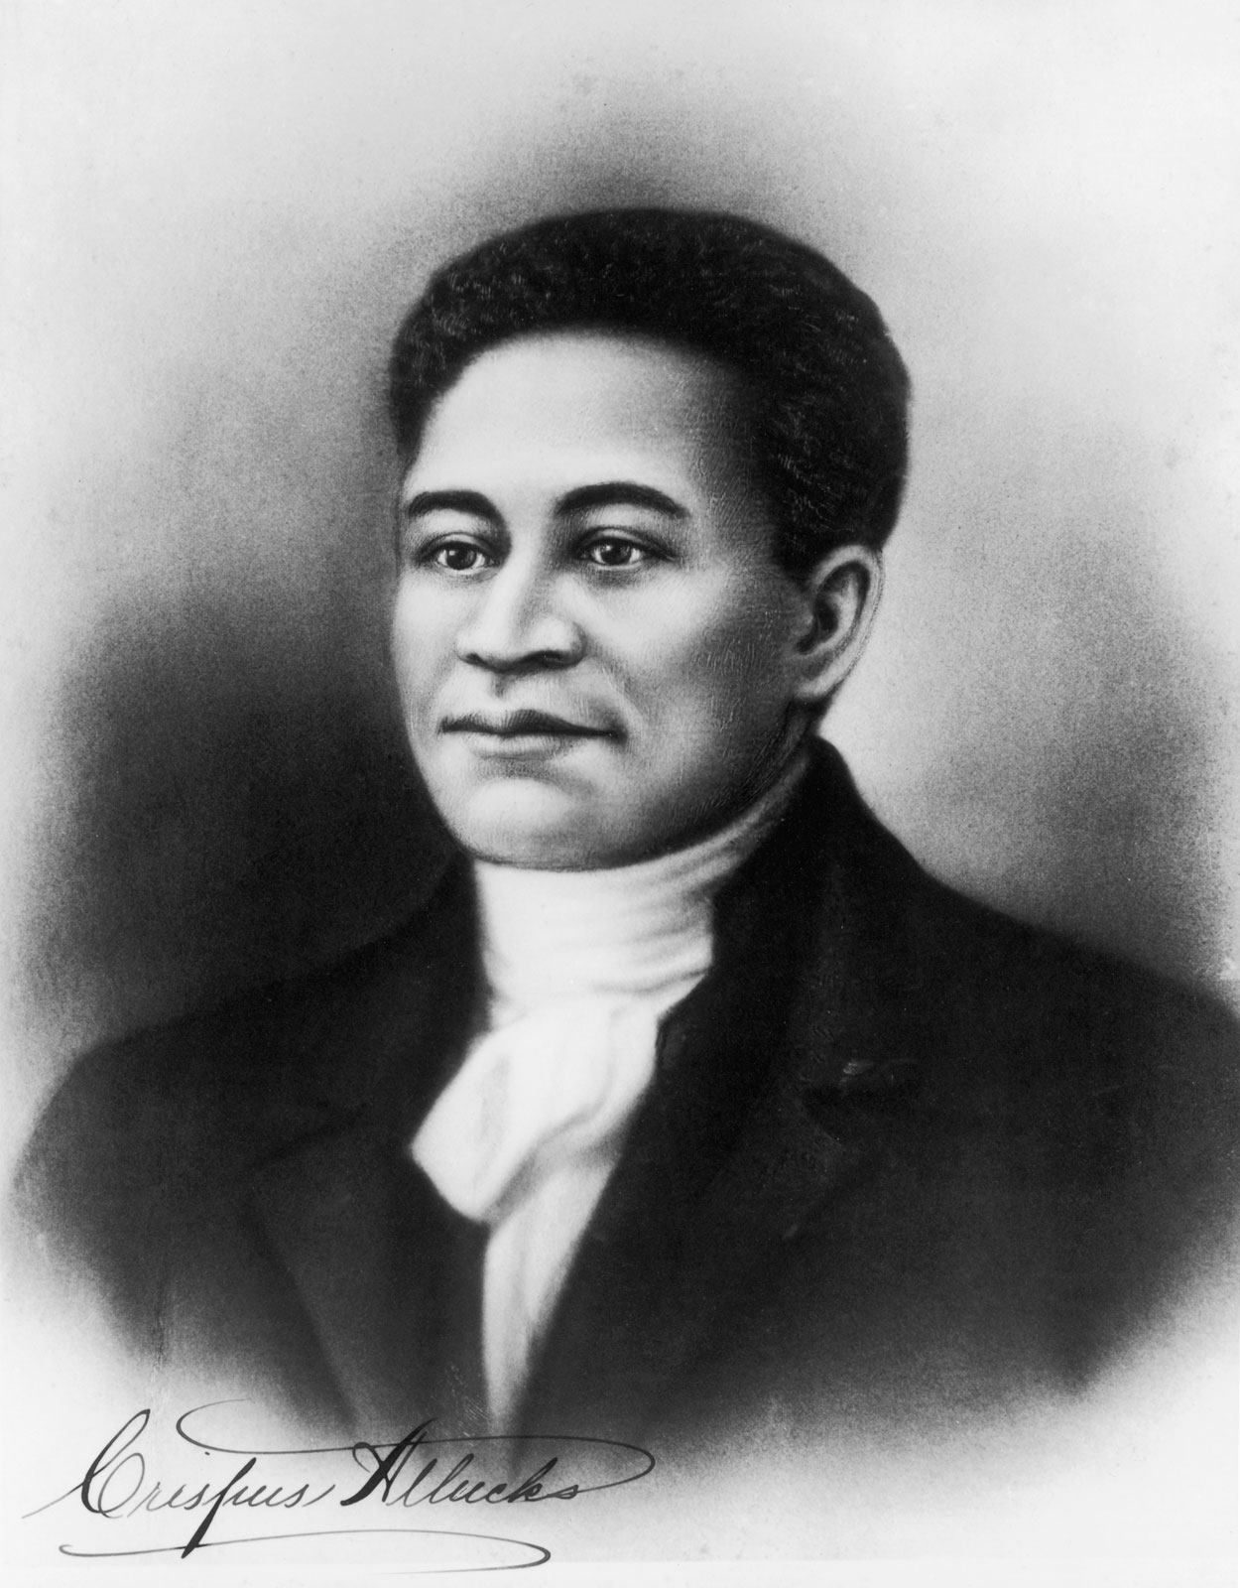

Crispus Attucks

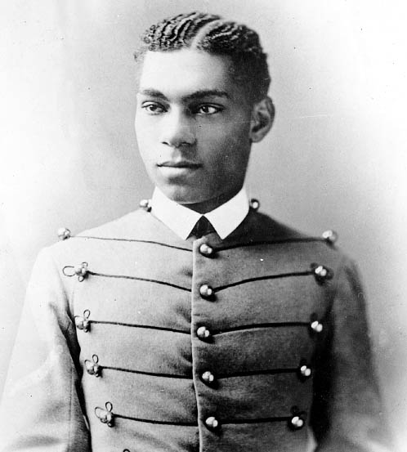
Henry O. Flipper
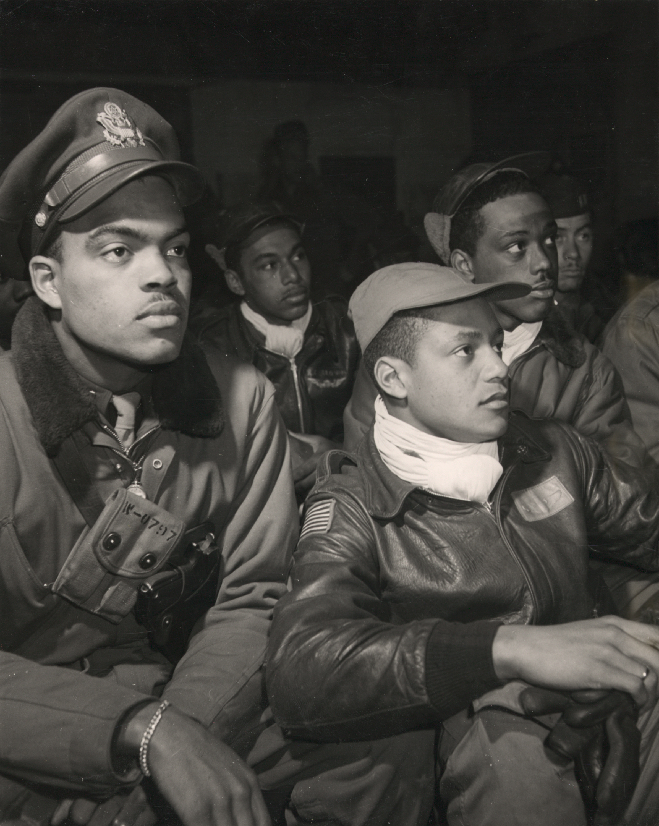
The 332nd Fighter Group

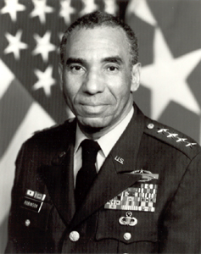

General Roscoe Robinson, Jr.

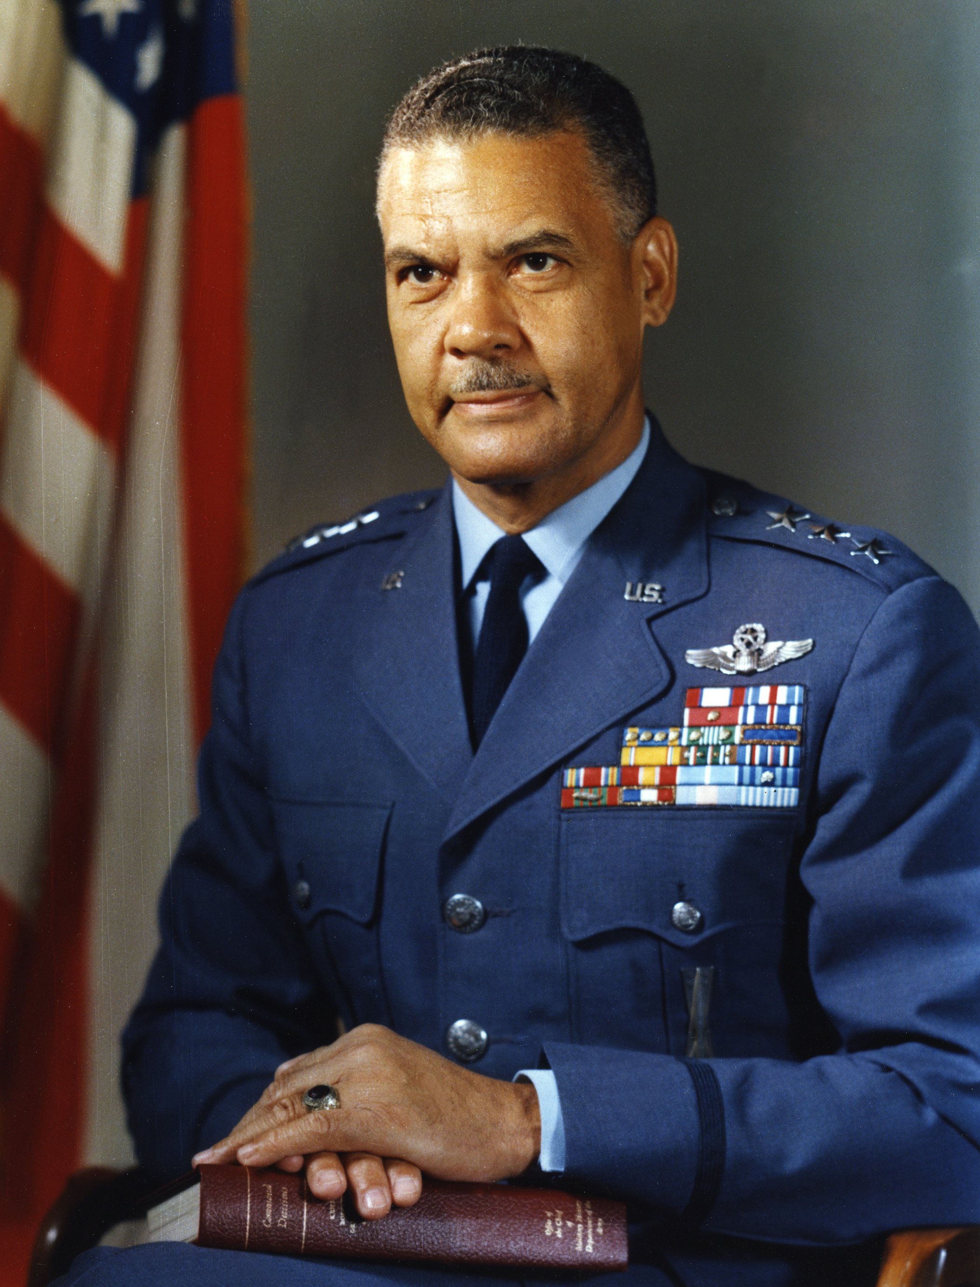

General Benjamin O. Davis, Jr.

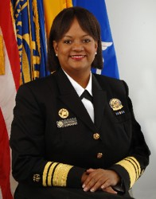

U.S. Surgeon General Regina Benjamin

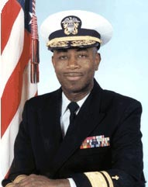

Rear Admiral Barry C. Black

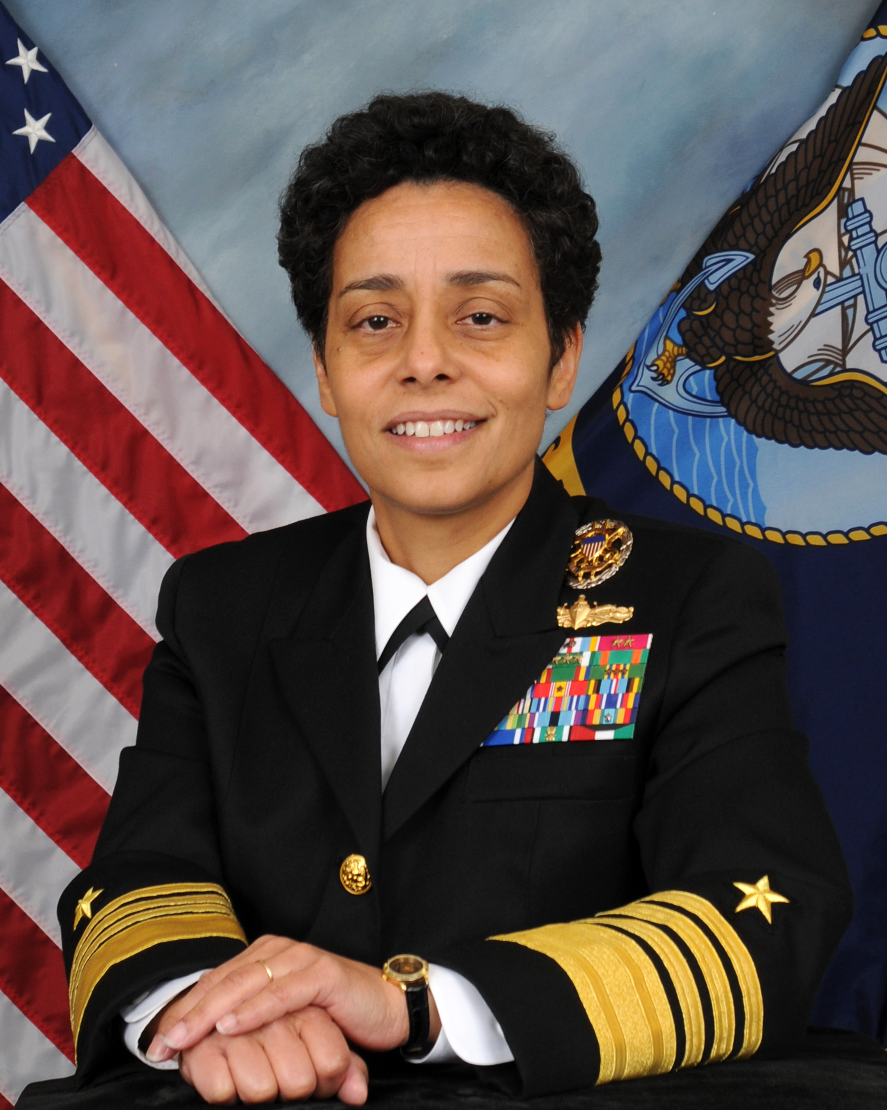
Admiral Michelle J. Howard

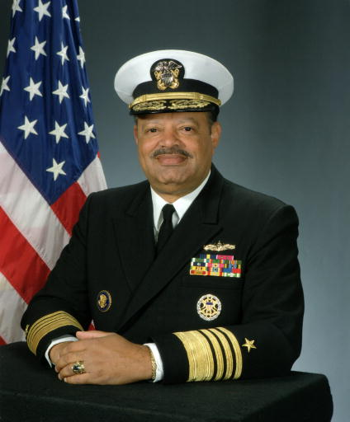
Admiral Joseph Paul Reason

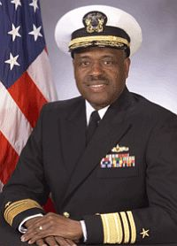
Admiral David L. Brewer

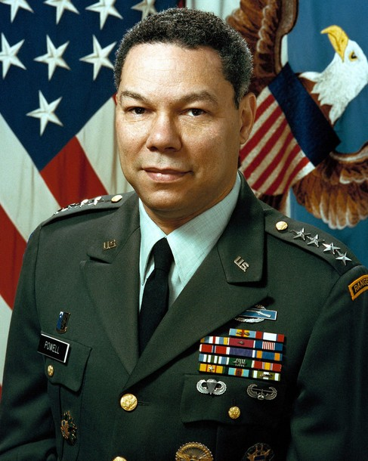
General Colin Powell

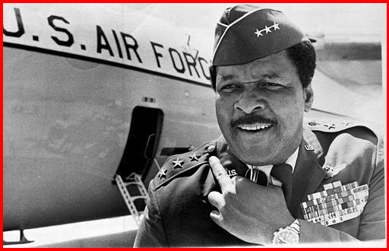
General Daniel “Chappie” James, Jr.

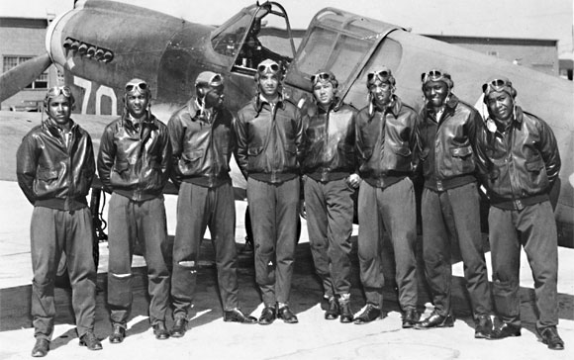

Tuskegee Airmen
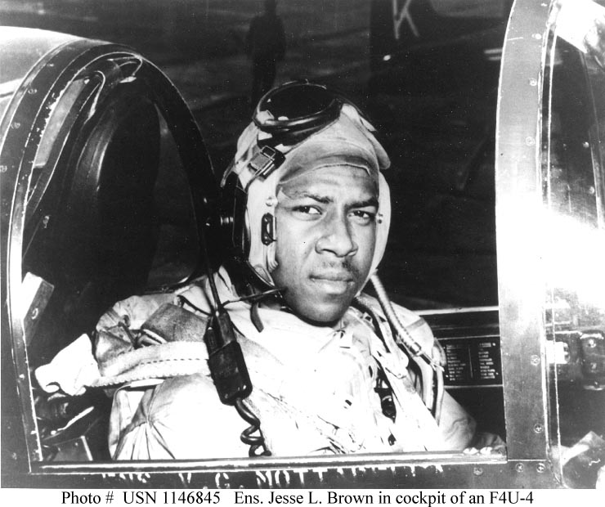

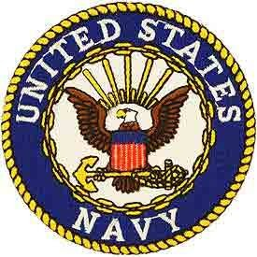

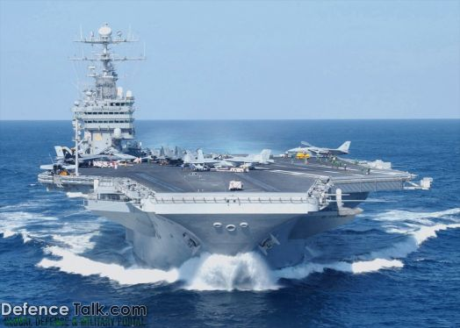

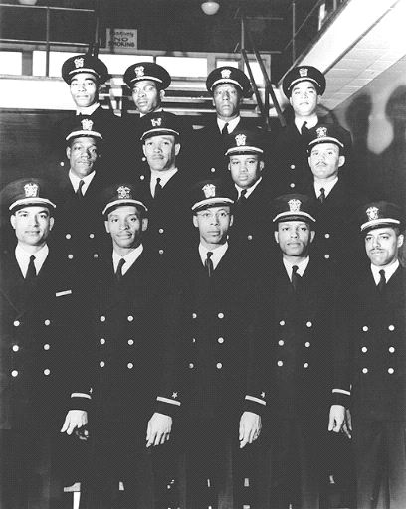
The Golden Thirteen
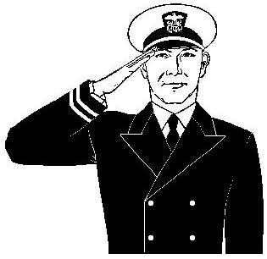
We Salute You! 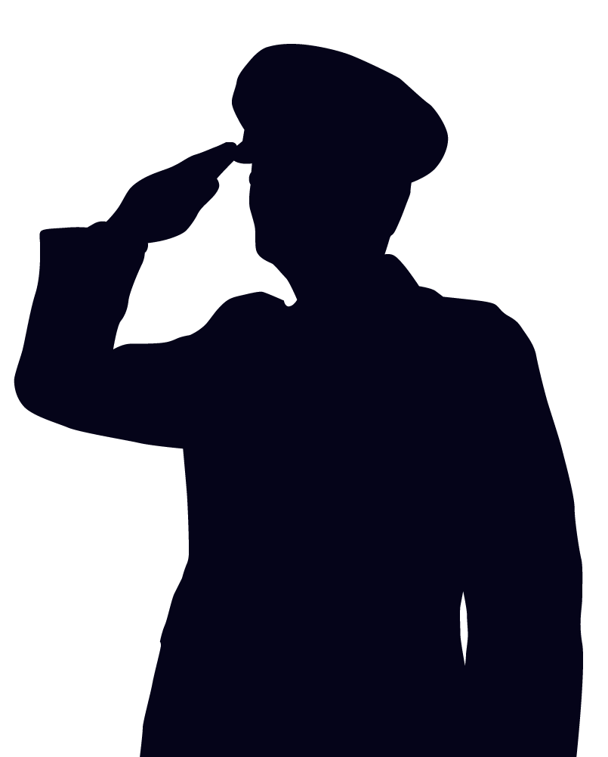


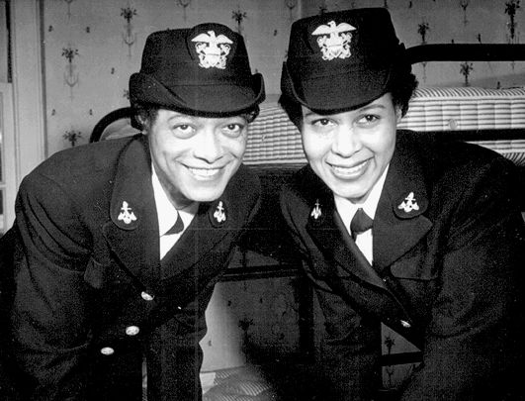
LTJG Harriet Ida Pickens and ENS Frances Wills

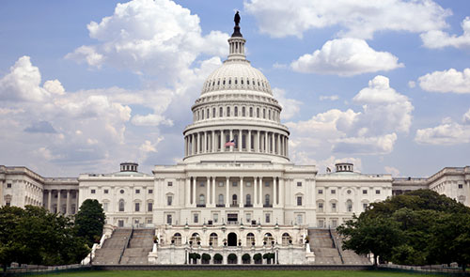

General layout of the poster (photos of all other people to be placed around/throughout the piece)
Robert Smalls
Navy ship
US Navy Emblem
My friend
Area of space at the bottom of the poster where I print:
History In the Making: You Sit Among The Greats
Congratulations Admiral Pringle

Old recruiting poster
My Friend
US Capitol
Pic of Crispus Attucks

