- Who we are?

We are an independent British estate agency based in the beautiful village of Deia in Mallorca. We pride ourselves on a personal approach to property, and being very human about it. Not like traditional stuffy typical estate agents, that people have grown to dislike.
Our values are Distinctive, Generous, Individual, Spirited and Trusted.

We want to bring our existing logo in line with this. Breathing some life into it; without dramatically changing it.

- Existing Logo

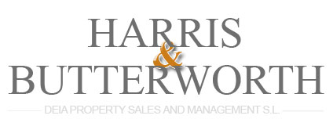

- New logo

For the new logo we would like the above to be sharpened up, and brought to life a little bit. We have this lettering on a big sign above the door which would be expensive to replace, so we don’t want to change it too much.

The idea for the new logo is to have:
- The ‘&’ to be a bit more of a focal piece
- The lettering to be just a bit sharper, but similar if not same font
- Remove ‘Deia Property Sales and Management” text
- Provide an option with “Real Estate Agents” written under the brand name
- Featuring above or below the brand name we like the idea of incorporating a key logo
- The style of this key and how we want it to look is defined below
- The output would be this new logo in good high res quality
- Also, the creation of a button that just featured the H&B in the same style would be great. This is abbreviated version may feature subtlety on stationary or on branded cars. We see it as being like the H&B “Stamp of approval”. So some sort of effect where it possibly looks like it has been stamped on would be great.

- Key style
For the key image, we really like the idea of this:
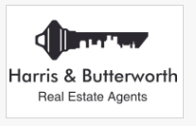
Where the skyline of the local area is used to create the shape of the key.
However, rather than the key featured above, we think the following is more in keeping with the style of the village we operate in. A little more old fashioned, traditional and full of character:

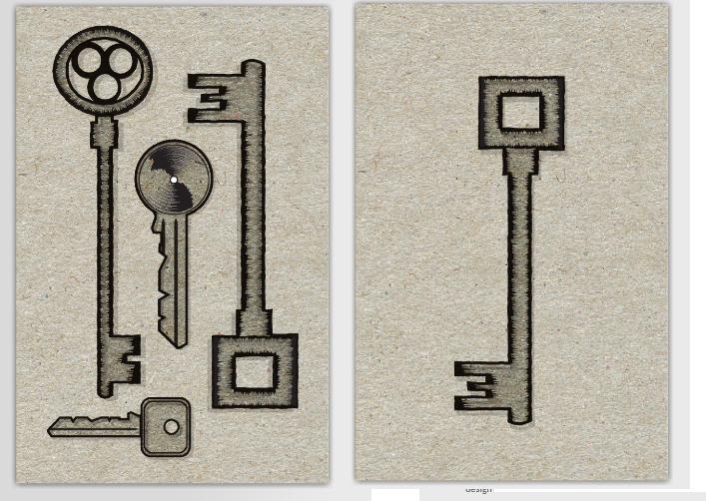
The skyline to be used should be taken from the following image. This is Deia, the village that we operate in. The highest building you can see is the church, which is the iconic building in this area which is lit up at night. We are hoping you can incorporate the skyline from below, into a key somewhat similar to those above and then feature it with the Harris & Butterworth text.
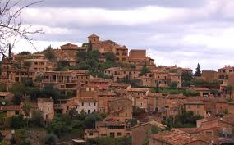
Similar to, but much better than this:
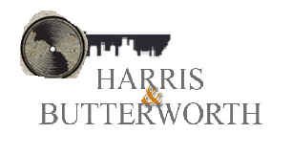
With a ‘button’ version featuring just “H&B” in the same style

