The biggest challenge faced by all investors and traders - What stocks to buy and when!
At Stock Selection we provide a simple solution to that challenge, giving you confidence, peace of mind and a game plan for your financial future….

Rotating Banner on Page

Our mission:

Helping everyday investors gain control and confidence in their investment decisions, creating a more prosperous financial future.

How we can help you

- We educate in plain English
- Our education is practical not theory based
- Real Life experience is the backbone to everything we do
- Help you buy your time back
- Provide you a total turnkey solution

What we don’t do

- We do not use jargon
- We are not a get rich quick scheme
- We don’t have a secret black box approach
- Speculate and take an aggressive approach
- Talk in theory or concepts

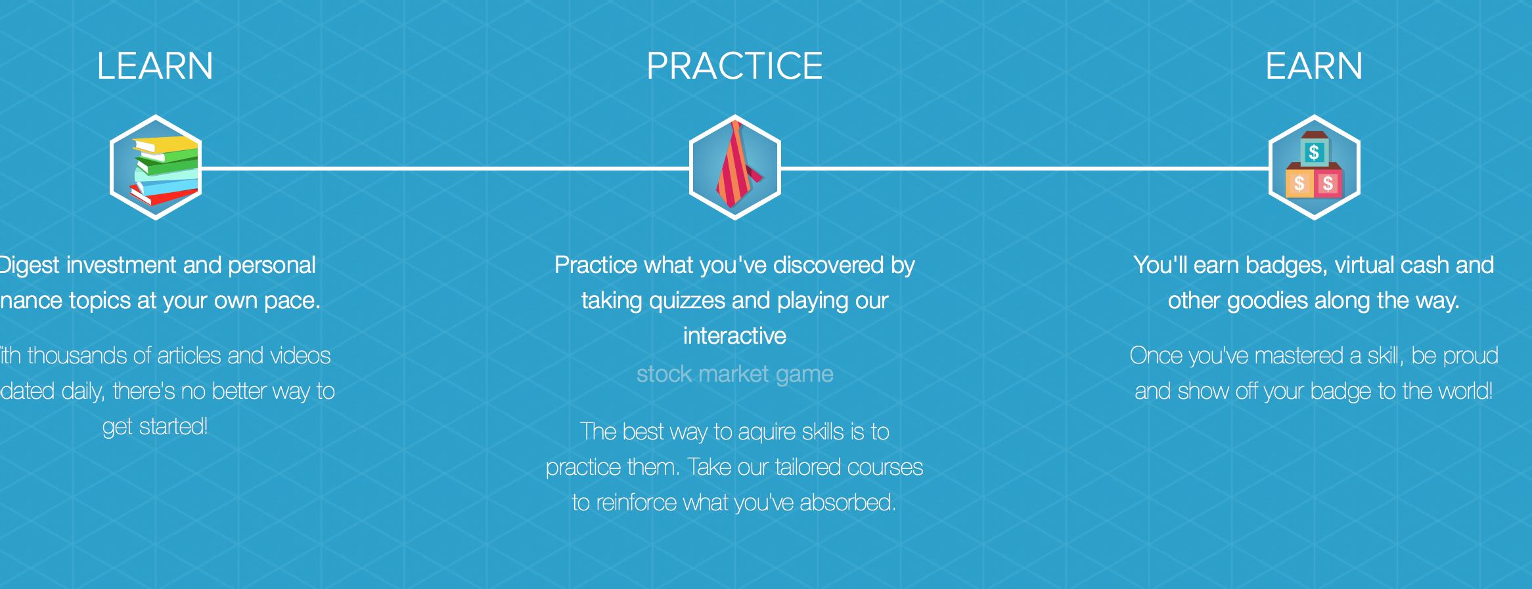
LEARN – PRACTICE – EARN

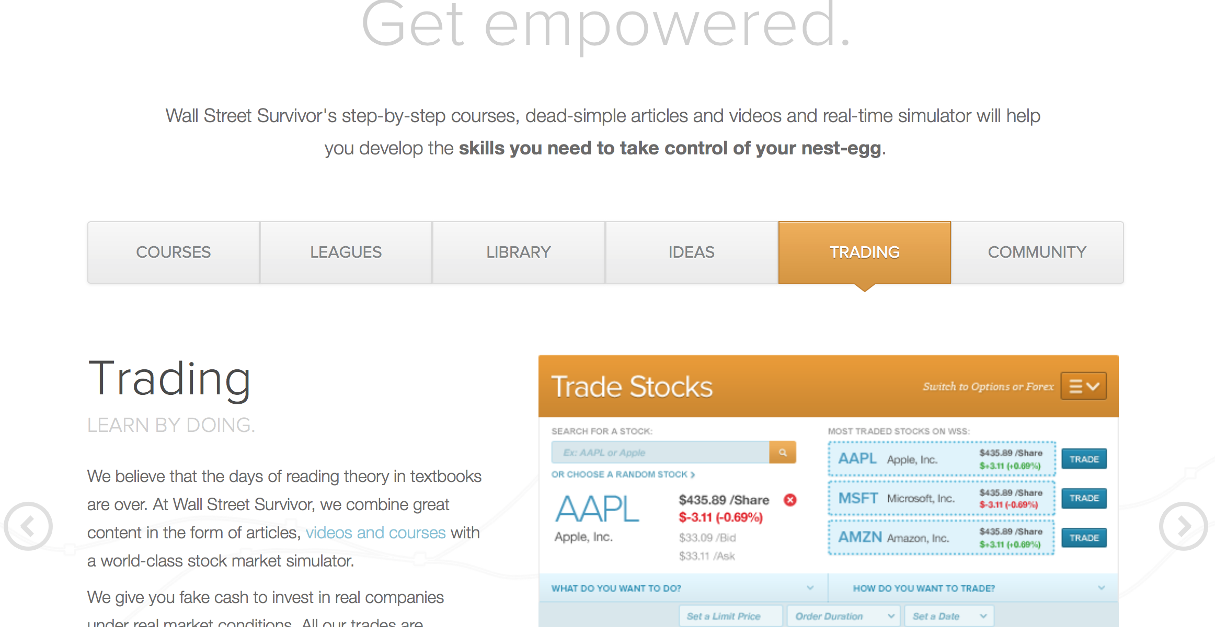

EDUCATION RECOMMENDATIONS TRADING

Education

Standing the test of time is one of the truest measure of real quality. Our
Stock Selection Masterclass program is now into it’s 15th year and has been used by thousands of our graduates!

Sure, of course it has had a couple of updates and “face lifts” fitting it into todays markets, but at its core, it remains one of the most comprehensive and robust stock trading education programs around.

The core of the program – its DNA – is based around decades of real life, hands on professional trades taken by the course author – a professional trader and former hedge fund manager. What this means is that you aren’t learning theory, you are learning from genuine irreplaceable experience.

The massive value of the program comes not only from this DNA but by how this teaching is delivered – in plain, jargon free English that just about anyone can understand.

Once you complete this course, you will enjoy the benefits of a bullet proof trading process that will help you find better trades, time your entry and exits more successfully and employ professional risk and money management.

If you want to be a better investor, this comprehensive 33 module course will help you get from A to B, quickly, safely and with confidence.

Our promise to you is to teach you how to be a better investor

Similar content for Recommendation and Trade

About Stock Selection
Stock Selection is dedicated to helping you build not just the skills and knowledge, but the confidence to trade the market like a pro!

Our jargon free education is based on decades of real life experience, and has been written by pro traders and former hedge fund managers who truly lift the lid on the techniques used for profitable trading.

Jumping in head first and managing your investments can be scary and rarely ends well. At Stock Selection, you can be sure that as your knowledge and confidence grow, so too will your investments!

Generic Footer – same style as Wallstreetsurvivor.com

