Secco – an early stage start-up challenger bank looking for inspirational designs.

Secco – where banking just happens

Our Mission - to make banking go away

Our Vision – hands-free financially confident customers

We don’t care whether banking is done at a branch, or on a phone or even in a smart watch – we think banking should just go away.

We believe that customers don't want to ‘have a relationship’ with their bank, and that frankly they've better things to do.

The Banks want to engage customers only when it suits them, or when required to.

We don’t think it has to be this way.

The Competition Markets Authority wants more Banks; the Financial Conduct Authority has had 26 challenger bank applications in the last year. They gave Atom Bank a license just last month.

We want to disrupt banking.

Disrupt the age-old business model where one side will always be worse off. Give control back to the consumer. Restore the balance.

With Secco the reason you don’t bank isn’t down to apathy, it’s because you don’t have to.

We will be the bank that does it for you, not because you can't but because you have bigger fish to fry.

We think some of you’ll want to be rid of banking as much as we do you’ll help us do it.

Life is too short to spend time on its admin. With Secco you don’t have to. You’ll be free to do the things you really want.

Secco is a bank that will not only securely hold your money, but also your data. Only you will have the key. You can unlock it to save you time and money. When and where you want.

- See a restaurant offer on Facebook. Book, redeem, invite friends and let the restaurant know you’ve a nut allergy and can’t stand north facing tables – then pay the bill by posting a picture of your meal - without leaving Facebook.
- Secco will know your car insurance is due and negotiate a policy only with providers that have the legal cover that matches your personal values; and pay the tax and book the MOT with a reputable local garage.

Big Brother? Maybe, but it’s already happening, just not with your express permission, and not always in your best interest.

Your money, your data should be yours to control. And through technology, releasing that value will be safe and easy.

Brief:

Secco Logo
- Name
- Flexible enough that name / image can be used separately
- Flexible to be used with or without ‘bank’ to follow
- Flexible that a strap line can be inserted
- Transparent background

Secco Font
- Complements logo text

Secco Brand palette
- Orange primary
- Dark grey/blue for accent / copy
- Works on white background
- Suggestions on contrasting colour, or treatment for CTA (e.g. sign-up now button)

(Nail the above and we’ll consider commissioning you to do the next design piece

Secco Pitch deck, beta prototype, web assets such as website / FB / Twitter / email
o Powerpoint design
o Icons, buttons etc
o Infographic of target market pen portrait
o Video editing
o Imagery
▪ Animation where possible

Be instrumental in our success at raising funding – and you could lead the creative team in Secco!)

Secco - brand values
Convenience, Choice, control, trust, safety, integrity, fairness, intelligence, self aware, early adopters, social, altruistic, ease, comfortable, witty, dry, organised, empowerment, autonomy, mature but modern, ambitious, open

Antonyms: Flippant, silly, inefficient, risky, elitist, selfish, old school, traditional, closed

Pen portrait and persona target market
- Mid-life busy working couples with children (managerial, professionals)
- Very time poor, but financially comfortable and astute (household incomes £75k+)
- Generally intelligent & technologically savvy, as far as time allows them they do like to try new things.
- Heavy web users they are practical with the time they spend online, keeping up to date, staying in touch via email and social media, researching, buying and organising their home and family lives – childcare, food shopping, leisure, culture, bills, services etc etc.
o Spending approx. 44 days a year on life admin
- More sarcastic than cynical, they know what they enjoy, but don’t get time to do it as much as they’d like. Their friends are in the same boat. Dinner party banter will be jovial mocking.

Personality / Brand associations
- They choose fair, quality brands, ones they can trust to deliver on promises of service.
- They don’t have time to make wrong brand choices, but will try new brands if those brands invest in getting the value proposition right.
- They need to get that feeling very quickly from the creative – it is a rational heuristic. Something that looks quality and is well written is likely to be for them.

If Secco were….
- an animal it would be a cat
- a grocer - Waitrose or a curated food box from local suppliers
- a car - Audi Q7
- a cartoon - Modern Toss
- a tv programme - Netflix original
- a speaker SONOS playing paid for Spotify
- a computer, a Mac air
- a department store, Amazon with a Prime membership, Notonthehighstreet , John Lewis
- a chocolate, Green & Blacks
- a paint company Farrow & Ball
- a trainer, Converse
- a holiday, a villa in Tuscany (would have liked to Airbnb but dealing with the owner may be too much hassle), ski-ing
- a kids summer activity – firetechcamp (coding school)
- a sport, cycling for charity

Why are we called Secco?
- Secco means ‘quick’ – think “in a second” – our service will reduce actions to mere seconds, saving our target market time so they don’t have to constantly say to their demanding children “in a second”
- Secco means ‘dry’ – think “safe and dry”, “dry sense of humour”
- Secco has “eco” in it – our target market is ethical and intelligent
- Secco as in ‘Prosecco’, a quality, fun but everyday drink that appeals to our target market who like and can afford it.

thank you from

secco

Inspiration:

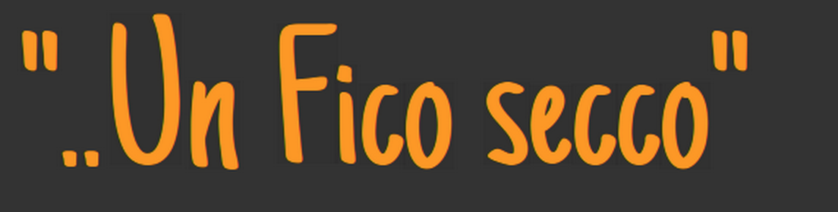

more below
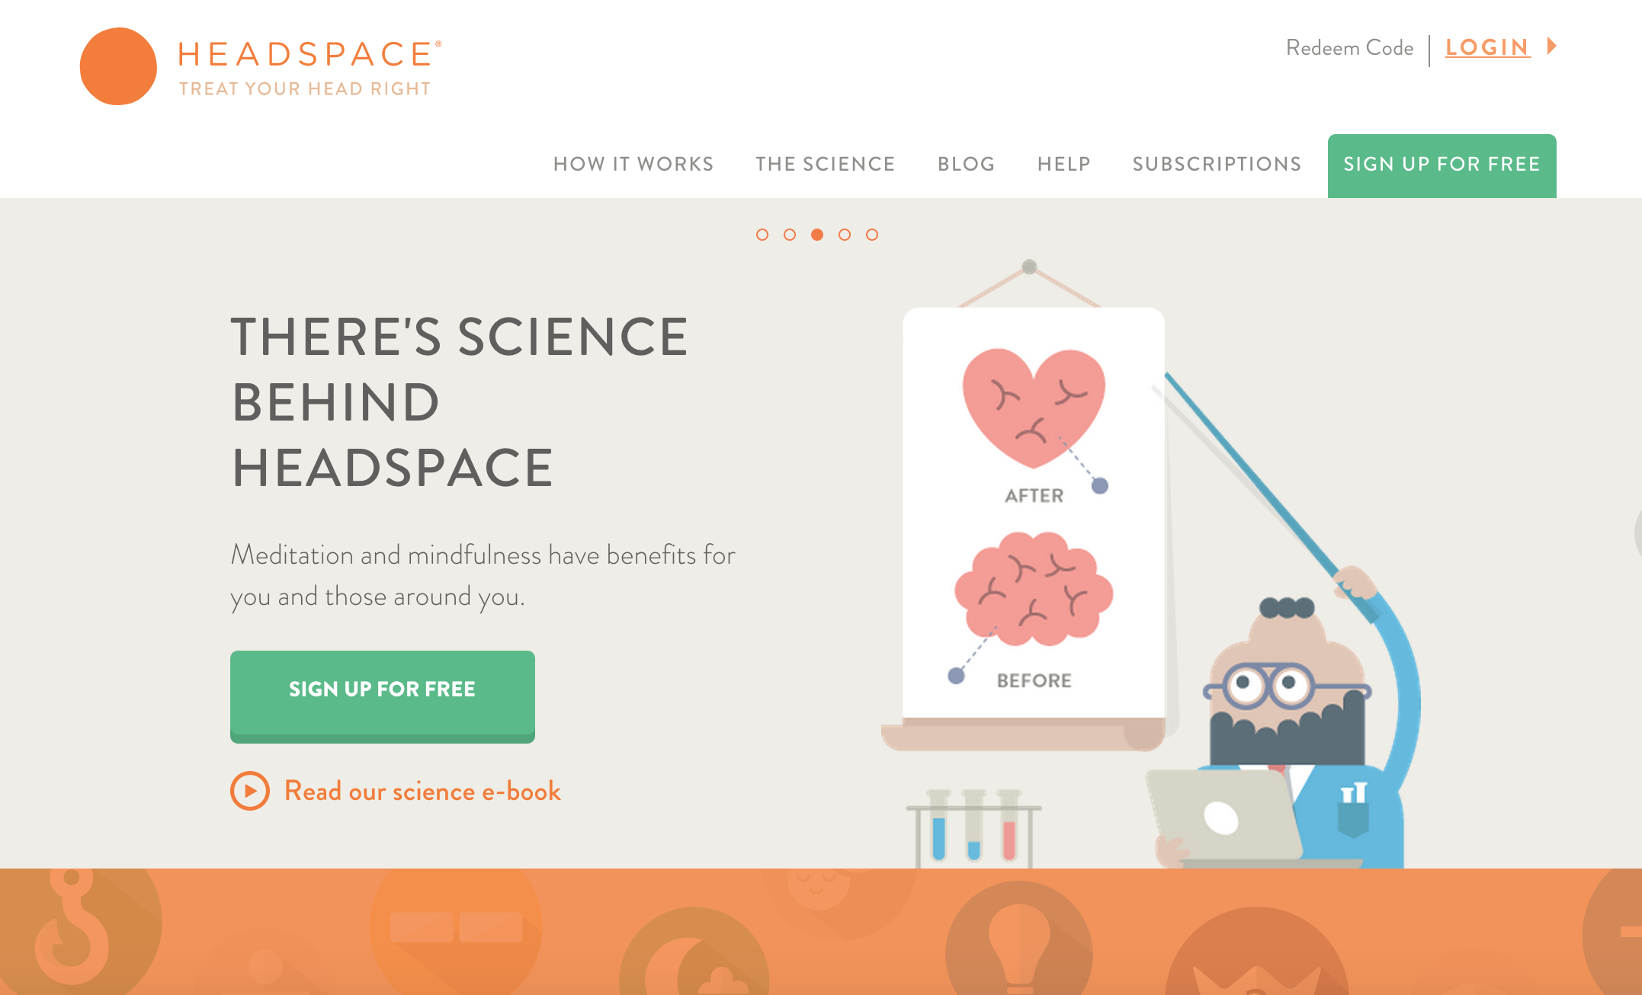

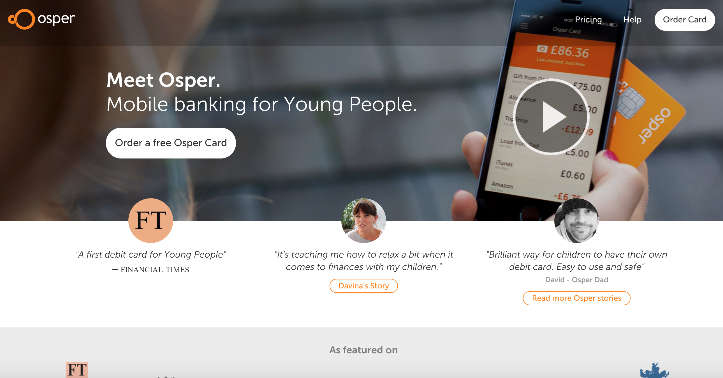

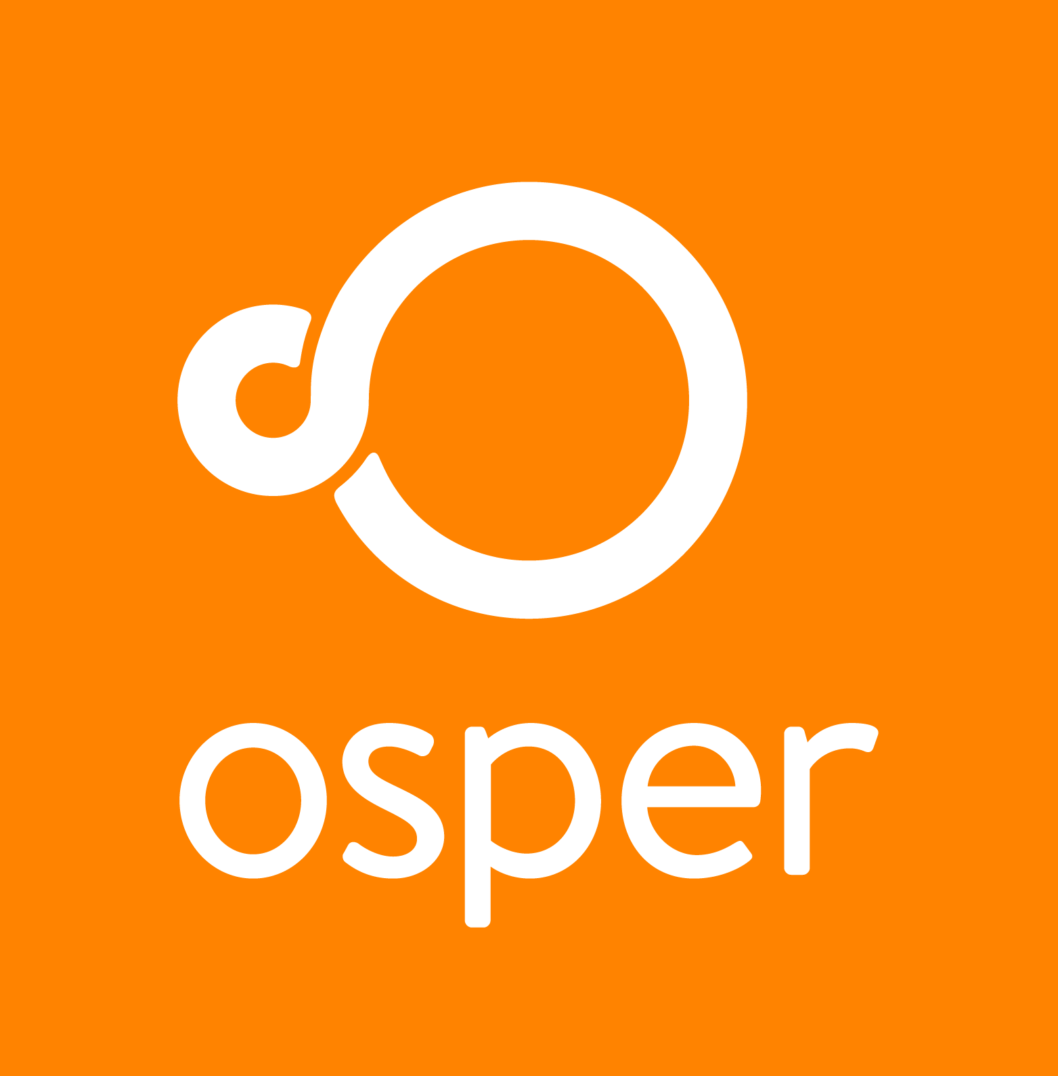
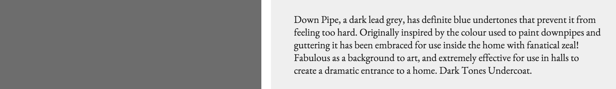


maybe too yellow




