Home Page | Contact | Blog | Language: English  French

Produits | Services | Our Approach | About | Ressources | FAQ
Home page
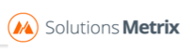
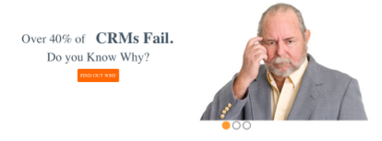

Solutions Metrix: CRM Simplified

What We Help Companies Achieve

More Productivity & Revenue Growth
All your business activities are automate, so you can focus on selling and maintaining your consumer relationships

More Visibility
Attain complete visibility of your sales activities
Centralize all your operation in the same software

Full control
Integrate your CRM with your applications (outlook, mobile, ERP…) and maintain contrôle on your operation all time.

We are CRM specialists

Why choose Solutions Metrix?

- Recommending on the best business practices of your industry
- Bringing councils to increase your sales force.
- Forward-thinking on new technology we are not afraid of offering
solutions to small cost to our customers.
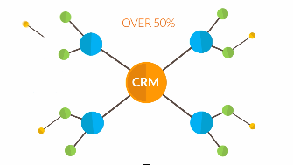
solutions Metrix video

You don't become just another client when you acquire Solutions Metrix products and services, you become part of our network of partners.

Who we are

- Over a dozen CRM specialists
- Cumulated experience with business processes spanning more than two decades
- 200 projects completed with almost as many unique clients with each their own business challenges

Discover how Solutions Metrix help compagnies to built customer relationship

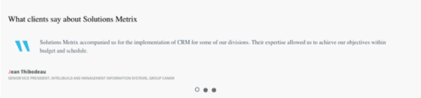
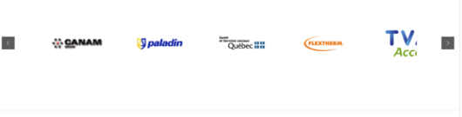
Solutions Metrix CRM Simplified
We Will Help Select the Right CRM

Get A Free Trial
Get A Demo
Compare Software

 | Contact | Blog | Language: English  French

Produits | Services | Our Approach | About | Contact | FAQ
Microsoft Dynamics

Build customers loyalty to drive repeat

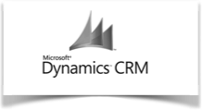
Demo

Used by leading companies worldwide, business solutions from Microsoft Dynamics CRM are

Flexible
with options for deployment, purchase, and access

Familiar and easy to use
it works like other Microsoft products

Integration:
Designed to fit your business through extensive customization and partner offerings

Value:
Every business experiences change. Whether through accelerated growth, mergers
and acquisitions, new regulations, or through budget tightening, your business must be ready to adapt to a dynamic business climate
With DynamicsCRM and the power of choice, you’re ready to make the most of your investment, adapting to almost any situation

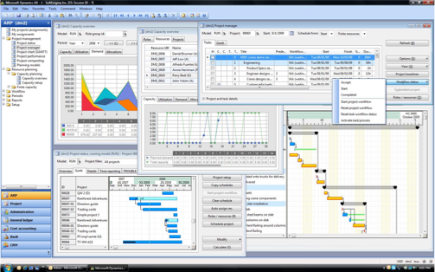

Organize Customers and Leads
Equip your team with a centralized source of customer information and actions:
- Share contact information
- Track leads and prospects
- Integrate with Microsoft Office Outlook

Automate Workflows
Create forecasts, get offline data access, and enjoy easy mobile integration:
- Manage team engagement process
- Generate real-time sales quotes and marketing campaigns
- Standardize handling across geographic locations

Synchronize Across Teams
Get fast, flexible access to real-time data for your teams:
- Use anywhere with mobile devices
- Set up territories and teams for optimal efficiency
- Use predefined workflows to streamline approvals

Sales, Service, and Marketing
- Establish a 360-degree view of customer interaction and sales opportunities
- Deliver value with integrated interaction and knowledge management
- Plan, implement, and measure more effective marketing campaign
Get in touch with us and together we’ll figure out if Microsoft Dynamics CRM is the right choice for your

OVERVIEW OF FUNCTIONALITIES
- Data Storage: SaaS Solution & On-Premise
- Analytics
- Email Marketing
- Mobile App: Windows 8 Phone, Windows 8, iPhone, iPad, Android
- Data Cap: Per User
- Email Integrations
- Free Trial Version

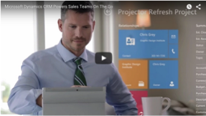

Solutions Metrix CRM Simplified
We Will Help Select the Right CRM

Get A Free Trial
Get A Demo
Compare Software

- Data Storage : SaaS Solution & On-Premise
Demo
Quick overview

Oracle Cloud
is one of the latest IT solutions providers to
have released a CRM that is compatible
with many mobile devices.

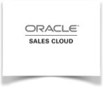

- Analytics
- Email Marketing
- Mobile App : iPhone, iPad, Android
- Data Cap : Unlimited
- Email Integrations
- Trial Version

Sell More Anytime-Anywhere-Any Device

Whether you are on the go or at your office you can make the most out of your time by pulling out your Smartphone or Tablet to track and close on Leads and Opportunities. The Oracle Sales Cloud App has been optimized by a team of designers and Sales gurus to ensure you get the most work done with a simple to use App.
“A-B-C… Always Be Closing!”

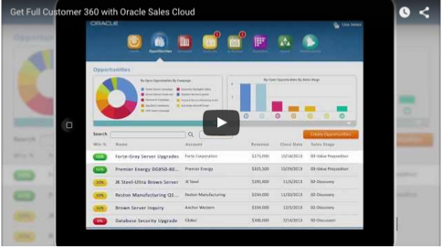

Get A Free Trial
Get A Demo
Compare Software

Solutions Metrix CRM Simplified
We Will Help Select the Right CRM

Demo
Salesforce.com

Is one of the best known CRM in the market today
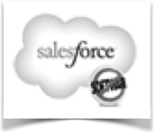

Completely web-based and integrated, with over 87,000 success stories, Salesforce has a strong presence everywhere.
Salesforce.com offers you what you need. Completely cloud-based, Salesforce.com integrates seamlessly with your work tools.

Salesforce is the best-of-breed CRM solutions and has some of the most advanced and most usable sales force automation functionalities. Salesforce provides a true 360-degree view of the customer, delivered directly from your most used applications.

Salesforce.com comes with modules for:
- Integrated sales force automation
- Customer service and support
- Marketing automation
- Document management
- Contract management
- Product catalog management
- Analytics

In a nutshell: Salesforce is internationally recognised and has won many awards.

- InfoWorld (2004, 2005, 2006)
- PC Magazine Editors Choice Award (2002, 2003, 2004)
- Visionary Award (SDforum, 2004)
- Best of the Web (Forbes 2003)
- CRM Excellence Award (2003-2006)
- Top 100 Innovators Award (Businessweek 2006)
- Innovation Award (AMR Research 2005)
- Codie Award for Best CRM (2002-2006)

Salesforce has earned a solid reputation as the leader in hosted CRM solutions. The company was an industry pioneer in offering customer relationship management on-demand during a period when others were still offering only location-based packages. Salesforce.com has perfected the hosted solutions model, and it’s robust architecture facilitates effective delivery of CRM applications via the Web.

Salesforce places a strong emphasis on customer satisfaction. The solution comes with a wide range of free support services and training in addition to best practice guidance. Salesforce solutions are constantly enhanced and improved with upgrades available to clients at no cost.

OVERVIEW OF FUNCTIONALITIES
- Data Storage: SaaS Solution Only
- Analytics
- Email Marketing
- Mobile App: iPhone, iPad, iPod (iOS 5+), Android
- Data Cap: Per User
- Email Integrations
- Free Trial Version

Solutions Metrix CRM Simplified
We Will Help Select the Right CRM

Get A Free Trial
Get A Demo
Compare Software

Services

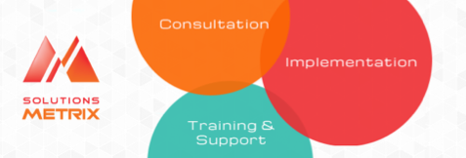

Consultation
Selection of the optimal solution CRM for you, according to your processes and business needs.

Implementation
Configuration of your system CRM and integration with your external and internet working tools and database

Training & support
Technical support and training for your teams sales, customer service and marketing

Book a Free CRM Consultation

We`ll get you started in the right direction.

Our Approach

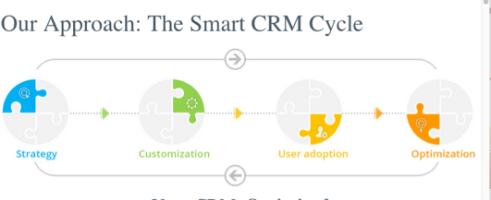

Your CRM Simplified
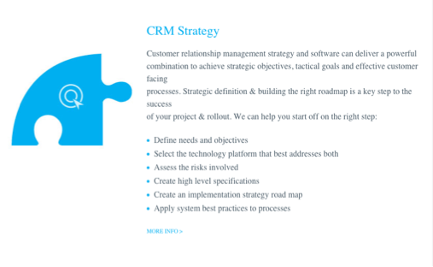

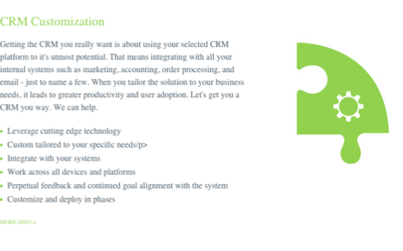
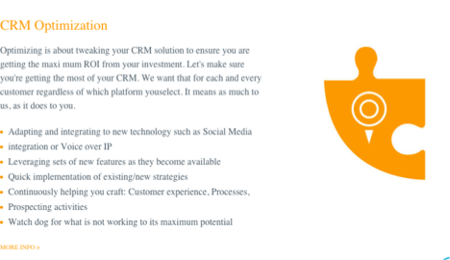
Book a Free CRM Consultation

We`ll get you started in the right direction.

About

About Solutions Metrix

Since 2001, Solutions Metrix made a success of more than 200 setting-up of recognized systems of customer relationship management ( CRM), such as Oracle Sales Cloud, Saleforce.com, SugarCRM and Dynamics CRM Microsoft.

Each of our setting-up is personalized to be the most adapted to the business needs for the company. Over the years, Solutions Metrix developed a process of setting-up which calls up to the success. By taking into account essential needs for the company with which we work, this process allows us to present the customer with a service which contains an excellent cost estimate of project.

The experts of Solutions Metrix implant the CRM systems at them customers so that they are used as real working tools and not as as simple databases. Hundreds of successful setting-up conferred us a unique know-how regarding solutions CRM. The process of integration and support of the customers optimizes the adoption CRM by our customers.

The secret of our success is simple: we adapt our solutions CRM to your business model, worked and industry!
Corporate overview

Renvoi vers la présentation corporative en format PDF

