Structure:
- ABOUT
  - Overview (See Felix http://www.felix-energy.com/)
  - Management Team (See Gulfport http://www.gulfportenergy.com/about/management-team )
  - Board of Directors (See Gulfport http://www.gulfportenergy.com/about/board-of-directors )
  - Our Partners (See Felix or Talon or Silverback http://www.felix-energy.com/about-us/our-partners http://www.talonog.com/about/our-partners http://www.silverbackexp.com/our-partners )
- AREAS OF INTEREST (See Grenadier http://grenadierenergy.com/areas-of-interest/ The map isn’t the best and more content area for each of the AOIs would be great.)
- INVESTOR RELATIONS
  - News & Resources
  - Presentations
  - Investor Login
- OWNER RELATIONS (See Gulfport http://www.gulfportenergy.com/royalty-owners )
- CAREERS (Something like Felix is fine…. http://www.felix-energy.com/careers )
- CONTACT (Something like Felix is fine…. http://www.felix-energy.com/contact-us )

------Menus------
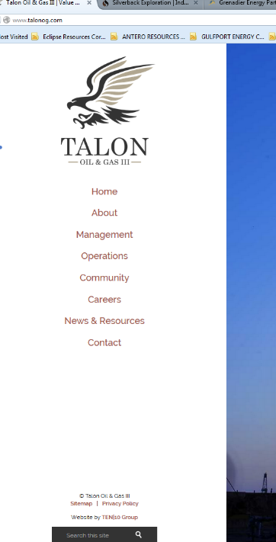
I like the vertical menu design like Talon and Silverback.
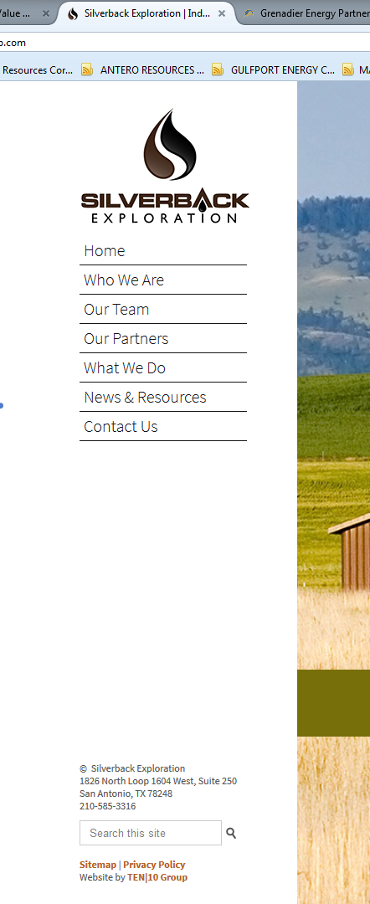
http://www.silverbackexp.com/
http://www.talonog.com/

I like the function of the menu navigation on Sandridge. http://www.sandridgeenergy.com/
------Home Page Design------

I like the clean design of Grenadier, Felix, Tapstone and Sandridge. http://grenadierenergy.com/ http://www.sandridgeenergy.com/ http://www.felix-energy.com/ http://tapstoneenergy.com/
Although I do not like the single page with scroll function on Tapstone.

