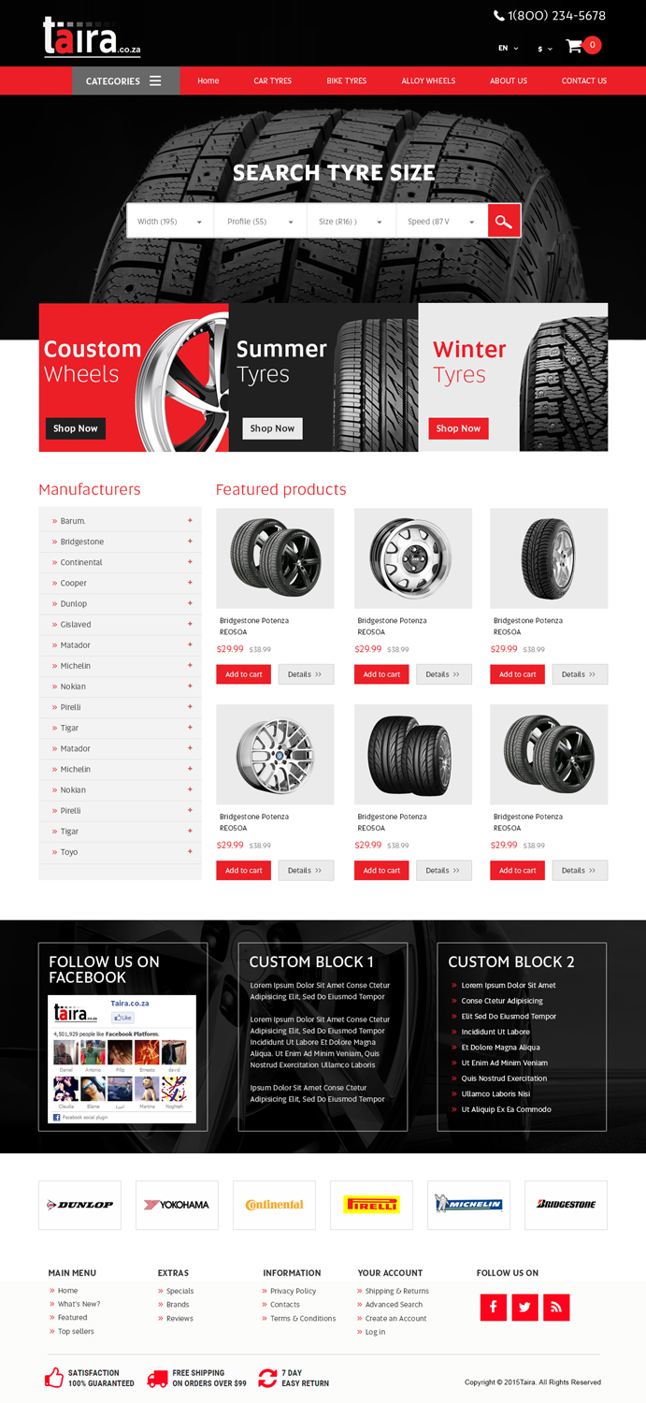 | Menu:  Home  Car Tyres  News  About Us  Contact Us  Remove the coustom wheels and put typre brands  Remove Facebook and Custom Block 1 and 2.  Put these brands on top too.
Example of the Home Page
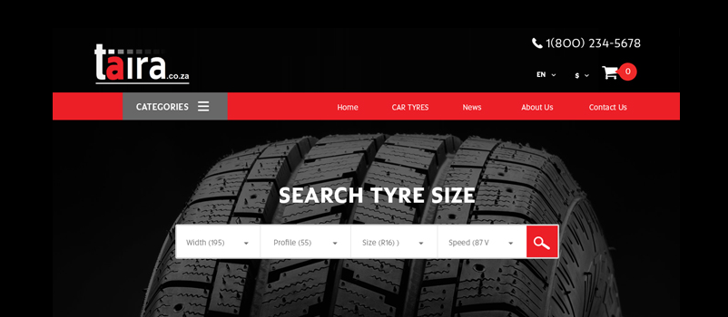
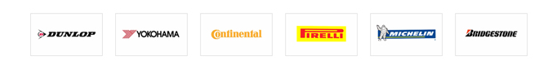
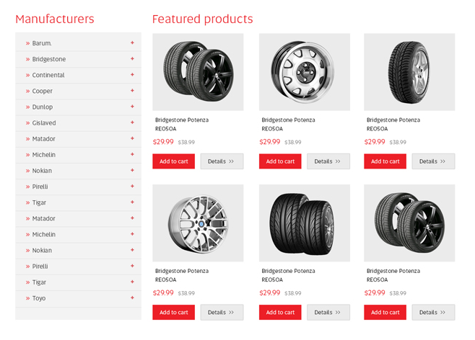
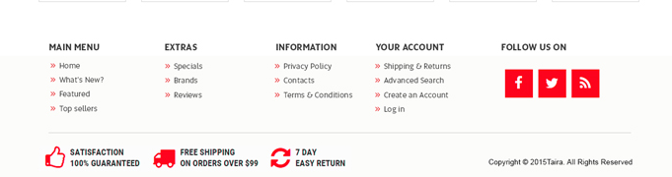

Web Pages:
1. Home Page

2. Car Tyres Page
Put the Search Tyre Size like on the home page:
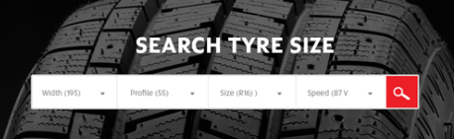
Put the list of Manufactures and Feature Products like on the home page:
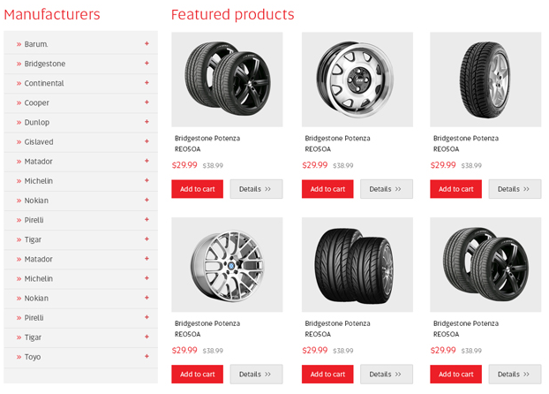
3. News Page

Create posts for publish news and Twitter and Facebooks boxes on the right.
NEWS TWITTER
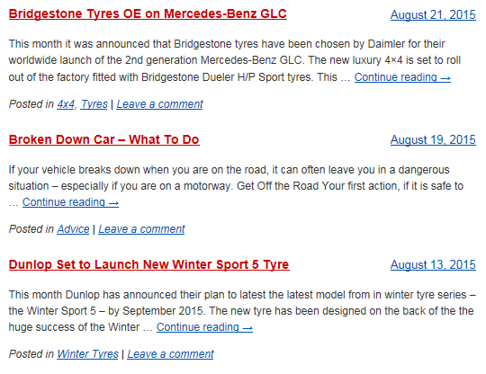FACEBOOK

4. About Us Page
About the company…

5. Contact Us Page

Our contact details
Form to send question

