

Website for the online retail of tyres

Logo & Website Design Specification

Document Version 2
August 2015

STATEMENT OF CONFIDENTIALITY AND NON-DISCLOSURE

This document contains proprietary and confidential information.

All data submitted to you is provided in reliance upon its consent not to use or disclose any information contained herein except in the context of its business dealings with GoDot Investments (Pty) Ltd. As a recipient of this document, you hereby agree to inform representatives of GoDot Investments (Pty) Ltd of any other party (apart from yourself), who view or have access to this document.

As a recipient of this document, you also agree to instruct other readers of this document, not to disclose of any information concerning this document to other except to the extent that such matter are generally known to and are available for use by the public. As a recipient, you also agree not to duplicate or distribute or permit others to duplicate or distribute any material contained herein without GoDot Investments’ written consent.

GoDot Investments (Pty) Ltd retains all title, ownership and intellectual property rights to the material and trademarks contained herein, including all supporting documentation, files, marketing and multimedia.

By acceptance of this document, the recipient agrees to bind by the aforementioned statement.

DOCUMENT STATEMENT
This document highlights the necessary information required to effectively define the purpose, architecture and system design, in order to give the Development Team guidance on how to develop the product. This document was first drafted during the Planning Phase and has evolved as the product became more defined and realised. Its intended audience is the Sponsor, Project Manager, project and development teams. Some portions of this document such as the user interface (UI) may on occasion be shared with the client/user, and other stakeholder whose input/approval into the UI is required.

1. INTRODUCTION
We need a logo and website designed for our business.

1.1 Logo
We do not have an existing logo.
The logo we require should be bold, masculine and professional looking.
It should be functional enough to be placed on the website and used for marketing, placed on corporate items and golf t-shirts.
Business name is TAIRA

1.2 Website
Design of an ecommerce website developed in HTML5 and should be responsive.
Design should be on a clean background.

The purpose of the website:
The website is for the online retail of tyres where users can do following:
- Search for the type of tyre they need (from the front page already)
- Pay online (through secure payment gate)
- Website should have algorithm to calculate delivery cost based on location of user)
- Tyre delivered at their home.
- User should be able to track ETA.

1.2 Multi-language
The website will be in the following (5) languages. We will provide translations in the other languages at a later stage of the design.

- English
- Afrikaans
- Zulu
- Oshiwambo
- Portuguese

Target Market
Private vehicle owners in Southern Africa, with later expansions into the rest of Africa.

2. WEBSITE DESIGN SPECIFICATION

2.1 Site Map

The website will require the following pages:
- Home page
- Search Result page
- About Us
- Contact Us

2.2 Content – Home Page

[header picture of tyres and logo]

[heading]
Best Tyres at the Best Prices

[how it works slider with appropriate pictures for each step]
- Search your tyre by Tyre Size
- Place your order online
- We deliver your tyre at your home or garage of your chose for fitting

[search criteria]
Search Tyre Size
Width (195) | Profile (55) | Size (R16) | Speed (87 V)
SEARCH

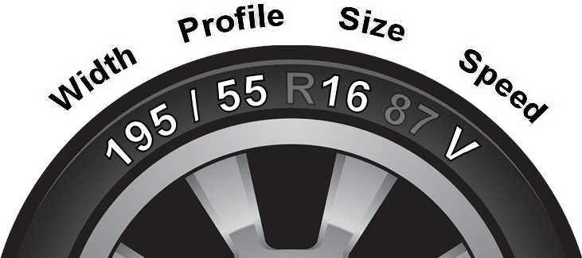

Tyre Size Explained
- Width
- Profile
- Rim size
- Speed rating

2.3 Content – About Us


We provide our customers with the best tyres at the best prices.
We aim to be Southern Africa’s leading online tyre retailer with a network of independent garages in the whole of Southern Africa for fitting your tyres.

We work hard to take the pain and confusion out of buying tyres. Most of our customers consider tyres a frustrating purchase to make and we try to make it as easy as possible whilst providing great choice and savings.

We offer a wide choice of brands and prices with our customers able to choose from an extensive range of tyres.

We offer:
Competitive Prices
Constantly monitoring the market for best values

Superior service
Exceptional customer service

How to order?
Ordering your tyre from us is as simple as ONE-TWO-THREE:

1. Enter your tyre size and choose from an extensive range of brands and prices based on your budget.
2. Make a secure online payment online, through a variety of options - debit & credit card.
3. State your delivery address and we will deliver your tyres.

2.4 Content – Contact Us

Will provide contact details at later stage of design.

2.5 Online Payment

We will provide secure online payment through the following payment gates:

- PayPal
- Payfast

2.4 Delivery Charges

We will also charge a delivery charge which will be calculated based on users location.
This will be provided at a later stage of the design.

