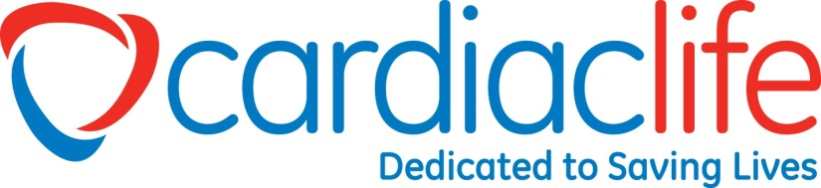 Empowering People to Make a Difference 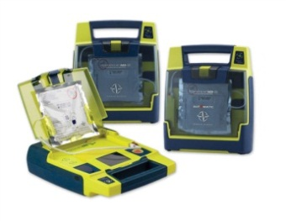
Medical
Trainings
AED Accessories &
Training
Equipment
Cert. & AED Tracking
AED Field Maintenance

AED Sales

- CPR/AED
- First Aid
- ECG/Pharmacology
- ACLS
- BloodBorne Pathogens
- Online Blended Classes
- Defensive Driving
- Pet First Aid/CPR
- All trainings can be taught at our new training center or at your location
- Yearly physical and system inspection of AED
- Required software updates
- Expiring supplies replaced
- Battery system inspection and replacement
- Email reminders of CPR certification expiration
- AED Batteries
- Cabinets
- Electrodes
- AED Signage
- Manikins
- Friends & Family CPR
- First Aid Kits
- AED Trainers
- CPR Supplies
- EpiPen Trainer

- Cardiac Science
- Philips
- HeartSine
- Physio Control
- Defib Tech
- Zoll
- AED Rentals
- Recycling Programs

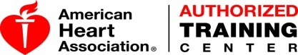
The team at Cardiac Life Products is 100% committed to providing the best AED sales and services possible. We offer a variety of AED brands and models. Our staff are trained on all the AED’s we sell, so we can ensure your AED purchase is the right one for you. No one wants to have to use an AED, but in the event you need to, having an AED, knowing how to use it and being trained in CPR could make the difference in saving someone's life.

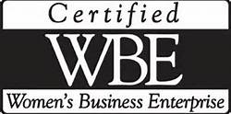
349 West Commercial St., Suite 1400 East Rochester, NY 14445 Phone: 585-286-3811 Fax: 585-3822 www.aedclp.com

