
Hello! Here is Curulis Quest, a chess-like strategy game for 3 or 2 players.
Game begins when Julius Caesar crossed the Rubicon river. Consul who conquers the curulis chair wins!

“Chess”board for 3 players (the original one!)  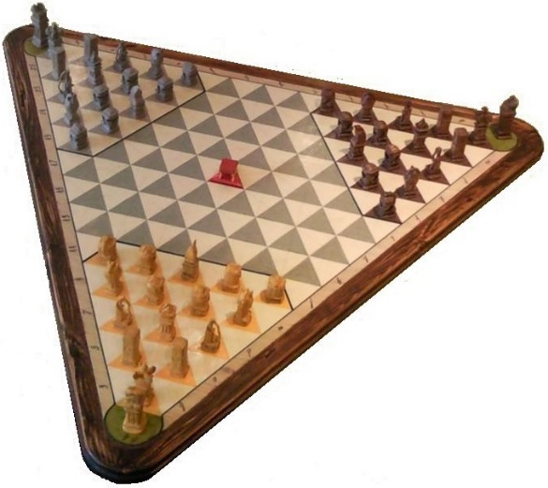 | “Chess”board for 2 players (created because asked by many players)  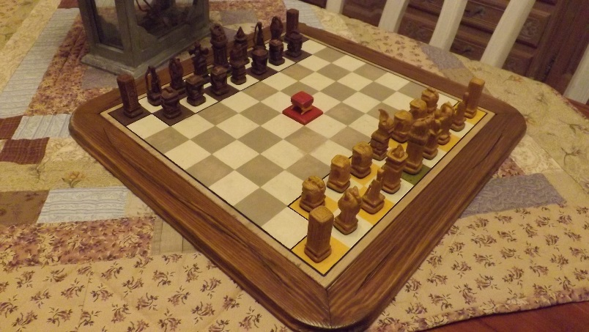

An idea of the new pawn set
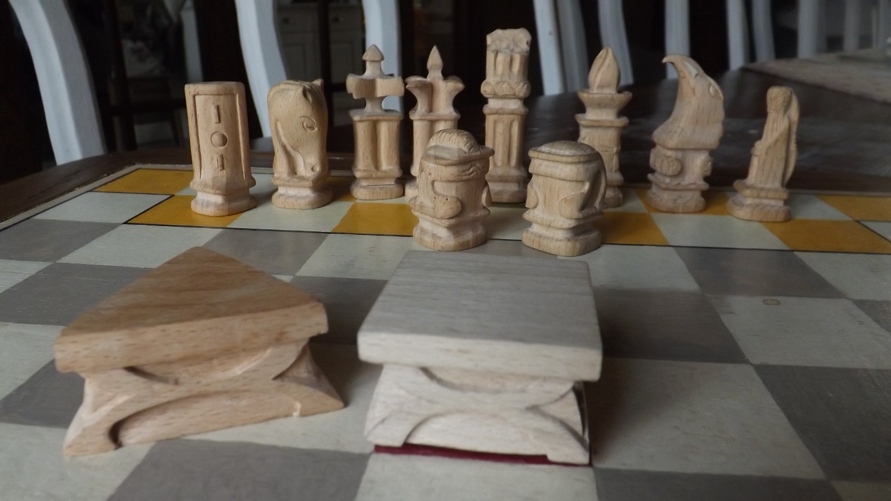

An idea of the poor attempts I made to find a logo! 