Color Scheme


Primary Blue
Hex: #03244d
R: 3
G: 36
B: 77

Primary Orange
Hex: #dd550c
R: 221
G: 85
B: 12

Secondary Blue
Hex: #496e9c
R: 73
G: 110
B: 156

Secondary Orange
Hex: #f68026
R: 246
G: 128
B: 38

Require Adobe Indesign file for final design
Use other colors that complement the main theme.
Use pictures from the website (nextideacademy.org) and other relevant creative images to uplift the theme

Use full logo in front page

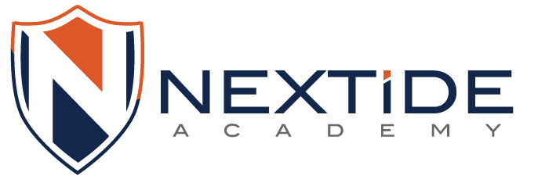

Use just the logo wherever appropriate based on the design.



Online American High School * Grades 6 – 12
A unique school
- Differentiated Education
- College Prep Curriculum
- Flexible programs
- Promoting intellectual maturity and responsibility
- Global Peer learning

A learning environment for all
- Gifted students
- Students engaged in significant pursuits in the areas of sports, arts, etc.
- Home schoolers
- English Language Learners
- Accelerating postsecondary completion through Advanced Placement® (AP®)* courses

Pictures 1, 2,3

Vision Statement
Nextide Academy is a premier American online high school offering comprehensive, collaborative, and affordable learning to a diverse and intellectually passionate global community.
Mission Statement

Nextide Academy provides high-quality, flexible, individualized educational experiences in a safe, technology-enabled learning environment to empower students to achieve their academic and personal goals.

Academics
Nextide Academy’s differentiated curriculum with project based learning at its core fosters critical reasoning and argumentation while engaging students in advanced academic content. Students work closely with the instructors in a peer-learning environment that motivates them to reach their full academic potential.

Students are placed in courses based on ability, not age or grade level, and he academic plans are tailored for each student that will prepare them for success in the future - college and beyond.

The curriculum includes Project Based Inquiry courses where students take part in learning experiences framed around answering Big Questions or addressing Big Challenges that guide instruction and serve to organize their learning progressions. As students pursue answers, they conduct investigations, make models, collect and analyze data, weigh evidence, write explanations, and discuss and present findings, a process that empowers students with STEM.

From middle school through high school, students are introduced to various aspects of competitive testing. Tests and quizzes that reflect college entrance tests like SAT and ACT are embodied into the curriculum that helps students develop deeper analytical skills.

Highlights: (Individual items To be used in highlighted boxes across the brochure)

- Award-winning courseware proven by third-party research and studies
- Inquiry-based learning – develop student knowledge towards solutions
- Our students can challenge themselves with AP* Courses
- Peer learning - mutually beneficial and involve the sharing of knowledge, ideas and experience across a global community
- Self Organized Learning Environment – Learn to Learn
- Personalized college counseling and planning
- Tutoring plans

Enrollment Options

Nextide Academy’s academic program offers flexible enrollment options, which include full-time, part-time and single-course enrollment.

The tailored aspect of the program also presents the opportunity for home school parents to enroll students in a curriculum only program keeping their learning ideologies intact.

Full-time (Complete curriculum):
Students who seek challenging course offerings and engage fully in the school’s global intellectual community are encouraged become full-time students. Students have complete freedom in choosing the courses they want to enroll and are not limited in what they can learn promoting independence, discipline and strong time-management skills. Since the curriculum is not bound by age or grade level, it allows our students to pursue diverse interests and exceptional talents.

Part-time (Up to 3 courses):

Students that seek to supplement their current school’s offerings in more than one area can enroll in our part-time program. Our part-time programs are highly flexible allowing the students to enroll in any combinations of courses.

Single Course:
Students who need to catch up or who have the passion for a subject can enroll. Nextide Academy has over 70 courses to choose from for students to develop the necessary skills in a subject area.
English Language Learners:
Nextide Academy offers courses of every level (elementary to advanced) and levels of intensity that support students who are learning English as a second language. Students can combine individualized courses and learn English effectively, efficiently, and in style

CONNECT WITH US:

www.nextideacademy.org
https://www.facebook.com/nextideacademy
https://twitter.com/nextideacademy

School supplies for the modern world:
Microsoft Office 365 Plan
Learning Management System
ePortfolio
Peerwise
Online Tutoring
Student Information System
Online Helpdesk

Affiliation logos:




Fine Print at the bottom:

*AP and Advanced Placement Program are registered trademarks of the College Board, which was not involved in the production of and does not endorse this product.
**AdvancED candidate

For design inspiration – use appropriately for content provided

