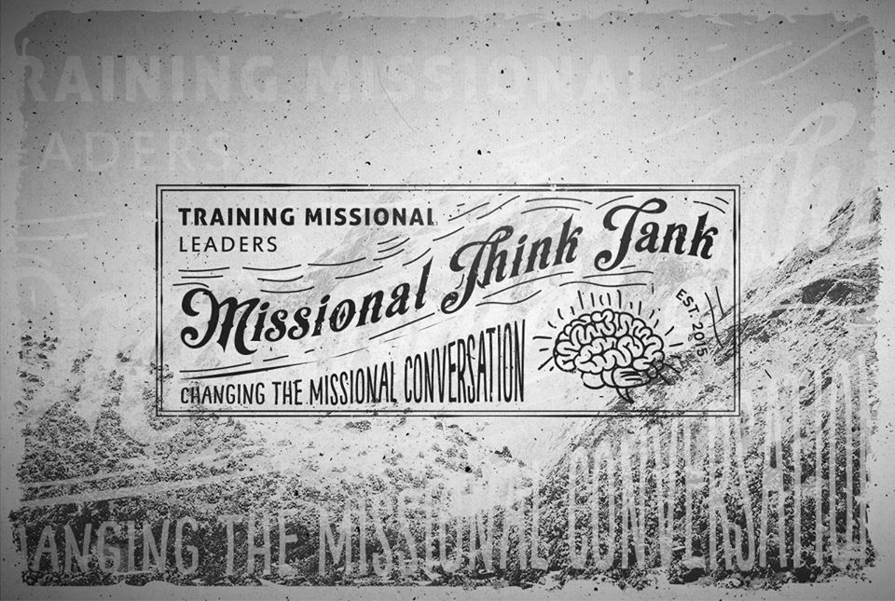

Missional Think Tank
CONNECTING GREAT LEADERS TO GREAT IDEAS

OUR MISSION – To Awaken Gods People, To Equip Gods Family and to Unleash Gods Mission.

OUR MODEL:
AWAKEN (Eph 5:14)

UNLEASH (Matt 28) EQUIP (2Tim2:2)

Awaken = Moving from Consumer to Contributor (I have a role in the kingdom of God)
Ephesians 5:14 - "Wake up, sleeper, rise from the dead, and Christ will shine on you."

Equip = Moving from a Follower to a Leader (Leaders develop other Leaders)
2Tim2:2 – “the things you have heard me say in the presence of many witnesses entrust to reliable people who will also be qualified to teach others.”

UNLEASH = Moving from Purposeless to a Life of Purpose (I have a Mission)
Matt 28: 19 - ¹⁹ Therefore go and make disciples of all nations, baptizing them in the name of the Father and of the Son and of the Holy Spirit.

DISCIPLESHIP

MISSION LEADERSHIP

Testimonial - Britton Smith – Sr Pastor – Moran Pk Church – Grand Rapids Michigan
“Missional Think Tank provided a place for me to learn and process how to lead the church in mission and discipleship. It wasn’t about trying to get me to fit into a mold or program but about growing into who God was calling me to be and what he wants me to do. Our church, in turn, has seen a lot of fruit from the coaching and training I have received from Missional Think Tank because it has helped shift our culture into one of mission and discipleship.”

OUR METHOD:
(Like this)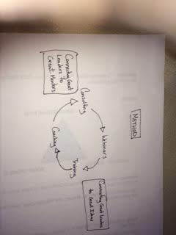

Connecting Great Leaders to Great Ideas
WEBINARS – Monthly Webinar with amazing thinking and leaders to stir thoughts, start questioning and ask questions. Learn from some of the best leaders, thinkers and practioners of discipleship and mission in the country.
TRAINING – 2 – 2 day seminars a year with leaders from all over the country – free events, free food.

Connecting Great Leaders to Great Mentors
COACHING – Monthly Coaching calls with your team to specifically coach your team in where they can grow.

CONSULTING - Monthly consulting call with your team leader to discuss issues

Testimonial –
Greg Ferrell – Business Leader – Prince Edward Island Canada

“Change is disruptive, but it can still be healthy. I’ve been trained and coached by Missional Think Tank leaders for almost two years now. Their content is fantastic, but their coaching is invaluable. Their personalized coaching has helped me not just better understand how to make disciples more effectively, but has helped me think about how to do so in the unique context God has placed me in. They’ve helped me pay attention to what God is already doing in my life, and business, celebrate the little things, and understand our unique strengths and challenges -all of this helps us move forward in a way that brings healthy, lasting change.”

YOUR OPTIONS:
BASIC (Teams of 1 to 2)
- Monthly Webinar
- Monthly Coaching Call with your team
- 2 – 2 day Seminars training your team how to lead like Jesus lead, and how to awaken, equip and unleash your people

Cost = $200 / month

PRO (Teams of 3-5)
All Of Basic +

- 2 workshops a year at your church or organization (Customized to your needs, for your entire team or church) – 10K Value
- Once a year Audit of your organization – We come in and ask the tough questions and look at your vision, values, mission, and much more – 5k Value
- Individual Call with team leader monthly – One on One coaching call with our team
(All travel costs are covered by hiring organization and not by missional think tank)
Cost = $600 / month

Additional team members are $50 each
For more information contact us @ ben@missionalthinktank.com
Also if you would like to customize this coaching in anyway let us know and we can work with you to create a training bundle that works best for your organization.

