St. Peter and St. Paul Orthodox Christian Church
Invites You to
The 2015 Orthodox Christian Youth and Family Conference
Mt. Union, PA
*Powered by St. Paul’s Fellowship of Labor, www.thespfl.org*
Conference Theme: The Local and Contemporary Saints of the Orthodox Christian Church

Description
The Orthodox Christian Family and Youth Conference offers Orthodox Christians an opportunity to meet other Orthodox Christians from around the country and learn about their Faith. We have an exciting schedule of lake visits, hikes, a movie theatre night, and a music concert scheduled for the 3 day event! Please join us and reserve your tickets today at Eventbrite.com under “Orthodox Youth and Family Conference.”
St. Peter and Paul Church
Sts. Peter and Paul's Parish was constructed and consecrated in 1916 by Bishop Tikhon, who eventually became Patriarch of Moscow and our father among the saints, St. Tikhon. Funds from the Czar of Russia were used to help construct this church in Mount Union, Pennsylvania. Today, the parish remain active and open with Father Christos Patitsas, Presbytera Katina, and flock there to liturgize.
St. Paul’s Fellowship of Labor
Founded in 2005, St. Paul’s Fellowship of Labor (SPFL) has organized and lead over 2,000 volunteers on nearly 100 Orthodox Christian service trips to traditionalist Orthodox Christian communities in need in 7 countries around the world.
Guest Speakers
The Orthodox Family and Youth Conference brings clergy, bishops, and theologians from 2 countries and 5 states together in order to provide you a spiritually edifying and enriching series of talks, discussions, and panels on the contemporary saints such as St. John Maximovich, St. Glycarios, and others of the 20th century.
- Archbishop Demetrius of America
- Metropolitan Moses of Toronto
- Father Patrick of St. Gregory of Sinai Monastery
- Mother Agapia of St. Nicholas Convent
- Father Christos Patitsas of St. Peter and Paul Church
Conference Entry Fee for all Ages and Families
- Daycare provided for 7 and under children Free of Charge
- Ages Primary School (8 to 11) $69/person
- Ages Junior/Middle School (12 to 14) $69/person
- Ages High School (15 to 18) $69/person
- Ages Adult (19 and Up) $69/person
- Banquet is $36/person ~ $18 for children 6-12 years of age ~ 5 and under eat Free!

Competitions and Contests: Prizes awarded in each Age Group
- Oratorical Contest “Baring witness to your Orthodox Christian Faith in the Modern World”
- Iconography Contest
- Musical Event and Talent Show

Purchase your tickets at Eventbrite.com: Search under “Orthodox Christian Youth and Family Conference”
Program Agenda for Youth and Family Conference 2015
Thursday, October 8th, 2015 “Arrival and Opening Night”
- 3pm to 5pm: Registration and Check in to Millstone Manor
- 5:30pm: Opening Dinner and Welcome at St. Peter and Paul Church
- 6:45pm: Akathist at St. Peter and Paul Church
- 8pm: Movie Night “Orthodox Themed” in downtown Huntingdon, PA
Friday, October 9th, 2015 “Scavenger Hunt, Panel Discussions, and Orthodox Christian Music Event”
- 8am: Morning Prayers and Breakfast at Hotel/Late Registration
- 8:45am: Morning Orthodox Christian Scavenger Hunt Challenge Activity
- 11am – 12:15pm Midmorning Orthodox Talks, Workshops, and Discussions
- 12:30pm - 1:30pm: Lunch and Announcements at Fire hall
- 1:45pm – 4:45pm Afternoon Orthodox Talks, Workshops, and Discussions
- 5pm - 7pm: Dinner and Announcements
- 7:45pm -9:45pm: Youth Conference Concert and Music Event at HAHS Auditorium
Saturday, October 10th, 2015 “Mountain Climb, Lake Talks, Vespers, and Bonfire Night”
- 8am: Morning Prayers and Breakfast at Hotel
- 8:45am: Morning Recreation Activities and Orthodox Talks
- 12:30pm -1:30pm: Lunch and Announcements at Fire hall
- 1:45pm- 4:45pm: Afternoon Recreation Activities and Orthodox Talks
- 5pm to 7pm: Dinner
- 7pm to 8:30pm: Vespers and Liti
- 8:45pm Bonfire and Outdoor Activity
Sunday, October 11th, 2015 “Hierarchal Liturgy, Banquet, Contests, and Closing Ceremony.”
- 7:00 am - 2:00 pm: Matins and Hierarchical Divine Liturgy at St. Peter and St. Paul Church
- 2pm - 6pm: Closing Banquet Dinner and Ceremony at Juniata College’s Ellis Hall

FAQs
1. What shall I bring to the conference?
Please bring appropriate clothing for Church services, and casual wear for conference outings. No alcohol, drugs, or bad attitudes permitted.
2. Does the registration fee include the main banquet ticket as well as lodging?
The registration fee does not cover the final Sunday banquet ticket or lodging. Instead the registration fee covers all your meals, excursion fees, and activities from Thursday evening the 8th of October until Sunday morning before liturgy on the 11th of October.
3. Are there any age limits to enter the event?
There are no age limits to attend although children under 12 must have a parent or chaperone.
4. What are my transport/parking options getting to the event?
The closest airport is SCE (State College University Park Airport) 60 minutes from Mt. Union and/or Harrisburg, PA International Airport which is 2.5 hours from Mt. Union. Amtrak train service provides a daily train that goes directly to Huntingdon, PA which is only 10 minutes from Mt. Union. Megabus and Greyhound bus lines go into State College, Pennsylvania which is 60 minutes from Mt. Union. We encourage attendees to organize carpools, buses, etc. for transportation to Mt. Union. There will be limited transportation offered locally.
5. Is my registration/ticket transferrable?
Yes, you can transfer your ticket to anyone with your written or oral authorization up until the day of the conference at no cost although the original cost of the ticket will be honored in full unless the person you transfer it to requires a higher fee.
6. What is the refund policy?
No refunds will be provided.
7. Do I need to bring cash as well to the event?
Attendees are encouraged to bring some spending money to casually buy snacks, etc. while at the event.
8. Is there a cost for Children?
Children under 8 years old are FREE for the conference, but separate charges apply for the Banquet event.
9. Where can we stay the night and what are the prices per room?
Lodging can be reserved at the humble Millstone Manor for all attendees by calling 814-643-0108 and use the name "Orthodox Church Conference" to get the discounted group rate up until September 17th. Other rates can be found with other hotels, but be prepared to pay much more as it is Columbus Day weekend and a big Penn State Game Weekend. Room information below:
Double room sleeps up to 4 people. ~ Queen room sleeps up to 8 ~ King room sleeps up to 8 people.
Thursday and Sunday Rates: Double ($59/night) ~ Queen($65/night) ~ King($108/night)
Friday/Saturday Rates: Double ($90/night) ~ Queen($83/night) ~ King($135/night)
10. What happens after I /we buy my/our tickets?
Following your ticket purchases, you will receive a confirmation email with your tickets that you will want to bring a hard copy of to the event when registration opens up on the 8th of October. Second, you will want to reserve your room at the Millstone Manor using the group rate code "Orthodox Church Conference." Then you will receive an email with a "Preliminary Program Itinerary" along with a survey in order to provide you the best Orthodox Christian Youth Conference experience possible.
11. Is there Childcare for children under 8 provided?
Every effort will be made to provide Childcare for young children during the lecture components of the conference in order to give parents an opportunity to mingle and enjoy the conference as well.
12. Are there additional hotel lodging options?
We encourage all participants to stay at the Millstone Manor as it will lend itself to the family and community feel that we are going for. For a complete listing please write Demetri Patitsas at djmpatitsas@gmail.com.
13. Are there partial tickets offered for only Saturday into Sunday morning?
No partial tickets will be provided.

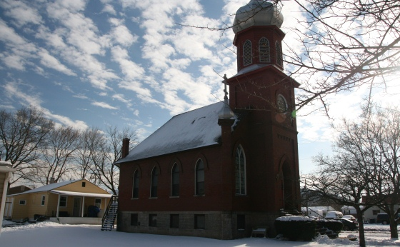

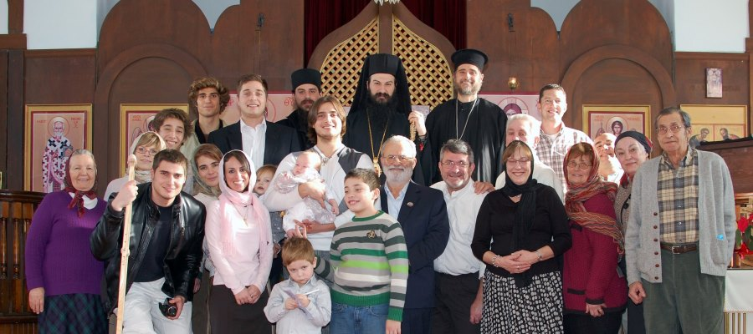

St. Peter and St. Paul Orthodox Christian Church
800 N. Front St.
Mount Union, PA 17066
http://www.sspeterpaulparish.com/

St. Paul’s Fellowship of Labor
www.thespfl.org

Contact Youth Conference Committee Chair, Demetri Patitsas at djmpatitsas@gmail.com or 814-386-5254 for further questions.
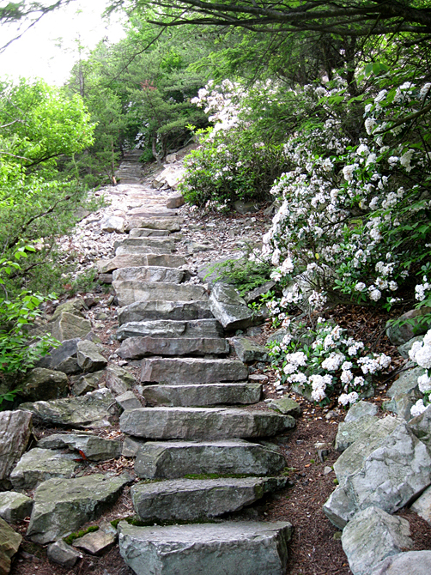
$1,200 Sponsorship for young adults and families and clergy’s transportation and snacks to participate in a mountain hike on Saturday of the conference at the historic “1,000 Steps” of Mt. Union, PA.

$450 Sponsorship for all youth, families, and clergy to attend the showing of “An Orthodox Christian themed film” Thursday evening, opening night of the Youth Conference includes popcorn, beverage, and candy at the iconic Clifton 5 theatre in downtown Huntingdon, PA.
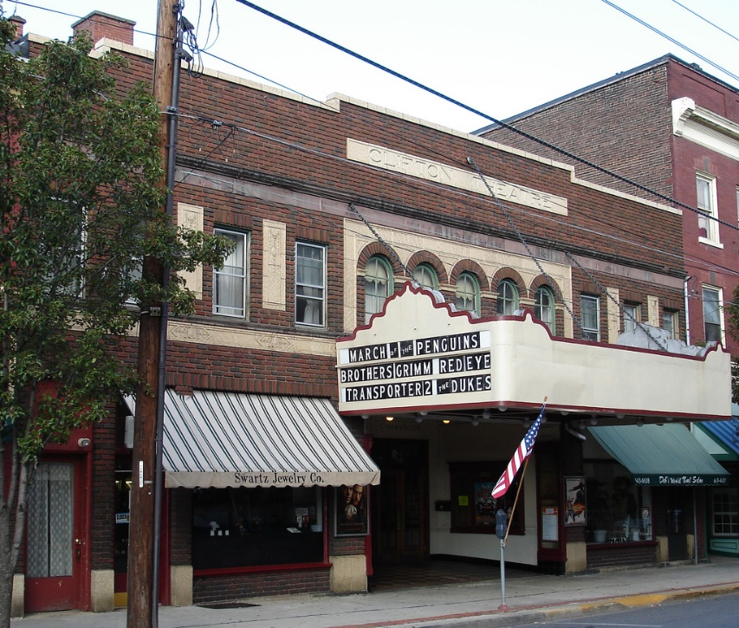
$300 for a scenic hike and view of Pennsylvania’s most popular natural attraction called Raystown Lake on Saturday of the Youth Conference for Youth, Family, and Clergy.
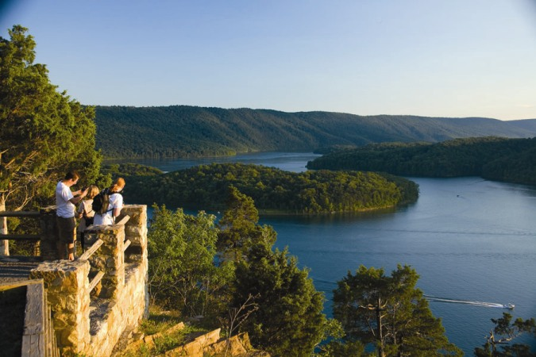

$500 Sponsorship for the 1st every Youth Conference Music Concert including instrumental music, Byzantine chant, religious folk music, and maybe even bag pipes!
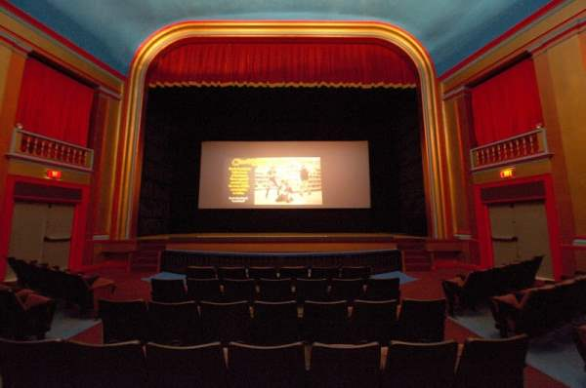

Consider being a business sponsor, benefactor, or donate in memory of someone for the following activities as well that occur throughout the event and banquet:
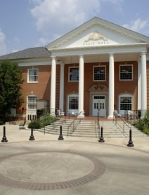
- Orthodox Christian Oratorical Contest Sponsor: $500
- Introductory Night Welcome Sponsor: $200
- Banquet Event Sponsor: $450
- Transportation Shuttle: $2,200
- Clergy and Bishop Transportation Costs: $1,000
- Ice Cream Social: $250
- Be included in our list of sponsors in all printed materials: $250

