DESIGN BRIEF: OCCUPATIONAL THERAPY POSTER (X2)
TITLE: MEET YOUR LOCAL SUPERHERO
SUBTEXT: THE OCCUPATIONAL THERAPIST

TEXT:
Imagine being defeated by an everyday task like putting your clothes on, catching a bus, spending time with your friends or taking care of yourself.
OCCUPATIONAL THERAPY IS HERE TO HELP.
The things that you do – your occupations – help express who you are, how you feel about yourself, and how you connect with others. Your health and wellbeing will be affected if you are unable to do the things you want and need to do, to live and enjoy your life.
OCCUPATIONAL THERAPISTS HELP PEOPLE OF ALL AGES AND WORK IN A VARIETY OF SETTINGS.
Occupations that could cause difficulty include preparing and eating meals; driving and mobility; recreation and exercise; use of a computer or workstation; showering or bathing; getting things done on time and in a preferred standard; having enough things to do and the confidence to do them; developing supportive relationships or friendships; or thriving in school.

SUPER HERO PROFILE BOX:
SUPERHERO PROFILE
My super powers help people to:
- Learn new ways of doing things following an illness or injury (e.g. dressing or cooking)
- Thrive in their senior years
- Regulate their strong emotions
- Achieve their goals at school
- Develop ways to manage pain
- Develop their confidence in social situations
- Access support available in the community
- Adapt material or equipment (e.g. wheelchairs or provide a special bath or toilet seat)
- Make changes to their living or working environment
- Develop new skills, abilities or interests (e.g. job readiness programmes)

FINAL MESSAGE:
JOIN US in celebrating occupational therapy by using the hashtag #YourLocalSuperHero Visit otnz.co.nz for more information
DESIGN BRIEF:
2 A4 posters to be created: 1 with a male super hero and 1 with a female super hero (see suggested design).
These posters will be used for a promotional campaign celebrating occupational therapy. The idea being – that occupational therapists are our local superhero. We see them as the ‘unsung heroes’ of our local communities, so this campaign is a play on that idea.
These posters will be displayed on community notice boards and in hospitals. They will also be used on display tables promoting what occupational therapy is. They will also potentially be used as handouts in presentations. We plan to use these posters for the coming 2 years.
As these will be displayed on noticeboards they need to be bright and colourful. The colours suggested in the attachment are the types of colours we would like used (blue, yellow and red).
We envision these posters being displayed side by side.
Although we are open to interpretation of the “super hero” theme – we particularly liked the black super hero images as they look similar to the symbol for wheelchair access (which occupational therapists use).
Alternatively, a comic book inspired design would also be appealing – see inspiration images.
This design needs to include the OTNZ-WNA logo which is included.
The superhero also needs to have a superman style logo somewhere visable. This could be on their chest or on their cape – depending on their angle. Instead of the Superman ‘S’, please put ‘OT’.
The content for both posters is identical. However, we would like 1 male version of the poster and 1 female version of the poster.
The superhero graphic needs to be G-rated. For the female graphic - it cannot include cleavage or clothing that is too tight/revealing.
It needs to have a professional feel to the poster.

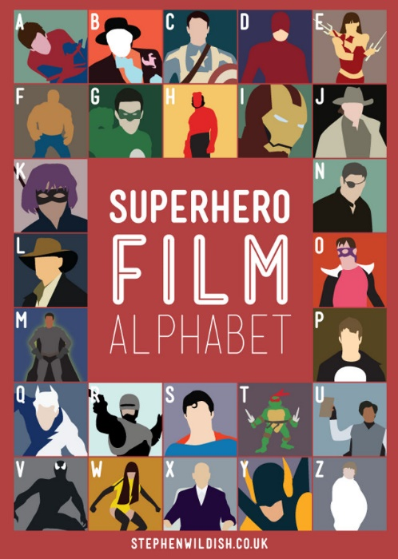
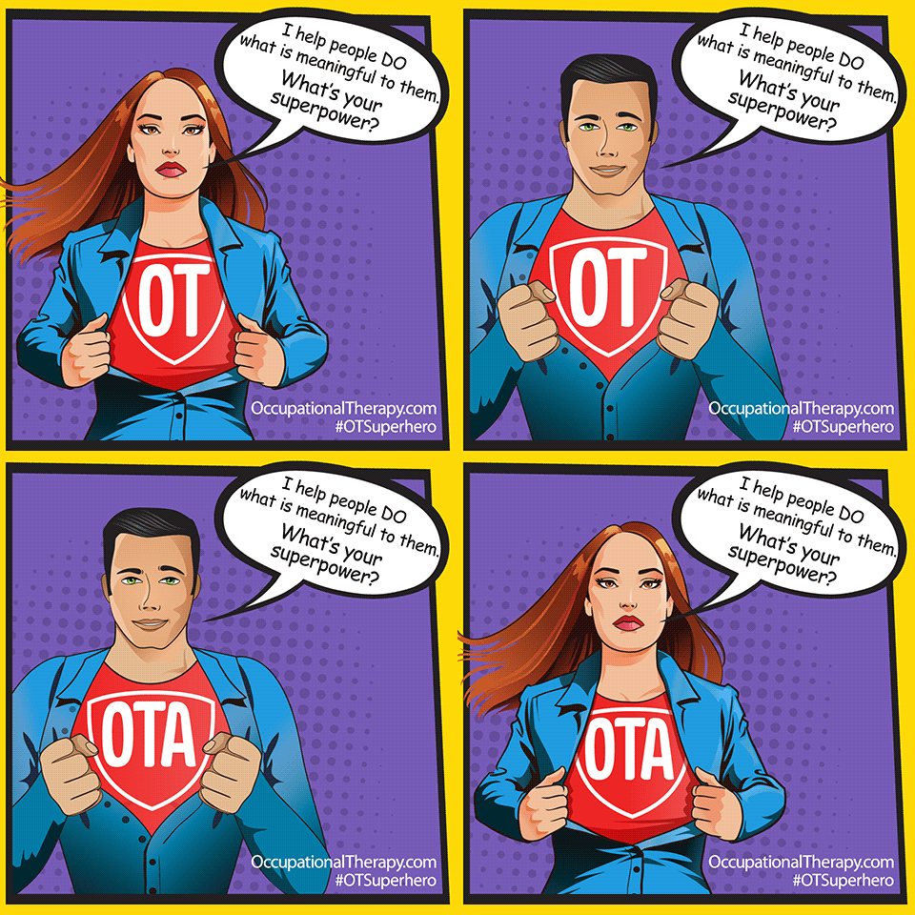
We have drawn inspiration from the following images:

