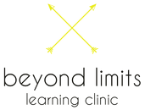
Providing Teen Mental Health First Aid Training to all school staff.

Today, schools are investing more deeply into the mental health and wellbeing of their staff and student bodies. Schools understand it is no longer sufficient for senior staff to be distributing general information to staff regarding the management of mental health issues among their students in order to be providing optimal pastoral care.
Studies show that 14% of young Australians aged 4-17 experience mental health or behavioral problems. Specifically, 12% of teenagers report to have thoughts of taking their own life, and 4.2% of them sadly attempt suicide. 20%, which accounts for 1 in every 5 students will develop one of the common mental illnesses such as depression, anxiety or substance use disorder in any 12 month period. In our community, the adolescent age group is at highest risk, which dramatically affects their academic performance as well as their physical and social development.
e.g. Secondary.
In a school of 800 students, in a single
12 month period
160 will develop a mental health illness,
yet only 40 will receive help.

Despite these alarming numbers, only 1 out of 4 young persons with a mental health illness receive professional care.¹Students and parents can be at a loss as to how to locate appropriate assistance at a period when in many cases, the young person has already reached a crisis point. At the same time, teachers who are at the front line of adolescent care may be unable to detect the early signs of a mental health illness and address them effectively.
The median age of onset for any one of the common mental illnesses is 18 years old... meaning most will experience their first symptoms whilst attending school.

The solution to managing the above presented statistics is straightforward. Both school staff and their students needs to be better equipped to readily identify and intervene both from a duty of care and pastoral care standpoint. If they do, simply put, they can save lives.

Beyond Limits Learning Clinic therefore has one main goal: to have all school staff and senior students trained in mental health first aid. Established in 2011, BLLC looks towards breaking down the lack of knowledge among adults and young people which can perpetuate the stigma about mental illness and champion the improved support, early detection and treatment of mental health illnesses in our community. BLLC is made up of highly qualified and extensively experienced teachers, clinical psychologists and allied health professional whom provide educational assistance for young people experiencing a range of cognitive, learning, social and behavioural difficulties as well as training for adults who care for these young people.

What is Mental Health First Aid?

Mental Health First Aid is a registered NREPP program, domestically and internationally respected and practiced.
Mental health first aid is the help provided to a person who is developing a mental health problem, or who is in a mental health crisis (e.g., the person is suicidal or has had a traumatic experience). Like physical first aid, mental health first aid is given until the person receives professional help or until the crisis resolves.

Mental health first aid strategies are taught in evidence-based training courses authored by Mental Health First Aid (MHFA) Australia and delivered by accredited MHFA Instructors across the country. Beyond Limits Learning Clinic offers MHFA courses as authored by MHFA Australia, delivered by Instructors who are currently accredited by MHFA Australia.

As of 2015, well over 200,000 people have completed the MHFA course and over 600,000 globally with participants from 21 other countries including England, U.S.A, Canada, Singapore, Japan and South Africa.

Beyond Limits Learning Clinic is your accredited Mental Health First Aid provider.

Beyond Limits Learning Clinic is not only MHFA accredited but highly qualified and talented facilitators are also are at the reigns.
With over 10 years experience within the educational field, Alena Farrugia is the Head Facilitator at BLLC. She has worked as a teacher in a variety of school settings, a training facilitator and has a deep comprehension of the vast range of psychological, sociological and ecological complexities surrounding the mental health of Australians.
She also holds two BA’s and numerous certificates and diplomas in the fields of education, the arts, youth mentoring and professional interior design which is geared towards assisting the creation of spaces to complement mental health treatment.

She is supported by an extensively experience and dedicated team of accredited facilitators who work in a cross section of the mental health and education industries throughout Australia.

BLLC also offer schools the 14 hr Youth and Standard Mental Health First Aid (MHFA) Course.

Breakdown: The 3.5hr teen Mental Health First Aid Course (tMHFA)

The 3.5-hour teen MHFA Course teaches high school students in years 10-12, how to provide mental health first aid to their friends. The course was developed in response to research indicating that young people have a preference for sharing problems with peers. The course curriculum is based on a study undertaken to determine the best actions a young person can undertake to support a peer with a mental health problem.
Developing mental health problems covered:
- Anxiety disorders
- Depressive disorders
- Eating disorders
- Alcohol and other drug use disorders
- Psychotic disorders

Mental health crisis situations covered:
- Suicidal thoughts and behaviours
- Non-suicidal self-injury (sometimes called deliberate self-harm)
- Being very intoxicated from alcohol and other drugs
- Bullying or abuse

What Will Students Learn?________
Students learn the Teen MHFA Action Plan, as well as information about different types of mental health problems and mental health crisis situations in young people, and the relationship between thoughts, feelings and behaviours.

Course Format & Delivery_________
The delivery format is 3 interactive classroom sessions of 75 minutes each, totalling 3.5 hours. The course has been specifically designed to be engaging for this age group.
Course participants receive a copy of the Teen MHFA Manual to keep and a Certificate of Completion.

Cost

Costs Vary depending on number

Flat Session Rate | Price
Max 30 Students | $

Multiple class bookings would welcome a negotiated rate.

Per Student Rate | Price
AdStarting from | $20

*Off site training can be arranged at an additional cost.

Together, let us create and develop a school community of empowered adults and mentally healthy, happy young individuals.

For more information, please do not hesitate to get in touch with our Head Facilitator, Alena Farrugia through the following:

Email: admin@beyondlimitslearningclinic.com.au

Phone: 0404 537 292

Website: www.beyondlimitslearningclinic.com.au
ABN:15 121 850 282

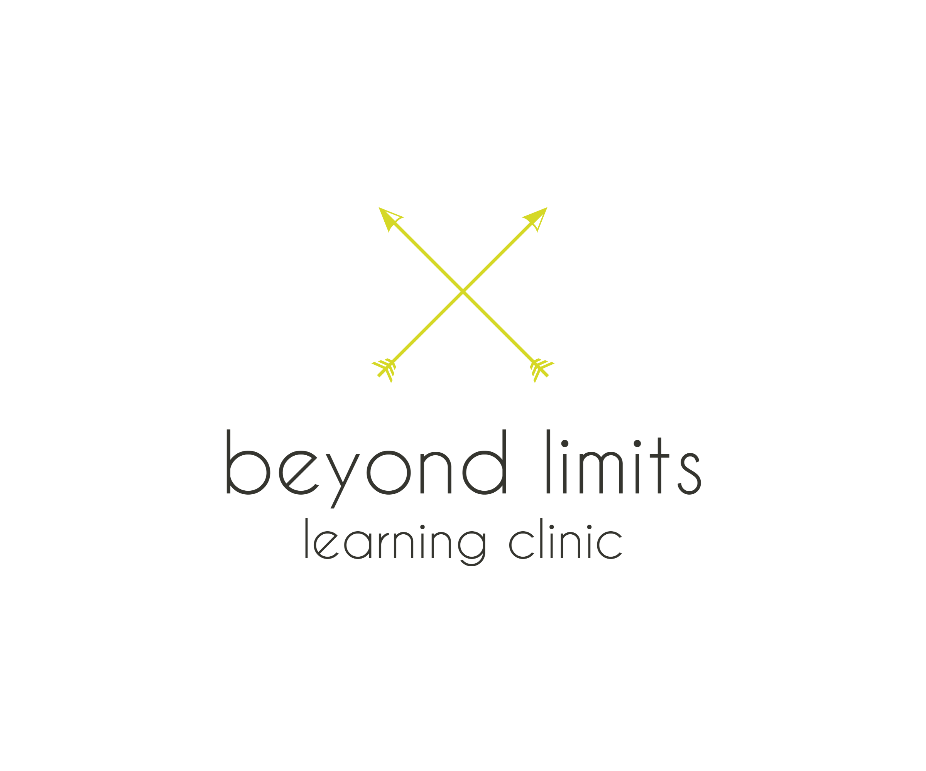
- 2007 National Survey of Mental Health and Wellbeing

