The website is expected to have the following six pages – HOME, SERVICES, PEOPLE, CLIENTS, CONTACT.

The top of the website is to have the Environmental Advisors graphic (refer attached file and also at end of this document) as well as the above menu.

Briefing | Website Words
HOME  Link to people>  Links to services page > | Environmental Advisors is Client focussed, offering highly experienced consultants providing effective and innovative environmental solutions.  Formed by Directors Christian Atkinson and Andrew Winters, Environmental Advisors brings to the table a wealth of experience combined with the responsiveness and reliability of a smaller company.  We offer a range of environmental services including Project Management, Contaminated Land Assessment and Remediation, Hazardous Materials and Occupational Hygiene, and related Environmental Assessment and Management Services.
SERVICES  Each of the key services listed here will have three project examples at the end – we would like each to have a little graphic and text words “Project Example” and perhaps the start of the text, but for the entire text to only be seen/pop-up once the graphic/intro words are clicked> | Project Management  Environmental Advisors has people skilled in the management of environmental, remediation and demolition projects, and can ensure that required outcomes are properly formulated and the necessary approvals obtained. We can assist with:  - Risk appraisal  - Scope refinement and staging  - Technical Specifications  - Tendering support  - Superintendency services  - Final certifications  [Project Examples]  Project 1 – This is a project example and will contain a description of an example project using around one hundred words words words words words words words words words words words words words words words words words words words words words words words words words words words words words words words words words words words words words words words words words words words words words words words words words words words words words words words words words words words words words words words words words words words words words words words words words words words words words words words words words words words words words words words words words words words words words words words words words words words words words words words words words words words words words words words words words words words words words words words words.  Project 2 – This is a project example and will contain a description of an example project using around one hundred words words words words words words words words words words words words words words words words words words words words words words words words words words words words words words words words words words words words words words words words words words words words words words words words words words words words words words words words words words words words words words words words words words words words words words words words words words words words words words words words words words words words words words words words words words words words words words words words words words words words words words words words words words words words words words words words words words words words words words words words.  Project 3 – This is a project example and will contain a description of an example project using around one hundred words words words words words words words words words words words words words words words words words words words words words words words words words words words words words words words words words words words words words words words words words words words words words words words words words words words words words words words words words words words words words words words words words words words words words words words words words words words words words words words words words words words words words words words words words words words words words words words words words words words words words words words words words words words words words words words words words words words words words words words words.
Contaminated Land
Contamination of land or groundwater can pose a heavy legal, financial and environmental burden on the owner of a property. Environmental Advisors provides effective management and remediation
services for the rehabilitation and management of contaminated land, dedicated to delivering innovative and cost effective solutions to benefit our clients.
Over twenty year’s industry experience provides the ability to anticipate where contaminated land issues are likely to pose problems, and how these may be most cost effectively addressed and guided through complex regulatory processes.

We have the experience and understanding of the requirements of property owners to achieve financial certainty and on time delivery for the following range of services:

- Stage One Preliminary Assessment
- Stage Two Detailed Assessment
- Due diligence for sale or purchase
- Remediation Design and Specification
- Remediation Project Management and Validation
- Statutory Audits

We are proud to be associated with Australian Environmental Auditors to support delivery of audit services by our Qld accredited Auditor, Christian Atkinson.

http://environmental-auditors.com.au/


[Project Examples]
Project 1 – This is a project example and will contain a description of an example project using around one hundred words words words words words words words words words words words words words words words words words words words words words words words words words words words words words words words words words words words words words words words words words words words words words words words words words words words words words words words words words words words words words words words words words words words words words words words words words words words words words words words words words words words words words words words words words words words words words words words words words words words words words words words words words words words words words words words words words words words words words words words words.

Project 2 – This is a project example and will contain a description of an example project using around one hundred words words words words words words words words words words words words words words words words words words words words words words words words words words words words words words words words words words words words words words words words words words words words words words words words words words words words words words words words words words words words words words words words words words words words words words words words words words words words words words words words words words words words words words words words words words words words words words words words words words words words words words words words words words words words words words words words words words words words words words words words.

Project 3 – This is a project example and will contain a description of an example project using around one hundred words words words words words words words words words words words words words words words words words words words words words words words words words words words words words words words words words words words words words words words words words words words words words words words words words words words words words words words words words words words words words words words words words words words words words words words words words words words words words words words words words words words words words words words words words words words words words words words words words words words words words words words words words words words words words words words words words words words words words words words words.

Hazardous Materials & Occupational Hygiene

Environmental Advisors is skilled with the provision of asbestos and hazardous materials services, occupational hygiene assessment and advice.

- Asbestos and Hazardous Materials Surveys
- Demolition and decommissioning
- Indoor Air Quality Assessment
- Exposure Monitoring for dust, noise, chemicals and similar

We are proud to be associated with Environment & Safety Professionals to support delivery of hazardous materials services by our Qld licensed Asbestos Assessor, Andrew Winters.

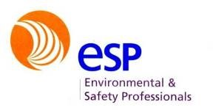
http://www.environet.com.au/

[Project Examples]
Project 1 – This is a project example and will contain a description of an example project using around one hundred words words words words words words words words words words words words words words words words words words words words words words words words words words words words words words words words words words words words words words words words words words words words words words words words words words words words words words words words words words words words words words words words words words words words words words words words words words words words words words words words words words words words words words words words words words words words words words words words words words words words words words words words words words words words words words words words words words words words words words words words.

Project 2 – This is a project example and will contain a description of an example project using around one hundred words words words words words words words words words words words words words words words words words words words words words words words words words words words words words words words words words words words words words words words words words words words words words words words words words words words words words words words words words words words words words words words words words words words words words words words words words words words words words words words words words words words words words words words words words words words words words words words words words words words words words words words words words words words words words words words words words words words words words words words words.

Project 3 – This is a project example and will contain a description of an example project using around one hundred words words words words words words words words words words words words words words words words words words words words words words words words words words words words words words words words words words words words words words words words words words words words words words words words words words words words words words words words words words words words words words words words words words words words words words words words words words words words words words words words words words words words words words words words words words words words words words words words words words words words words words words words words words words words words words words words words words words words words words words words.

Environmental Assessment and Management

Environmental Advisors has a broad range of environmental skills and can assist with a number of general environmental assessment and management projects.

- Waste Management
- Landfill Monitoring
- Ecological Assessment
- Erosion and Sediment Control
- Environmental Noise and Dust Monitoring
- Environmental Management Plans and Specifications

[Project Examples]
Project 1 – This is a project example and will contain a description of an example project using around one hundred words words words words words words words words words words words words words words words words words words words words words words words words words words words words words words words words words words words words words words words words words words words words words words words words words words words words words words words words words words words words words words words words words words words words words words words words words words words words words words words words words words words words words words words words words words words words words words words words words words words words words words words words words words words words words words words words words words words words words words words words.

Project 2 – This is a project example and will contain a description of an example project using around one hundred words words words words words words words words words words words words words words words words words words words words words words words words words words words words words words words words words words words words words words words words words words words words words words words words words words words words words words words words words words words words words words words words words words words words words words words words words words words words words words words words words words words words words words words words words words words words words words words words words words words words words words words words words words words words words words words words words words words words words words words words.

Project 3 – This is a project example and will contain a description of an example project using around one hundred words words words words words words words words words words words words words words words words words words words words words words words words words words words words words words words words words words words words words words words words words words words words words words words words words words words words words words words words words words words words words words words words words words words words words words words words words words words words words words words words words words words words words words words words words words words words words words words words words words words words words words words words words words words words words words words words words words words words words words words words.

PEOPLE  Provide link to Christian Atkinson CV.pdf>  Provide link to Andrew Winters CV.pdf> | 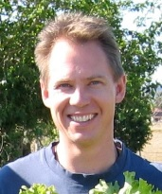  Christian Atkinson  christian@environmentaladvisors.com.au  Mobile 0403363011  Christian Atkinson has twenty years’ consulting experience in occupational hygiene, asbestos and other hazardous materials surveying, land contamination assessment and demolition management.  Christian formed part of the steering committee for the Qld Branch of the Australian Contaminated Land Consultants Association, and was the inaugural secretary. He is a Suitably Qualified Person for land contamination assessments.  With complementary skills in project management, demolition and hazardous building materials, Christian has successfully delivered several major projects involving the assessment and abatement of above and below ground environmental liabilities for government assets, power stations, defence establishments and other industrial and commercial estates. [link to pdf CV]  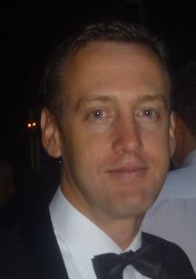  Andrew Winters  andrew@environmentaladvisors.com.au  Mobile 0409662747  Andrew Winters has twenty years’ consulting experience in occupational hygiene, asbestos and other hazardous materials surveying, land contamination assessment and demolition management.  He has completed industry training for bonded and friable asbestos removal up to Supervisor level and has held numerous NATA accreditations for hazardous materials.  Andrew formed part of the steering committee for the Qld Branch of the Australian Contaminated Land Consultants Association, and was the inaugural secretary. He is a Suitably Qualified Person for land contamination assessments.  With complementary skills in project management, demolition and hazardous building materials, Andrew has successfully delivered several major projects involving the assessment and abatement of above and below ground environmental liabilities for government assets, power stations, defence establishments and other industrial and commercial estates.  [link to pdf CV]
CLIENTS  add supplied image clients.jpg]> | The key people of Environmental Advisor have successfully completed projects for the following organisations.  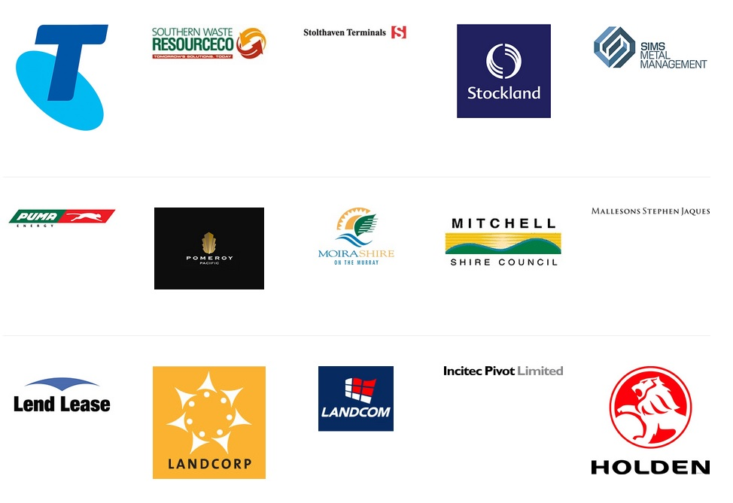
CONTACT | Environmental Advisors  36 Elsa Court, Peachester, Qld, 4519  PO Box 123, Kawana, Qld, 4575  admin@environmentaladvisors.com.au



