Creative Brief for GroupGrams logo design
I am working on a website called GroupGrams.com. The purpose of the site is to help groups of family or close friends stay in touch in a more meaningful way. I envision it being used by groups of college friends after they all graduate from college and move to other parts of the country or by an extended family who has people living everywhere. This is achieved by creating a group newsletter every X months. The group can decide how often they want to send out a newsletter. The website provides the interface to create the groups, collect each individual member’s update, send reminders to people when they have not submitted their update and ultimately compile and distribute the newsletter to all the group members in an electronic format.
So that is the idea. I thought it would be good to give you some background on the site before talking about what is needed from a design perspective.
So here are the things that I need help designing.
- A logo – I have created a very simple logo but I would like something with a more professional style. Here is the logo I created:
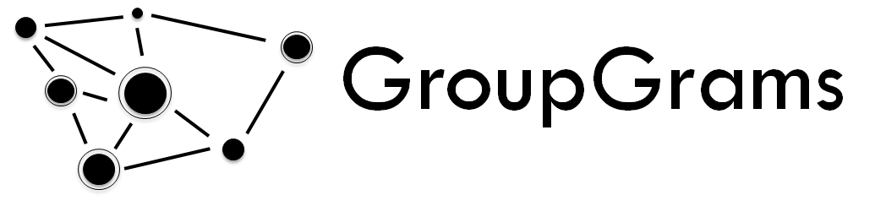
I want the logo to represent people being connected or coming together. That is what I was going for with the various dots and lines connecting them.
For reference, the color palette that I have chosen for the site is the following:
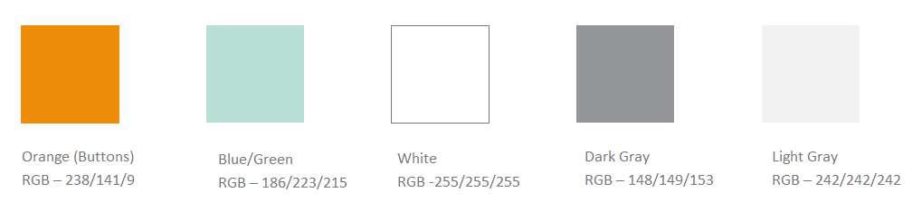

Here is a mockup of an email we plan to create so you get a sense for how we plan to use the colors.
