What will your electricity bill look like in 5 years’ time?

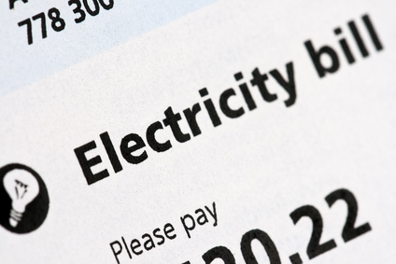

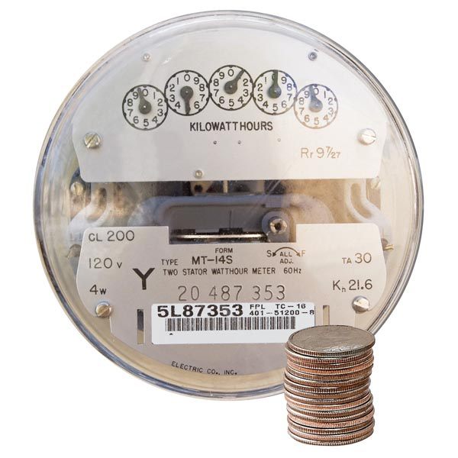

Install Solar power today and start saving!
3 reasons to install solar….
1 The sun provides ample amounts of free, clean energy every day
2 The government provides generous incentives saving you thousands of $$ (see overleaf)
3 Advanced technology allows you to store your energy and use it at night

Back Page
About us
We are a local family run business providing quality solar panel installations throughout the Illawarra. Dave is our licenced electrician and accredited solar panel designer & installer. We truly believe solar is the future for meeting our energy needs and one of the best ways to save money and the environment.

Testimonial
“We had Dave from Sparky Solar & Electrical install a 4.5kW system at our home. Our latest electricity bill was half what we paid for the same period the previous year and we also received a credit of $120 on our bill, all thanks to the solar installation!” (Jean from Woonona )

Price Guide
System Size | Without rebate | With rebate | Savings
2kW (8 panels) | $3,587 | $2,152 | $1,435
3kW (12 panels) | $5,323 | $3,153 | $2,170
4kW (16 panels) | $6,594 | $3,724 | $2,870
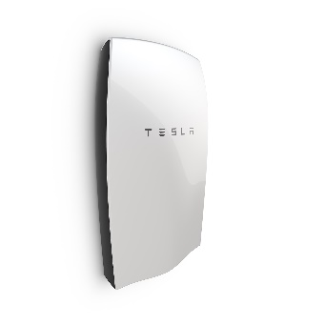
We can design a variety of systems and supply products to suit your needs and budget, this is a guide only. To save even more money you can store your energy in batteries like this one from Tesla. Give us a call and ask us how.
Tesla Powerwall

Footer Section on back page
Abn: 68716450590. Electrical Licence No: 221823C. Solar Accreditation No: A8913325. Sample price includes labour & materials and is based on a single storey standard pitch corrugated roof. Prices are subject to change based on STC rates, installation conditions & equipment selected. Price does not include freight charges and meter installation by Level 2 ASP.

