Invitation
25th Anniversary Celebration
Cacapon and Lost Rivers Land Trust
Saturday September 19, 2015
Historic North River Mills, WV
11 am – 4 pm

History and Nature
Celebrating a Generation of People Protecting Land
www.Cacapon.org

Please join us for great food, local ole timey music, a live auction, and the chance to learn more about what makes the Cacapon and Lost River Valley so very special. The day’s activities will include a presentation by Rodney Bartgis past director of the West Virginia Chapter of The Nature Conservancy, a guided hike of Ice Mountain and the chance to tour the historic village of North River Mills.

Agenda
11 am Music
12:30 Lunch and Presentations
1:30 Live Auction
3 pm Ice Mt. Hike and Historic Village Tour

Tickets: $25 (kids 12 and under are free) please reserve your spot by Sept 11, 2015
RSVP: P.O. Box 58, Wardensville, WV 26851
Phone: 304-856-1188

Thank You To Our Business Sponsors

Benefactors – Largest Logos

Keenan Shanholtz
www.4wvland.com
304-813-4858

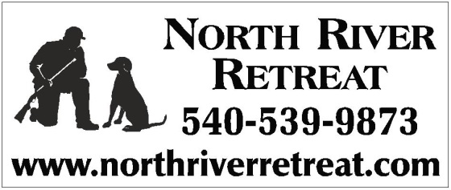


Concordia
Power

Size smaller logos




304-496-Tree (8733)
Just Names
Old Possum Tree Farm
Shenandoah Restorations
Amerigas

Invitation RSVP
Please order tickets by Sept 11, 2015
Tickets $25 each (kids 12 under free)
Sponsorship Opportunities
____River Otter @ $100 - $199 (incl. 2 tickets)
____Brook Trout @ $200 - $499 (incl. 4 tickets)
____Wood Turtle @ $500 - $999 (incl. 6 tickets)
____Benefactor @ $1,000 and up (incl. 8 tickets)

____ I would like to send my support, but cannot attend.
____ Total number of guests attending
____ # vegetarian meals requested
____ I would like to donate an item for the auction, please contact me.
Name ____________________________________________
Phone_ ___________________________________________
Email ____________________________________________

Please make checks payable to
Cacapon and Lost Rivers Land Trust.
For directions, please visit our website at www.cacapon.org
or call 304-856-1188.

We are also happy to mail written directions upon request.

