Tyalgum Rum Packaging Design

We are a start-up craft distillery looking to set up in the Beautiful Tweed Valley in Northern NSW, Australia. We will begin with a pot distilled rum, as the Tweed is a traditional sugar cane growing region. The working title is 'Tyalgum Rum' as that is the town where the distillery will be based. 'Tyalgum' is also the name of a steamship that was wrecked at Point Danger in 1939. The Tweed Valley is dominated by Mt Warning, so named by Capt Cook in 1770, so a nautical theme is essential.
Because we are a start-up, we are looking for a strong theme(s) that can be used to attract funding and that can also be used in advertising and so on. But the foundation of all that is the packaging for the rum itself.
Bottle
The bottle should be traditionally shaped (squat and round) with a short neck and rolled lip, sealed with a cork stopper and with a paper seal. The glass should be clear. See an example here:
https://s-media-cache-ak0.pinimg.com/736x/0b/34/39/0b343961c64a1ee10239770b72109c91.jpg
This bottle (not the label) is also good:
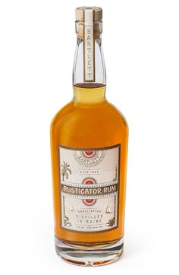
The paper seal should have the red white and blue compass rose:


Labels – we are looking to evoke a 19th century feel nautical feel by using a combination of imagery, lettering, use of flags, and the colours red white and blue.

Lettering
The lettering should evoke a 19th century sensibility - almost as if it is from an etching. The St Georges distillery (pic above) does this very well. Another St Georges example is here:
https://s-media-cache-ak0.pinimg.com/236x/16/bf/ef/16bfef61d1a3bc4fff5484c7b150c889.jpg
Other examples include:
https://s-media-cache-ak0.pinimg.com/236x/29/6e/fe/296efe43aec39889461b16d7d1ca5a2a.jpg
https://s-media-cache-ak0.pinimg.com/736x/c6/2b/45/c62b45c021400bf51376127580aeca6a.jpg
https://s-media-cache-ak0.pinimg.com/736x/56/d3/15/56d315323616bccca419c89a8c67fc56.jpg
https://s-media-cache-ak0.pinimg.com/736x/48/0d/fd/480dfd3a6db6210f237f8c4cd6ad5776.jpg
We are looking for a cross between an advertising poster for a shipping line and a circus poster for entertainment with a list of the features and main attractions. I particularly like the slingshot coffee company text on the side banner, as it borrows the idea of the circus poster list of attractions very well. A circus example I like is here:
https://s-media-cache-ak0.pinimg.com/736x/e2/9d/36/e29d361caf69e05ff2517eb0d7fa0d47.jpg
The name of the Rum is ‘Tyalgum Rum’, but we are also tinkering with the idea of calling it “Captain Kavanagh’s Tyalgum Rum”. If the latter, then the “Captain Kavanagh” part would be in cursive writing similar to the cursive writing on the St George’s bottles.
We need to work on the precise words a bit more, particularly for the legal compliance matters, but this should be enough to get started. You can assume that we will need additional information, such as quantity by volume, a percentage of alcohol content, a reference to the maker and location and address.

Imagery
The imagery should be based upon a shipping line poster such as the following examples:
https://s-media-cache-ak0.pinimg.com/236x/c1/00/e1/c100e12e92a2da1575e2ae50db31291e.jpg
https://s-media-cache-ak0.pinimg.com/236x/4d/91/26/4d912661cf4e46db549994e580613a78.jpg
https://s-media-cache-ak0.pinimg.com/236x/14/80/f1/1480f1b1128aa24226b480ce55064490.jpg
https://s-media-cache-ak0.pinimg.com/236x/9a/7e/9c/9a7e9c747f7c70a817a7af1f075a177d.jpg
The itself should be a ship (The SS Tyalgum) in profile (sideways) in the centre, with the colouring strongly evoking the Sterling Stoves advertisement. The Canadian Pacific Steamship Line is almost perfect in its use of lettering and the ship, together with a mountain in the background. But I like the slanted lettering in ‘The Atlantic Oean’ too.
We would like to have the profile of Mount Warning been the background of the image. Mount Warning looks like this:
https://s-media-cache-ak0.pinimg.com/736x/4d/aa/49/4daa497e65e29b926e00b9a29bc60b0a.jpg
and
https://s-media-cache-ak0.pinimg.com/736x/71/08/e2/7108e2306e05c714c2afd5fa0d3735c9.jpg

If we use “Captain Kavanagh” in the name, then we would like a stylised image of an appropriately grizzled old sea captain, perhaps based on something like this:
https://s-media-cache-ak0.pinimg.com/736x/23/ee/d2/23eed28339fc61a1fb8e26a0dbcaf631.jpg
or this
https://s-media-cache-ak0.pinimg.com/236x/ab/5d/13/ab5d135537555e17d52b449e31b739aa.jpg

Logo of Tweed Valley Distilling Company will be like the house flag of the North Coast Steam Navigation Company –
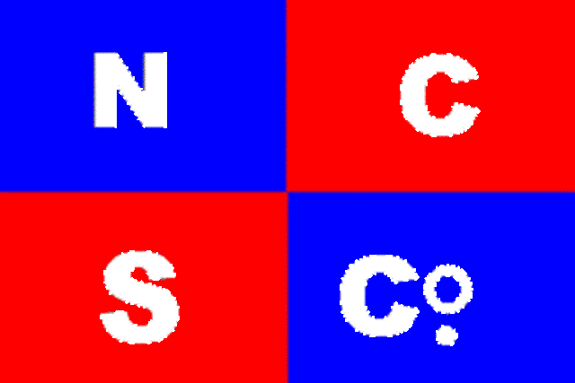
Only replaced with TVDC – The Tweed Valley Distilling Company Pty Ltd
I suggest to make the flag work better, a white cross should be used to divide the red and blue quadrants.
The flag is sourced from here, along with a range of photographs of the various ships owned by the North Coast Steam Navigation Co http://www.flotilla-australia.com/ncsnc.htm
The photograph of the Tyalgum is from when it was a ground in 1939, and might form the basis of an evocative image.
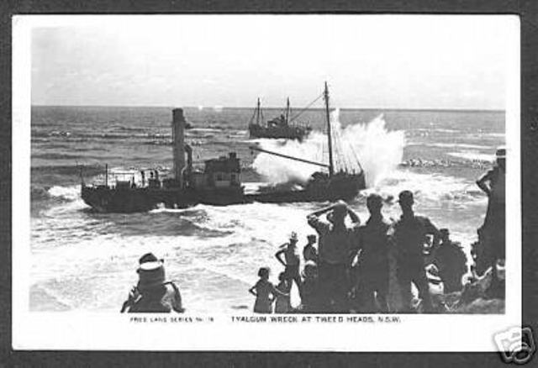
http://images.powerhousemuseum.com/images/zoomify/TLF_mediums/7832.jpg
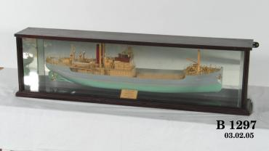

FLAGS?
There is probably more than enough ideas already, but we did wonder whether signalling flags might make an attractive border or detail for the label or for the neck of the bottle or for the back label.
Check out the flag creator:
http://www.enchantedlearning.com/signalflags/nameinflags.shtml
If we use the words “Tweed Valley Distilling Company” – as a border around the edge of the label, then the flags would look like this:
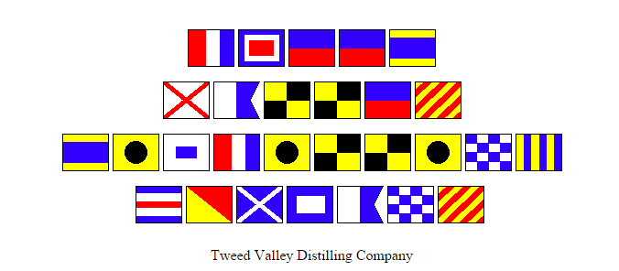

Cf with:

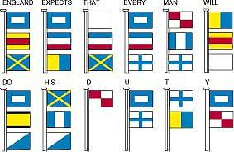

Another idea would be to use the colour compass rose in the top centre of the label as the main ‘logo’, and the TVDC house flag on the reverse label.

Conclusion
As you can see, there are a lot of ideas going on here, and we may need to simplify. But to summarise, the packaging design should be:
- A classic, clear, round bottle with a cork stopper and a paper seal;
- the label should evoke a 19th-century steamship advertisement using red white and blue as the main colours
- the lettering should evoke an etching style, kind of a cross between the steamship advertisement and a 19th-century circus poster
- the image should be of the steamship Tyalgum in profile and with Mount Warning in the background
- if we decide to go with the “Captain Kavanagh” idea, then an image of a grizzled master Mariner in an oval cameo style frame should be in the centre top of the label
- the use of nautical signalling flags might be considered as a border or detail
- the house flag of the Tweed Valley distilling company should appear on the reverse of the label.

