Gledden Ventures

Style Guide – Logo and Fonts

The “Start-up G logo” combines the turn-on (start-up) symbol and the letter G
I really like what you have done with this logo.

Could you complete the letter G as per …

and The “Turn On” symbol.


For the Header logo, could we use the “Start-up G” logo above and “LEDDEN VENTURES” in a serif style font like the one below.
 or  using the cursive script (depending on which you think is best).

On the splash page, could we use the following layout – “Start-up G” Logo and GLEDDEN VENTURES below…
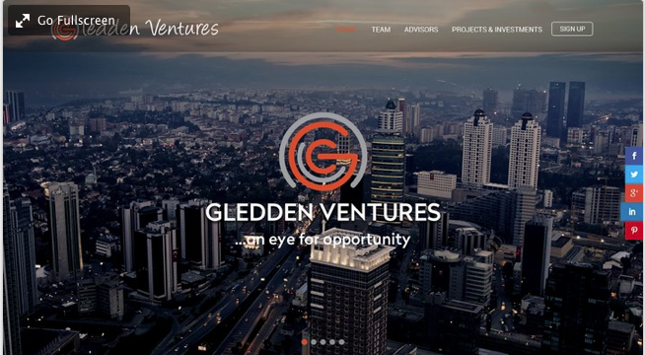
Could you add a “Get Involved” button or a “Start it up” or “Get started” if you think that works…

Home

Slider Images
Could we have 4-5 slider images, each pointing to the home page. The sliders are just to add some dynamism rather than highlight different pages/content.

Each slider page should include “Start-up G” logo, “GLEDDEN VENTURES”, “…an eye for opportunity”, “Get Involved” button.

Melbourne

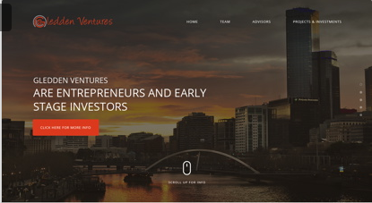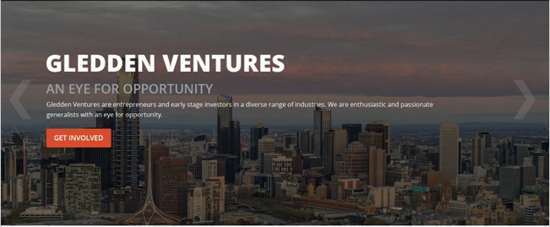
$6622027, , ,#6651754

Sydney
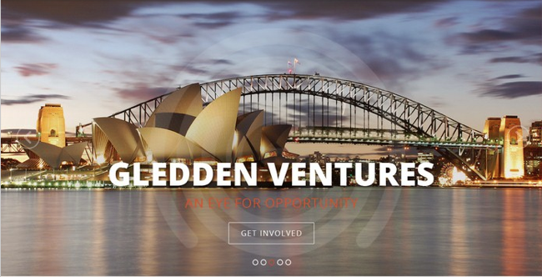
#6642034, #6642070

York
I’m attempting to license this from www.eborimages.co.uk

London

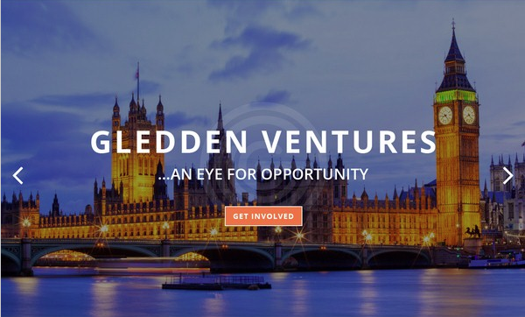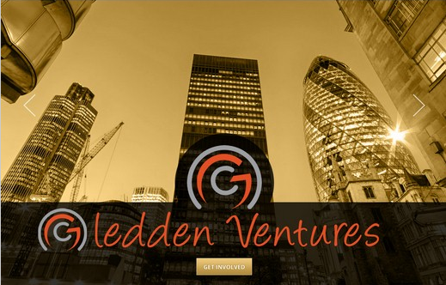
#6642050, #6642047, #6651739

Los Angeles

San Francisco
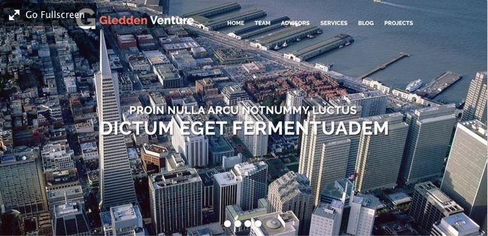
#6642066, #6642038

New York
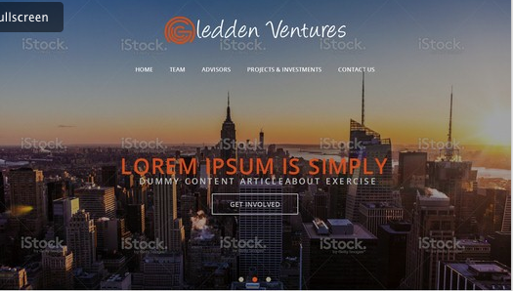
#6652062, #6651752

Home Page Copy

“Gledden Ventures are entrepreneurs and early stage investors in a diverse range of industries. We are enthusiastic and passionate generalists with an eye for opportunity. We are also consultants, advisors and manage investments for the Gledden Family Trust.

Our values include Family, Relationships and Fun.”

Under the Home Page Copy could we have a “Services” Panel
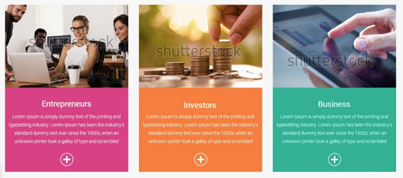
Services Copy
Entrepreneurs  We get actively involved building companies from idea through ramp up to exit. | Investors  We invest in private companies, property, equity and debt securities, managed funds and alternative assets. | Advisors  We provide consulting and advisory services regarding strategy, execution, sales and marketing, capital raising, disposal and exit.

Team
Can we set up this section as a gallery? At this stage the “team” in me only (!) I’d like to be able to add others later.
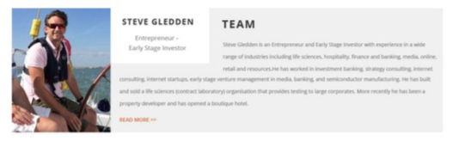
#6642050
I also like

#6651732
Steve Gledden is an Entrepreneur and Early Stage Investor with experience in a wide range of industries including life sciences, hospitality, finance and banking, media, online, retail and resources.

He has worked in investment banking, strategy consulting, internet startups, early stage venture management in media, banking, semiconductor manufacturing. He has built and sold a contract laboratory organisation that provides testing to large corporates. More recently he has been a property developer and has opened a boutique hotel.

He has degrees in Science and Commerce from Melbourne University and an MBA from Oxford and is a former member of the Young Entrepreneurs Organisation.

Advisors
Could we set up an advisors Gallery (scrolling)… at this stage there are only two advisors – Karen and Paul, but I’d like to add others once the site is published. Something like this would be perfect…
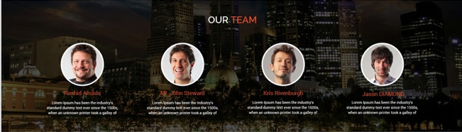
Dr Karen Wilson

Karen has over 20 years experience including McKinsey & Anderson Consulting, and corporate healthcare and technology start-ups. She holds a PhD in biochemical engineering specialising in immuniassay development. She has worked in biotechnology, bioscience & engineering in the UK, Australia, & the US. Her experience spans corporate, research & public health organisations such as Baxter Bioscience (US), the Peter MacCallum Cancer Institute, CSIRO & Australian Red Cross.
Paul Hunt

Paul is a commercial and corporate lawyer that advises innovative, fast growing companies, their boards and shareholders on the legal aspects of transactions and growth strategies, and operational legal issues, including dispute solutions, litigation and mediation. He is known for his strategic thinking and negotiation skills and attention to his client’s desired outcomes.
Early in his career Paul held in house counsel roles in telecommunications, media and technology (TMT) businesses, gaining insights into how best to serve business as a lawyer. Since 2001 Mr Hunt has brought this knowledge to private practice.
In his own corporate law firm from 2004, and then as a Partner in mid tier eastern sea board law firm, he serviced clients in a broad range of industries including corporate advisory, mining and mining services, insolvency, manufacturing, health, property development, retail, advertising, financial services, sports and entertainment, as well as TMT businesses.

Projects & Investments
On the projects and investments page I’d like to have three separate galleries using the following images and logos:
- Projects & Investments
- Companies We Like
- Corporate Advisors
This format for each gallery is perfect – image and short blurb…
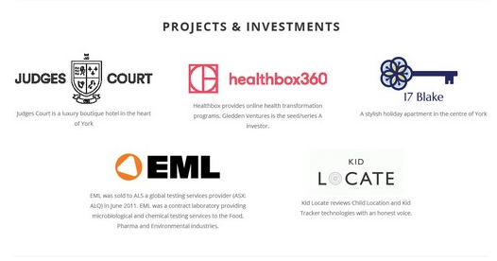
Projects & Investments Copy


https://www.healthbox360.me

Healthbox provides online health transformation programs. Gledden Ventures is the seed/series A investor.


http://www.judgescourt.co.uk

Judges Court is a luxury boutique hotel in the heart of York


www.17blake.com
A stylish holiday apartment in the centre of York


www.kidloc8.com
Kid Locate reviews Child Location and Kid Tracker technologies with an honest voice.

http://www.alsglobal.com/en/Our-Services/Life-Sciences/Pharmaceutical/News/ALS-Acquires-EML-Pty-Ltd
EML was sold to ALS a global testing services provider (ASX: ALQ) in June 2011. EML was a contract laboratory providing microbiological and chemical testing services to the Food, Pharma and Environmental industries.

Regal Tasman Market Neutral Fund

Macquarie Asia New Stars Fund

Platinum Asia and Platinum European Funds
PIMCO Global Debt Funds

Principle Global Fixed Income

Legg Mason Brandywine Fund

Zurich Global Growth Fund

Companies we like







Imagination Entertainment


Baxter Bioscience



Corporate Advisors

Wealth Management and Investment Advisors

Wealth Management and Investment Advisors

Accounting and Tax Advisors

Corporate Lawyers

Tax and Corporate Lawyers

Private and Business Banking

Private Banking

Business Banking

Social Media and Blog
Could we have a social media and Blog panel…

Twitter @SGledden
Linked In Profile
https://uk.linkedin.com/in/sgledden
No Facebook

Contact
Could we use the following contact panel…


Copy

Gledden Ventures
Level 20, 111 Elizabeth Street
Sydney, NSW 2000
Phone (UK): +44 7780 47 42 43
Phone (Australia): +61 418 350 737
Phone (US): +1 415 999 8881
Skype: SGledden
Email: steve@gledden.com

