Gledden Ventures

Home
Gledden Ventures are entrepreneurs and early stage investors in a diverse range of industries. We are enthusiastic and passionate generalists with an eye for opportunity. We are also consultants, advisors and manage investments for the Gledden Family Trust.

Our values include Family, Relationships and Fun.

Team

Steve Gledden is an Entrepreneur and Early Stage Investor with experience in a wide range of industries including life sciences, hospitality, finance and banking, media, online, retail and resources.

He has worked in investment banking, strategy consulting, internet startups, early stage venture management in media, banking, semiconductor manufacturing. He has built and sold a contract laboratory organisation that provides testing to large corporates. More recently he has been a property developer and has opened a boutique hotel.

He has degrees in Science and Commerce from Melbourne University and an MBA from Oxford and is a former member of the Young Entrepreneurs Organisation.

Advisors
Dr Karen Wilson
Karen has over 20 years experience including McKinsey & Anderson Consulting, and corporate healthcare and technology start-ups. She holds a PhD in biochemical engineering specialising in immuniassay development. She has worked in biotechnology, bioscience & engineering in the UK, Australia, & the US. Her experience spans corporate, research & public health organisations such as Baxter Bioscience (US), the Peter MacCallum Cancer Institute, CSIRO & Australian Red Cross.
She retains a strong interest in technology transfer & primary research and - being a chronic disease sufferer - is passionate about improving UK chronic disease management, health & patient care.

Dr James Gledden

Projects & Investments

https://www.healthbox360.me

Healthbox provides online health transformation programs. Gledden Ventures is the seed/series A investor.


http://www.judgescourt.co.uk

Judges Court is a luxury boutique hotel in the heart of York

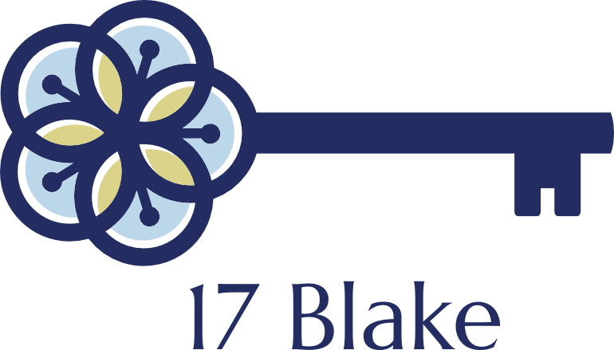
www.17blake.com
A stylish holiday apartment in the centre of York


www.kidloc8.com
Kid Locate reviews Child Location and Kid Tracker technologies with an honest voice.

http://www.alsglobal.com/en/Our-Services/Life-Sciences/Pharmaceutical/News/ALS-Acquires-EML-Pty-Ltd
EML was sold to ALS a global testing services provider (ASX: ALQ) in June 2011. EML was a contract laboratory providing microbiological and chemical testing services to the Food, Pharma and Environmental industries.

Companies we like







Imagination Entertainment


Baxter Bioscience




Regal Tasman

Macquarie Asia New Stars
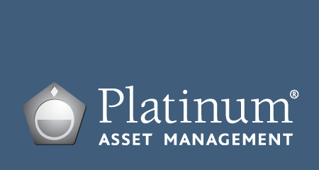
Platinum Asia
Platinum Europe
PIMCO

Principle

Legg Mason Brandywine

Zurich

Advisors
JBWere
Goldman Sachs
BDO
Smith Wilson
Paul Hunt
Hall & Wilcox
Enslin & Associates
NAB Private
Yorkshire Bank Private
Natwest

Sent from my iPad
_________________________
Stephen Gledden
Fairfield Farmhouse
Shipton Rd, Skelton
York, North Yorkshire, YO30 1XW
UK
p/f: +44 1904 620 460
m: +44 7780 47 42 43
e: stephen@gledden.com

