Brand: | Stick It
Task: | Stick It – Concept Packaging Artwork
Objective: | Our company is launching a new range of self-adhesive products in Australia.  For launch, the product range will consist of self-adhesive blackboards and whiteboards. We need mock-ups of the packaging to show to internal team and suppliers to get their buy-in.
Deliverables: | - 4 concept packaging designs set up as a rendered box image to mimic the layout of the box shown in below images.  - 2 design options for the Blackboard box and 2 design options for the White board box
Artistic Direction: | - Box Size: 450mm(l) x 38mm(w)  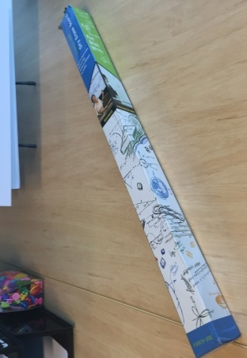  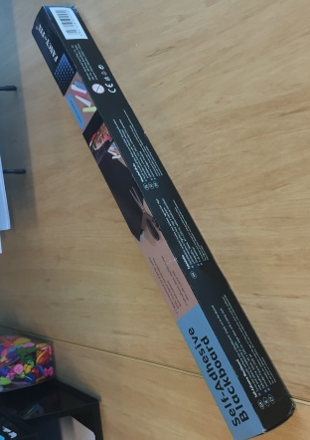  - Existing box design from supplier:  Blackboard Box  Whiteboard Box  (See attachments on ‘Design Crowd’ for actual photos)  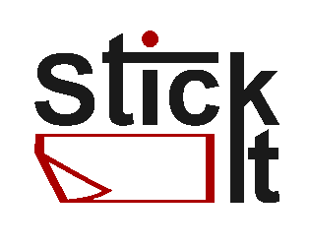  - This is our logo (for now)  - These products are targeted at home owners, offices and businesses so the artwork needs to reflect this.  - This range will be available in major retail stores so the packaging needs to be commercial and appealing to the masses.  - Below are mandatories for the design, when you are working on this, if you feel that some won’t fit in this view, please advise.
Mandatories: | Blackboard  - Logo  - Product Name ‘Stick-On Blackboard’  - Phrases ‘Easy application and removal’ & ‘Use on any surface’  - Product Size: 45x200cm  - Includes 5 piece Chalk set  - Picture of chalk – doesn’t have to be exact colours  - Image of a to-do list on a blackboard  Whiteboard  - Logo  - Product Name ‘Stick-On Whiteboard’  - Phrases ‘Easy application and removal’ & ‘Use on any surface’  - Product Size: 45x200cm  - Includes markers  - Image of someone writing on a whiteboard surface.

