CONTENT
TITLE: Jaguar Timing and ITS YOUR RACE: Innovation for Today's Athletes

Page 1:
Welcome to the next revolution of RFID Race Timing
Building a better race experience, it’s our passion. It’s what drives us to continually push the envelope in the timing industry. Our Jaguar™ Timing System was designed and built to meet the needs of our race directors and athletes. It’s the only fully integrated system that includes software, hardware, chips, remote control, real-time reports, and world-class support. The Jaguar™ Timing System revolutionized the industry by providing everything from the ground up: new hardware, new software and new chips designed specifically with race timing in mind. When your race is timed by a Jaguar™ Timing System, you’re guaranteed accuracy up to 1/1000th of a second.
Use this image:
https://www.dropbox.com/home/Brochure%20Share?preview=Tar+Heel+10+Miler+2015-1-ZF-9988-48892-1-001-001.jpg

Page 2:
Any Event. Any Condition.
Our Jaguar™ Timing System is built to withstand the toughest race conditions. From road races with thousands of participants to mud runs to triathlons and even boating races, we have chips for any type of event. The actual hardware is unlike anything you've ever seen in an RFID timing system. We use overhead or side mounted antennas, so no mats or ramps are needed. This means your participants experience the freedom to cross the finish line at full speed without having to worry about trip hazards!
https://www.dropbox.com/home/Brochure%20Share?preview=winterpark.jpg

Page 3:
More than Just Timing Your Event
Our company not only offers state-of-the-art timing, we also bring additional race management services to provide a seamless race experience for timers, race directors and athletes. We’ve partnered with ITS YOUR RACE, which is a software platform fully integrated with our Jaguar™ Timing System software that offers online race registration AND seamless race-day registration. In using ITS YOUR RACE for your online registration solution, you’ll also have a mobile app for your event, live results via the web and mobile app, live athlete finisher photos, a fundraising platform for your athletes and more!

(CREATE A GRAPHIC HERE that shows that we’re bringing all aspects of a race full circle. Here’s a rough sketch:
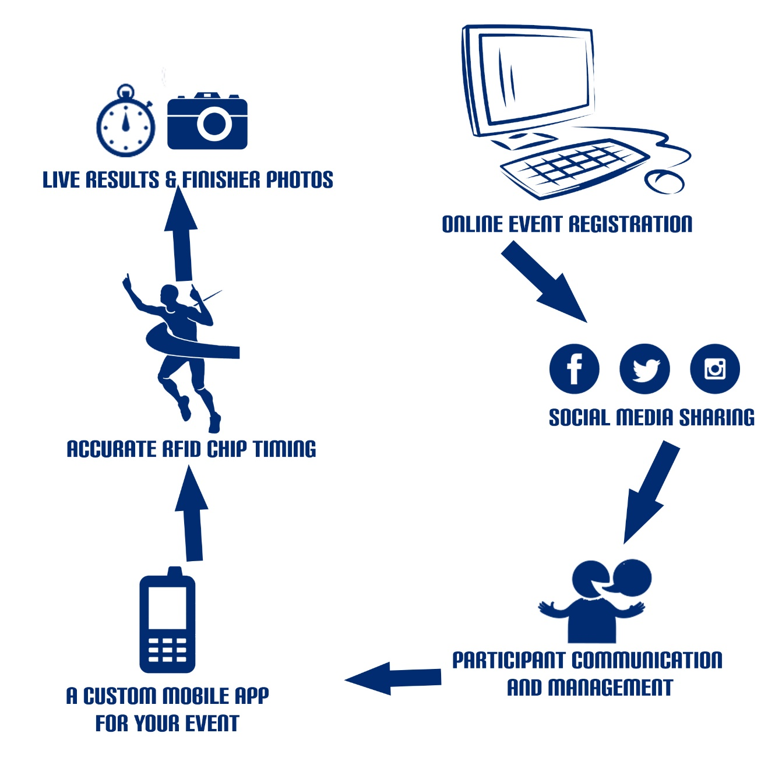
Again, that’s just a rough sketch, but we need something on this page that’s similar. You can feel free to use the text, but we’d like to see a more uniform graphic that goes with the design of the brochure.
Page 4:
Real. Live. Results & Photos.
Picture this. Your #1 athlete crossing the finish line with his arms raised high. He comes through the chute, on cloud nine after winning his first big race. He catches his breath, grabs a water and finds his mobile phone to see exactly what his time was. His results have already been share to his Facebook account because ITS YOUR RACE allows athletes to connect their account when they register. He’s able to view his finisher photo right away and shares them on Facebook with his friends and family for free. Sound too good to be true? With the partnership between the Jaguar Timing System and ITS YOUR RACE, instant gratification is delivered to your participants. The free ITS YOUR RACE mobile app for your event delivers live results and photos to athletes and spectators.
Create a montage of 3 Images here….
https://www.dropbox.com/home/Brochure%20Share?preview=ITS0004.JPG
https://www.dropbox.com/home/Brochure%20Share?preview=results.jpg
https://www.dropbox.com/s/d0fr3ry4jpr24qj/facebook_share_photo.jpg?dl=0

Page 5:
Simple Online Race Registration for Your Event
Let us handle your online registration setup! We put your event on ITS YOUR RACE and set up all of your registration types, divisions within your event and price increases. Then, we invite you to set up your payment information. You can choose to be paid monthly via check or get paid right away by setting up direct deposit!
You’ll have full access to the backend admin system in ITS YOUR RACE so you can download your participants as often as you want, and you can view the breakdown on revenue from your online registrations daily. ITS YOUR RACE is packed with advanced features such as promo codes, team registration, fundraising by individuals or teams, charity setup and advanced reports that race directors love to see and show their sponsors!
Display this screenshot of the software on this page:
http://www.clipular.com/c/4843877501501440.png?k=qVJ2XlFJ3tPIlaab-iRDBlvhH0M

Page 6:
A FREE Mobile App for Your Event
By using IYR to host your event’s online registration you’ll receive a free full-featured mobile app which includes:
- Event Details and Directions | - Live Results & Photos
- Live Athlete Tracking | - Sponsor Information
- Course Maps | - Event News and Information
- Nearby Places (hotels, restaurants, etc) | - AND MORE!

Page 7:
We Know Today’s Athletes
Race timing and event management are our passion. We strive to bring more participants to your event and give them a great experience when race day arrives. We’re not just about showing up on race day to time your event. We’re here to help you from registration to results and beyond. Racing events are not simple as they once were, and we have the new technology that athletes have become accustomed to. Let us work with you to bring all of this and more to your event.
Image to use:
https://www.dropbox.com/home/Brochure%20Share?preview=pros.jpg

Page 8:
Ready to learn more?
We’d love to partner with your event. Contact us today to find out more.
Leave a blank square space for a business card to be placed inside.

