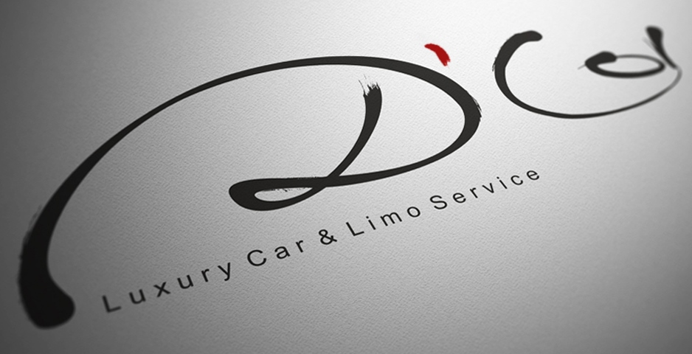
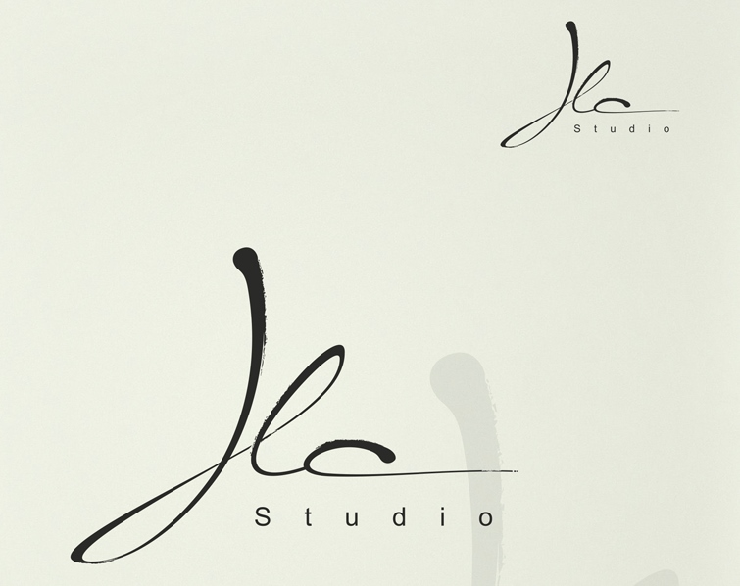
We Like this style of elegant lettering ie brush stroke
_______________________________________________________________

My business partner likes the browns and greens in this design – possibly light mint green background to design?
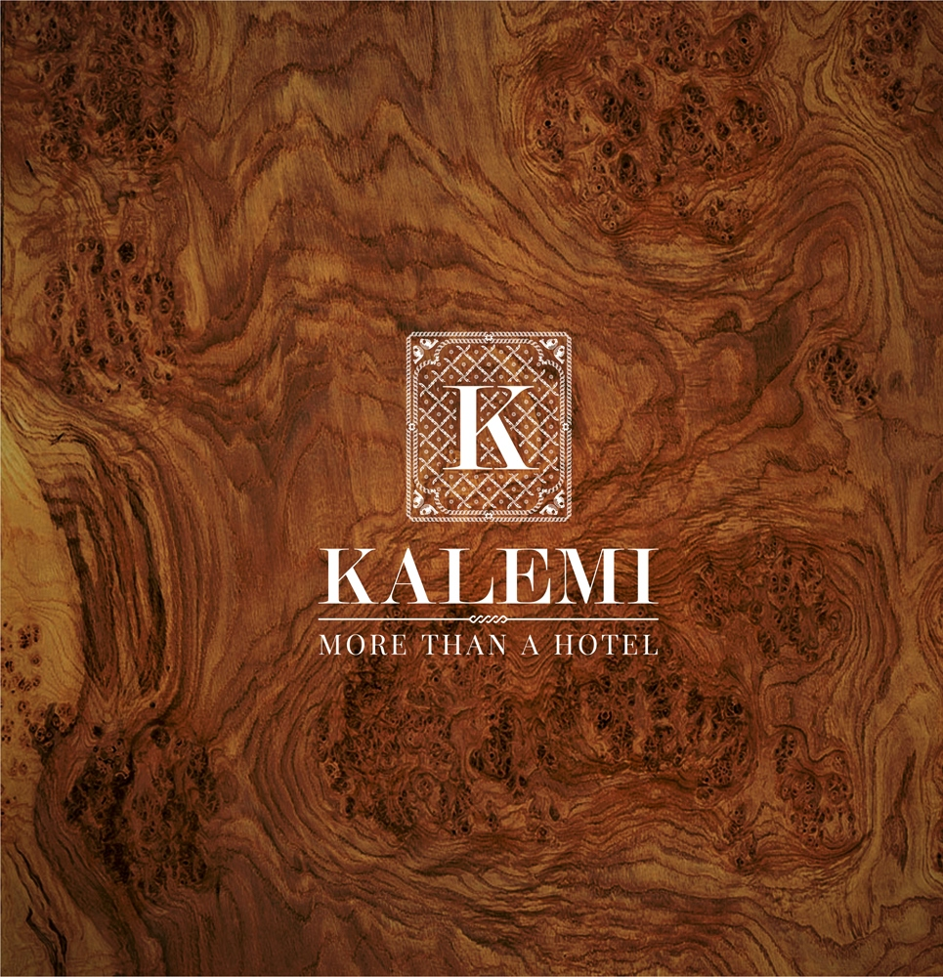
We liked the background to this and also the line under the name title


We liked these colours too as possible background colours


