LOGO DESIGN BRIEF:

The logo

- Words in logo: THRIVE
- Tagline to be included in logo: Inspired Industry Intelligence.
- Six adjectives: Luxury, Modern, Feminine, Serious, Aspirational, Simple
- The logo should be; simple, memorable, timeless, versatile, appropriate
- - - - - - - - - - - - - - - - - - - - - - - - - - - - - - - - - - - - - - - - - - - - - - - - - - - - - - - - - - - - - - - - - - - - - - - - - - - - - - - - -

Background:

This event is designed to provide a comprehensive and content-rich educational platform to the spa and wellness industry in Australia, NZ and the Pacific.
Education streams to be delivered by subject matter experts (not necessarily related to industry) with the primary aim being to socialise new information, share
key success strategies, demonstrate via real-life case studies and tried and tested learning examples

The event will be promoted in industry trade magazines and a website will be developed, in conjunction with an integrated multiplatform marketing campaign.

The event will occur over two days and sessions/keynotes will cover commerciality, Marketing, Experential/Immersive, Industry Intelligence/Round Tables
- - - - - - - - - - - - - - - - - - - - - - - - - - - - - - - - - - - - - - - - - - - - - - - - - - - - - - - - - - - - - - - - - - - - - - - - - - - - - - - - -

Goals and Objectives:

- Create attention, interest and desire to attend event, commit to purchase of attendance
- Short term, we need a strong visual identity to launch this new event in place of an existing industry event that is not occurring, so the logo must be very strong, eye catching, slick looking that communicates to the audience that attending will be a must
- Long term, we hope to hold the event annually and position it as the thought leader event in the industry, attracting significant sponsorship and international opportunities

- - - - - - - - - - - - - - - - - - - - - - - - - - - - - - - - - - - - - - - - - - - - - - - - - - - - - - - - - - - - - - - - - - - - - - - - - - - - - - - - -

Concept background:
thrive
The underlying theme of this s concept revolves around the ‘I’, hence why it is in a different colour here – this is not creative direction, it is just how we have conceptualised in order to integrate the vertical streams of the event, however the logo should visually communicate this an utilise the ‘I’ somehow. The whole context of the conference would be wrapped around i-thrive with varied lateral connections. As an individual if i-thrive so does my business, my people, my product, my offering. Eg.
i – learn
educational stream, keynote sessions, main conference sessions
i– experience
tradeshow area, penthouse experience rooms, competitions, give-aways
i–contribute
industry round tables, penthouse interactive sessions, charitypartnership
i – engage
online training platform, networking, social events and community activities

- - - - - - - - - - - - - - - - - - - - - - - - - - - - - - - - - - - - - - - - - - - - - - - - - - - - - - - - - - - - - - - - - - - - - - - - - - - - - - - - -

Target audience
- Business Owners Spa, Salon, Clinic & Wellness Owners, Product Creators/Owners, Franchisees & Education Providers Operational Managers Spa & Clinic Managers, BDM’s, Group Operators, Assistant Managers & Supervisors
- Brands&Suppliers: Sponsorship opportunity for skincare brands and industry suppliers including food, supplements, apparel
- Students: targeted approach to key beauty schools to deliver professional bridging sessions
- Who are you trying to attract with your marketing message? Be specific.
- What is the overall message you want to convey to your target audience?

- - - - - - - - - - - - - - - - - - - - - - - - - - - - - - - - - - - - - - - - - - - - - - - - - - - - - - - - - - - - - - - - - - - - - - - - - - - - - - - - -

Tone & Image:
Tone: positioned as a thought leader with a down to earth, conversational and collaborative tone rather than a dominating/condescending tone.
Imagery: specific visual goals include an upward, progressive, fluid and moderately dynamic.

- - - - - - - - - - - - - - - - - - - - - - - - - - - - - - - - - - - - - - - - - - - - - - - - - - - - - - - - - - - - - - - - - - - - - - - - - - - - - - - - -
Success is number of delegates attending the event and, in the smaller session sell outs, acquiring sponsorship and exhibitors at full capacity.

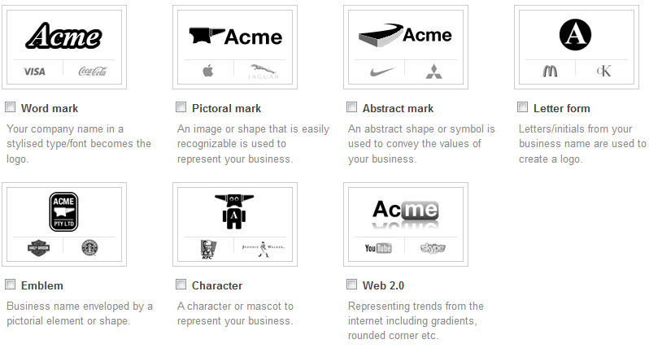
- - - - - - - - - - - - - - - - - - - - - - - - - - - - - - - - - - - - - - - - - - - - - - - - - - - - - - - - - - - - - - - - - - - - - - - - - - - - - - - - -
Colours – Green, Grey.
Try a version in orange – to inspire creativity, energy, motivation
Logo Genre: Pictorial Mark
- - - - - - - - - - - - - - - - - - - - - - - - - - - - - - - - - - - - - - - - - - - - - - - - - - - - - - - - - - - - - - - - - - - - - - - - - - - - - - -

