Company Name: Home Hygiene (Pink)

Email: tony.page@mollymaid.co.uk (pink)

Tel: 01707 655 259 (Pink)

Content:

Front: Picture with just the company name and what we do (Carpet & Upholster
Cleaning). Picture below as an example, name in bold, with carpet and upholstery
cleaning written underneath.

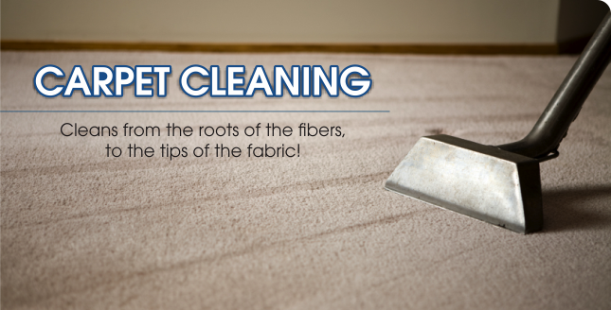

Back: Half picture

under picture

Reliable: We pride ourselves on providing outstanding services to our customers.
From a single carpet or rug, to a whole-house clean, we provide a reliable
and friendly service. Call us to discuss your needs.

Professional: We use the latest hot water extraction cleaning technology to give
us the ability to get into the ground down dirt deep down inside the
Fibres.

Trustworthy: We are fully insured to work in your home, we guarantee all our
work so if any issues do arise we will do our up most to put it back
right for you.

Written on the back will also be our contact details, name of company, phone no, email address.

PLEASE FEEL FREE TO SEARCH ANY PICTURES YOU FEEL MAY GO RIGHT WITH THE LEAFLET, IF MINE ARE INSUFFICIENT, MINE ARE ONLY EXAMPLES OF WHAT I LIKE.

