
NEW

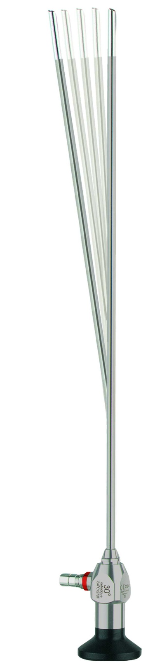
Semi flex Endoscopes
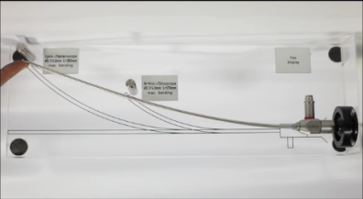
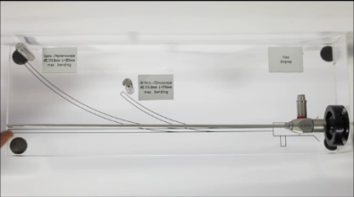
Endoch developed an advanced optical system that is less sensitive to bending; Accordingly, the endoscope-tube can be bent multiple times without any damage as with regular rigid endoscopes.
Though less sensitive to bending, the excellent image quality of an optical lens system is preserved.

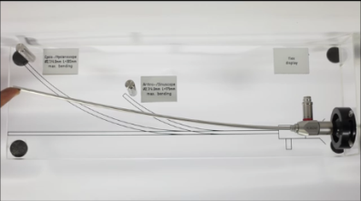

Arthroscope semiflex | wide angle | HD
Autoclavable
diameter / length
2.7 / 110.0 | AS-2700.110FA |  | AS-2730.110FA
2.7 / 175.0 | AS-2700.175FA |  | AS-2730.175FA
2.7 / 187.5 | AS-2700.187FA |  | AS-2730.187FA

Arthroscope semiflex 2.0 | wide angle | HD
Autoclavable
diameter / length
4.0 / 142.0 |  |  | AS-4030.142FA
4.0 / 175.0 | AS-4000.175FA |  | AS-4030.175.FA | AS-4045.175FA | AS-4070.175FA

Sinuscope semiflex | wide angle | HD
Autoclavable
diameter / length
2.7 / 110.0 | AS-2700.110FA |  | AS-2730.110FA
2.7 / 175.0 | AS-2700.175FA |  | AS-2730.175FA
2.7 / 187.5 | AS-2700.187FA |  | AS-2730.187FA

Sinuscope semiflex 2.0 | wide angle | HD
Autoclavable
diameter / length
4.0 / 175.0 | AS-4000.175FA |  | AS-4030.175FA | AS-4045.175FA | AS-4070.175FA

Hysteroscope semiflex | HD
Autoclavable
diameter / length
2.7 / 302.0 | AS-2700.302FA | AS-2712.302FA | AS-2730.302FA

Hysteroscope semiflex 2.0 | HD
Autoclavable
diameter / length
4.0 / 302.0 | AS-4000.302FA | AS-4012.302FA | AS-4030.302FA |  | AS-4070.302FA

Cystoscope semiflex | HD
Autoclavable
diameter / length
2.7 / 302.0 | AS-2700.302FA | AS-2712.302FA | AS-2730.302FA

Cystoscope semiflex 2.0 | HD
Autoclavable
diameter / length
4.0 / 302.0 | AS-4000.302FA | AS-4012.302FA | AS-4030.302FA |  | AS-4070.302FA

