GENERAL VISUALS INFO: PLEASE CREATE THE VIDEO FOLLOWING THIS EXAMPLE, SIMILAR STYLE AND MUSIC, BUT USING GBR COLOR PALETTE, BASICALLY WHITE AND DIFFERENT BLUE TONALITIES.
https://www.youtube.com/watch?v=FhiEJOC_-kc&list=PLS4K-D9f9ldkJc-GFQnnhILg5JbfgbfBC

¿Drones para estudiar la topografía de un proyecto minero? | ('Drones to study the topography of a mining project?') - please show an animated drone flying example provided below') (1)
¿Camiones mineros que se manejan solos? | ('Driverless mining trucks?') - please show an animated mining truck, example below. If possible, it would be nice to show the driver going out of the truck, then the truck (2)
INFORMACIÓN ES VALOR
INFORMACIÓN ES NEGOCIO
INFORMACIÓN ES PODER | (leave "INFORMACIÓN ES" in a fixed position, then change the words VALOR, NEGOCIO and PODER in an animated way, make some emphasis on the word PODER
GBR ES SU FUENTE DE INFORMACIÓN DE REFERENCIA | (GBR as a logo, not text, - 'GBR is your key source of information')
MINERÍA Y METALES - ENERGÍA - PETRÓLEO Y GAS - QUÍMICA Y FARMACÉUTICA - AERONÁUTICA | (The different sectors we work in - bring them on to the screen with relevant animations, examples below) (3-4-5-6-7)
MÁS DE 1700 ENTREVISTAS A CEOs CADA AÑO | (over 1,700 CEO interviews per year)
300 REPORTES PRODUCIDOS EN 86 PAÍSES | (300 reports produced in 86 countries)  (show an earth globe rotating)
MINPER 2015 ES LA GUÍA MÁS COMPLETA SOBRE MINERÍA Y ENERGÍA EN PERÚ | (show MINPER 2015 book cover, if we could animate pages being flipped that would be nice) 'Minper 2015 is the most complete guide on mining and energy in Peru)
PRODUCIDO EN ORGULLOSA COLABORACIÓN CON IIMP | (show IIMP as IIMP logo, not text)
DISPONIBLE EN ESTA FERIA - VISITENOS EN EL STAND 235, PABELLÓN 2
 | (SHOW GBR LOGO TO FINISH)

DRONE example (1)
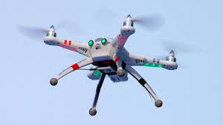

EXAMPLE OF MINING TRUCK (2)

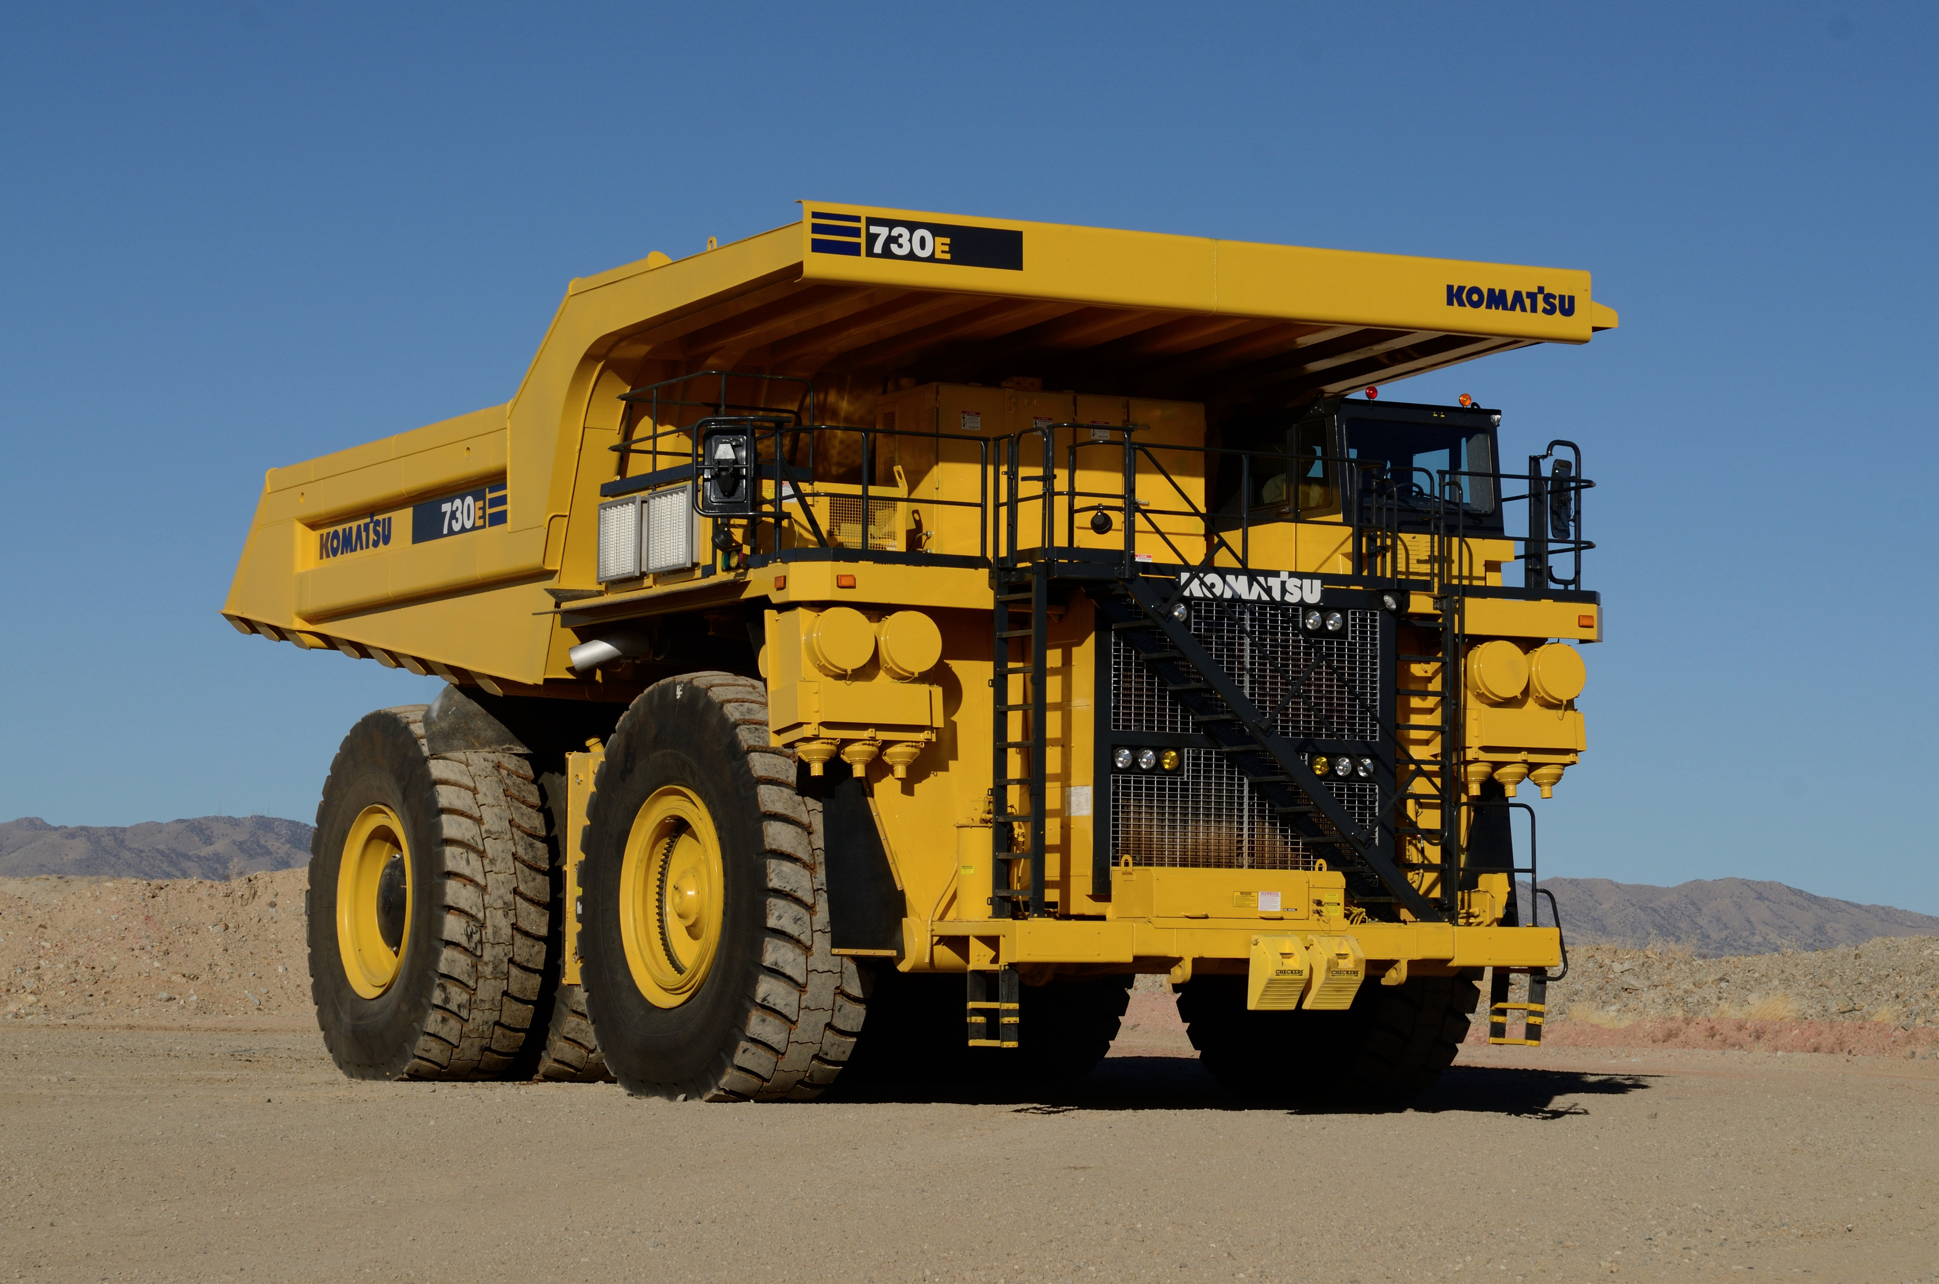
ANIMATIONS FOR THE DIFFERENT INDUSTRIES WE WORK IN
MINERÍA Y METALES (MINING AND METALS) (3)
we can show a ball mill in operation
https://www.youtube.com/watch?v=lTNaGZyE22Y (look at 50'' to 1:00 for a good angle)

ENERGÍA (ENERGY) (4)
- we can use a hydroelectric dam with water being discharged, example. Alternatively, a wind turbine could also work, and be easier to animate.
https://www.youtube.com/watch?v=JGyAL8_tcjs

PETRÓLEO Y GAS (OIL AND GAS) (5)
we can use an offshore oil platform, and it's the fire (from flaring gas) that it's animated.

QUÍMICA Y FARMACÉUTICA (CHEMICALS AND PHARMACEUTICALS) (6)
we can perhaps animate some of this laboratory elements? with steam coming out of them?
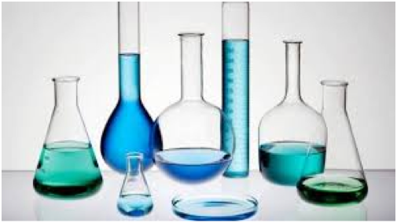

AERONÁUTICA (AEROSPACE) (7)
Show a plane taking off.

