BLOGGERSSEO

Website Design Brief
May 2015

Overview:

Design a website for an online product targeted towards bloggers. The online product will be a step-by-step system for bloggers to implement SEO for themselves. They will need the facility purchase online and login to get access to learning modules and guides.

Please note - Content is still to be provided.

Colour Scheme: This is a suggestion only. I am happy for other colours.





Home Page:

Follow similar layouts of the two sites listed below
http://followupmachine.com/ - Clean, white and simple
http://www.optimisepress.com/ - follow this layout with the clean and simplicity of the site above.

Similar Banner with BLOGGERSSEO as the logo

Include Social Media links in banner 
Menu Titles - Success Stories FAQs Blog Login

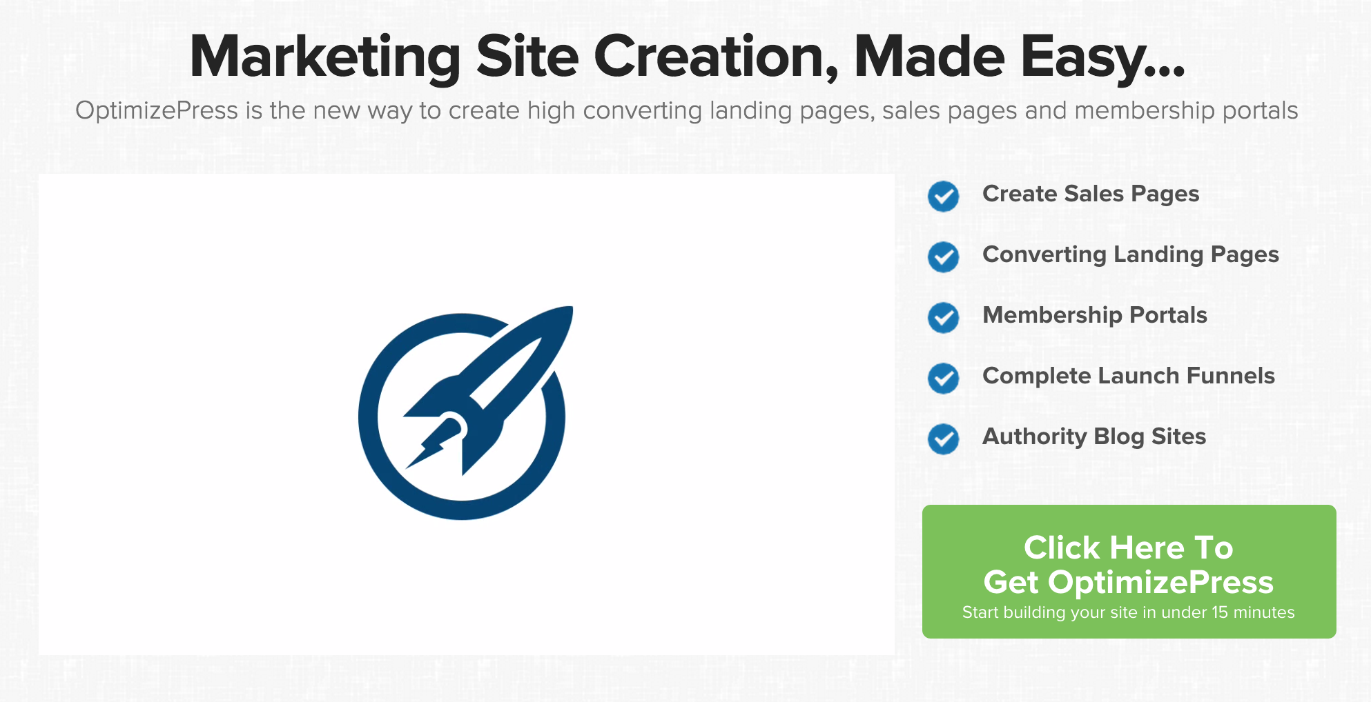
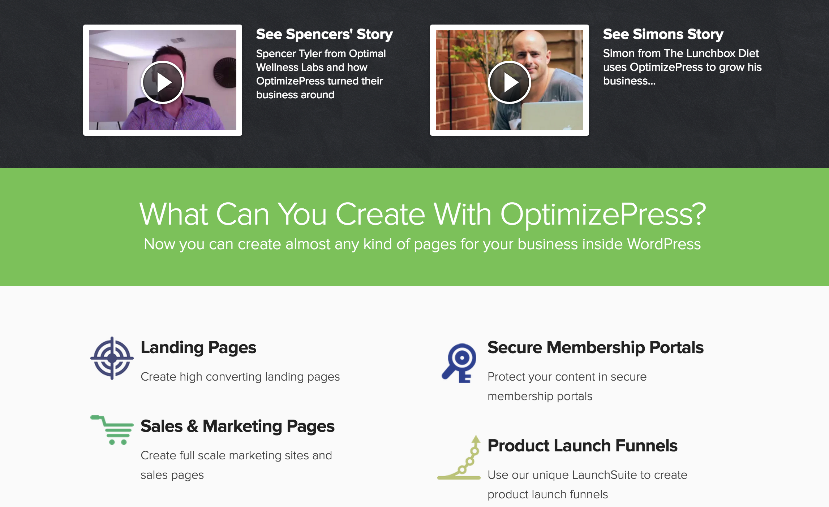

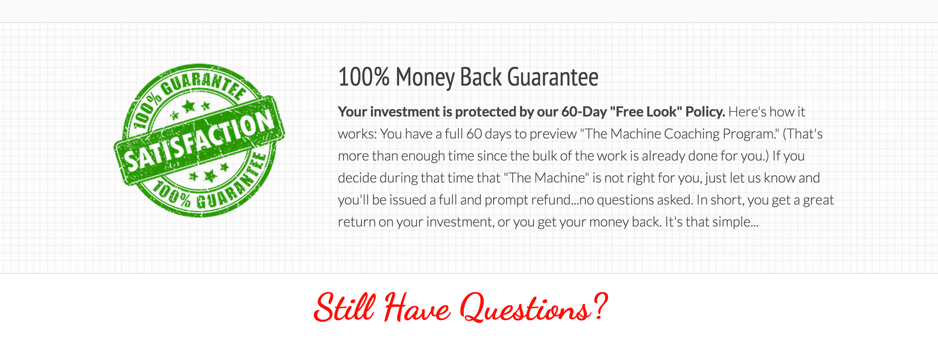

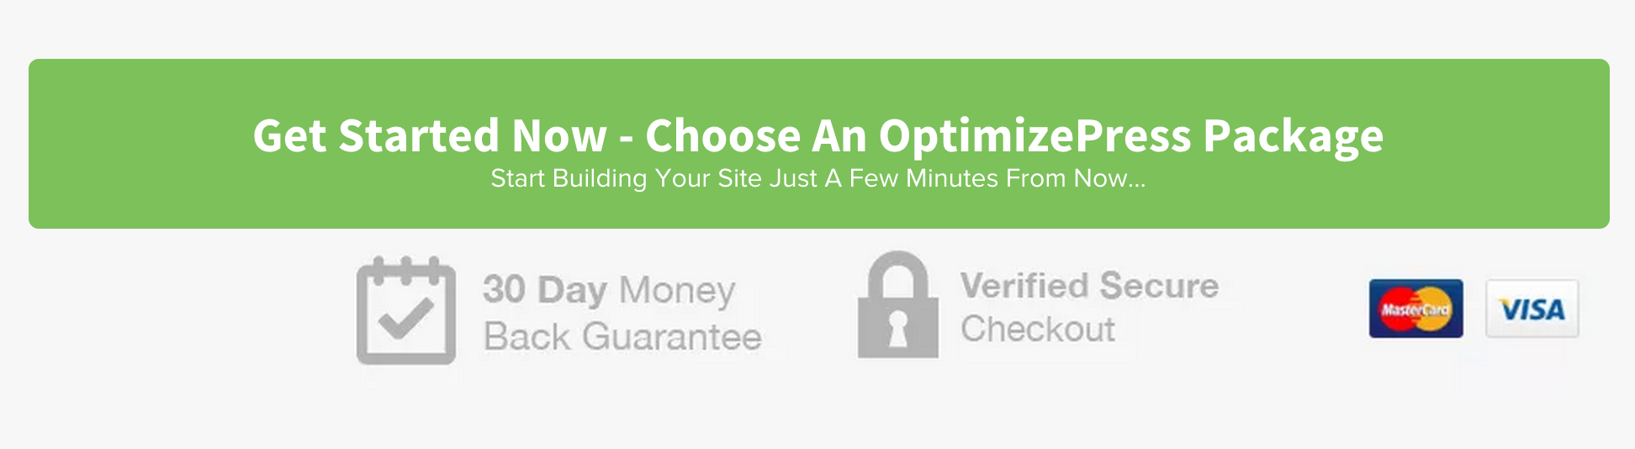

Bottom Banner to have T&Cs Privacy Policy

