Introduction

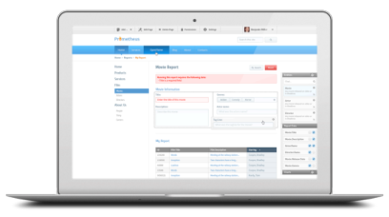
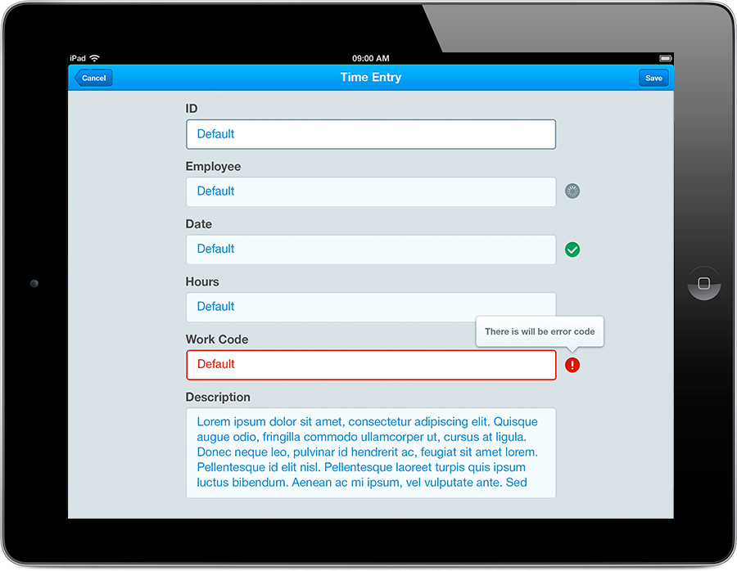
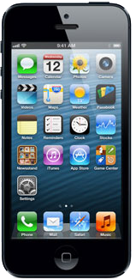
Introducing the Firejack Platform™. The power of off-the-shelf; the capability to do-it-yourself.
Create custom enterprise software where you need it connecting customers and partners to you.
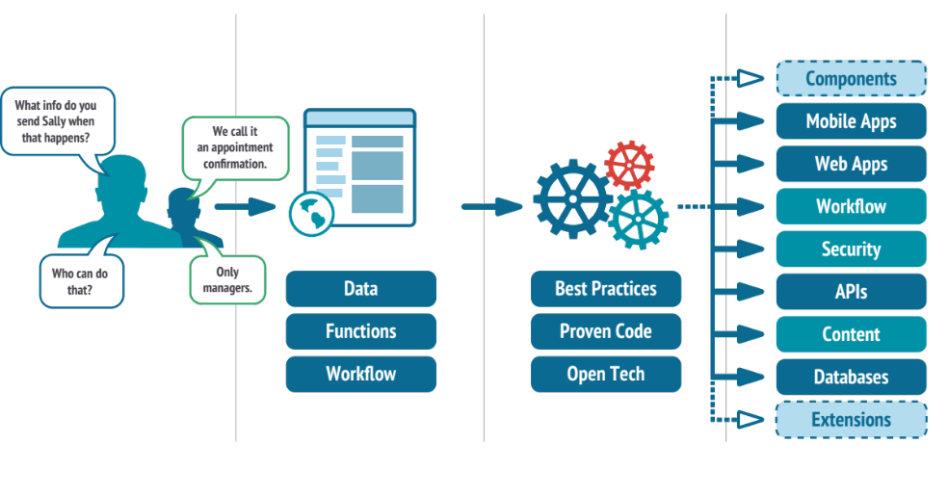
Create broad sweeping solutions that are up and running fast.
Converse
Capture
Create
Capabilities
Close the gap on expectations without increasing costs. Focus more on what is specific to your business.
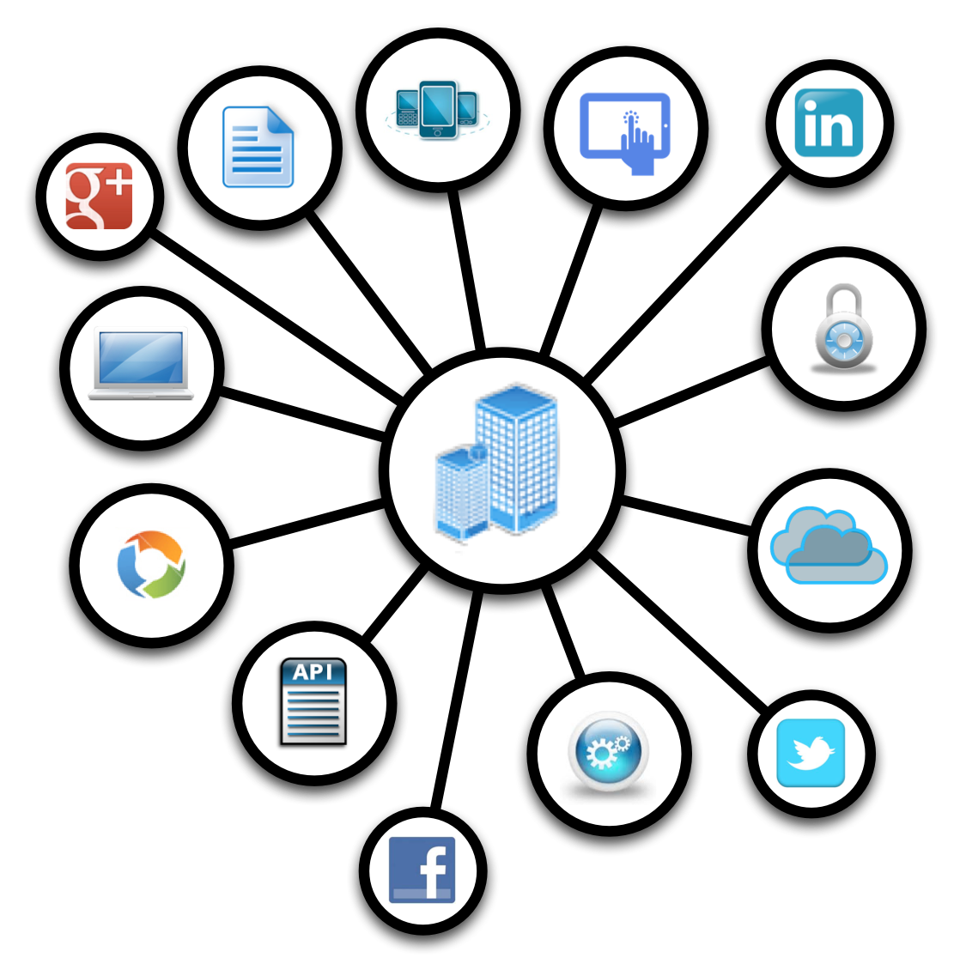
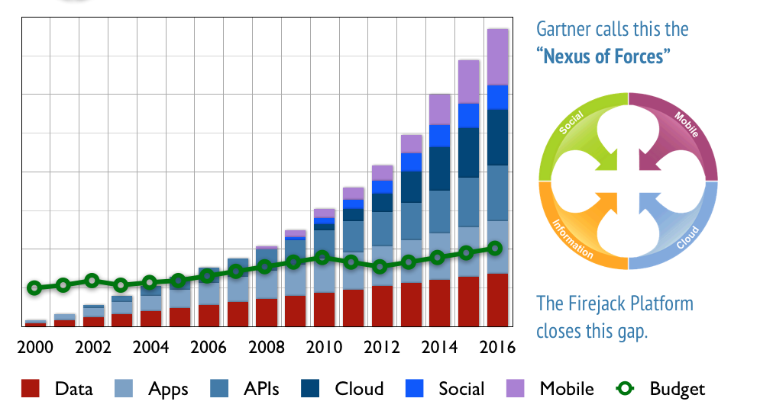
One Business. One System.

Document how your business works and translate that into a consistent user experience across all your channels. Let Firejack close the gap on features and control from your “One Business” model.
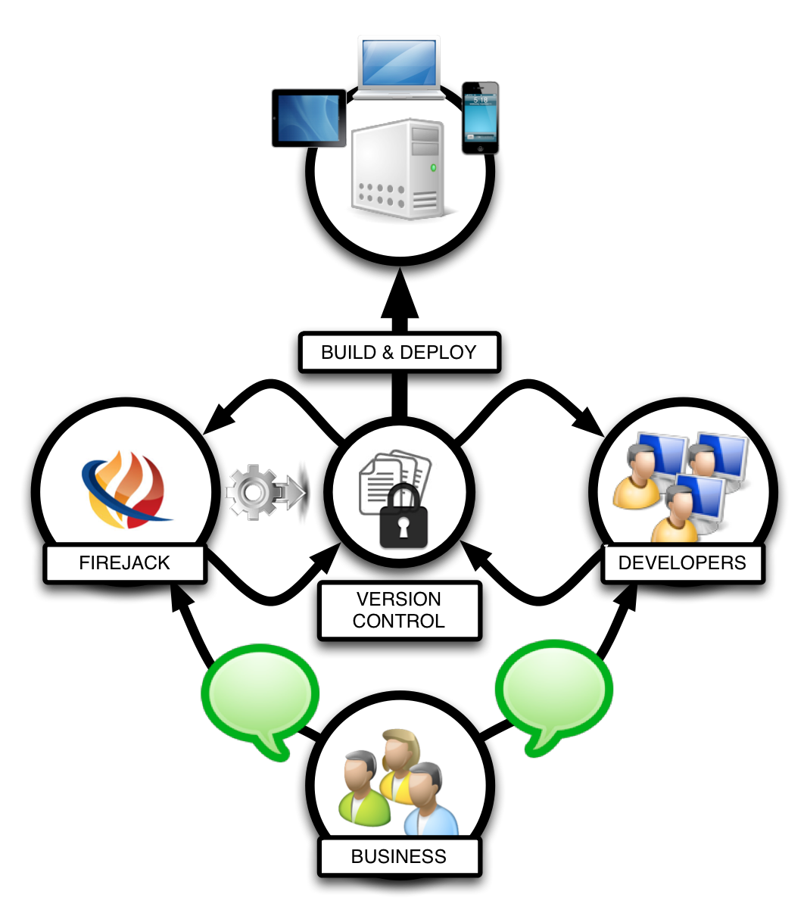
One Development Process

Create assets your development teams can use and still enable business to get instant gratification. Make business a partner in creating solutions and keep the SDLC intact.

Save Time and Money
The Firejack Platform™ reduces the time and effort it requires to deliver enterprise software without compromising your process.

Do More with Less | Improve Quality | Future Proof
Deliver custom software and services with 80% less work and better visibility. | Eliminate defects on software that has nothing to do with your business. | Upgrade to the latest technology in a fraction of the time and save.

Quickly Solve Serious Problems in a New Way

Invent | Re-Imagine | Integrate & Secure
Translate concepts into working systems you can touch with white-box software creation. | Refresh legacy systems. Let Firejack auto-discover and create working software you can use right away. | Fill gaps and create connections in record time. Secure apps and information from one place.
Mobilize | Coordinate | Consolidate
Create mobile and tablet apps that work just like your desktop systems. Do your work from anywhere. | Coordinate activities across departments. Easily embed workflow in any application. | Create one application to access all your business operations fast.

Platform
Start with the Firejack Platform as a Service or License the Platform to host on-premise. Either way, your applications reside on any server, any database, any OS, anywhere.

Platform as a Service
Firejack Platform as a Service is available in minutes. Choose a plan and get started. All packages provide managed, scalable cloud infrastructure, back-up plans, support, and high-availability.

Basic | Business | Enterprise
Create and run multiple applications. Handle up to 100k transactions / day, store 100GB of data and content, and serve 100s of users*.  Learn more >> | Integrate with legacy systems and directories. Handle up to 250k transactions / day, store 250GB of data and content, and serve 1000s of users*.  Learn more >> | Host mission critical systems that can handle up to 500k transactions / day, store 1TB of data and content. Serve up to 1 million users*.  Learn more >>
* References to “users” are estimates. Users are unlimited up to specified transaction and storage levels.
For larger installations contact sales@firejack.net

License the Platform
Bring the power of the Firejack Platform™ on premise or relocate it on your cloud of choice. Manage it yourself along with everything else in your enterprise.

Basic | Business | Enterprise
Create and run multiple applications. Handle up to 100k transactions / day and serve 100s of users*.  Learn more >> | Integrate with legacy systems and directories. Handle up to 250k transactions / day and serve 1000s of users*.  Learn more >> | Host secure, mission critical systems that can handle up to 500k transactions / day and serve up to 1 million users*.  Learn more >>
* References to “users” are estimates. Users are unlimited up to specified transaction levels.
For pricing or to discuss unlimited licenses contact sales@firejack.net

Product Features
For the Business, the Firejack Platform™ allows analysts and SMEs to define information and concepts and then creates working systems they can use immediately.

For the IT Manager and the developer, Firejack lets more people see the great work getting done and takes almost all the grunt-work out of delivering really impressive, integrated systems.

Manage Concepts Visually
Capture concepts and relationships in HUMAN terms and view it visually from the Platform. Create a level of understanding and visibility for all your systems that’s often missing.

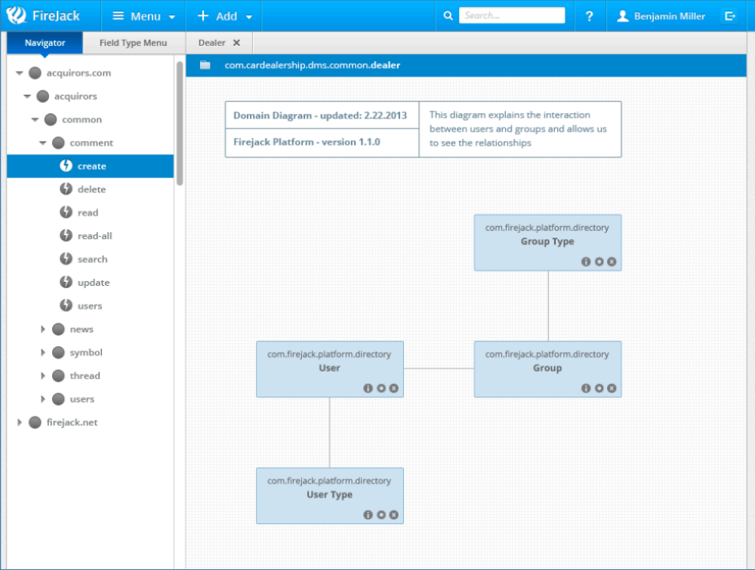

Define Concepts in Human Terms
Capture the details around your business and how it operates easily and let Firejack start creating real systems alongside traditional development efforts.

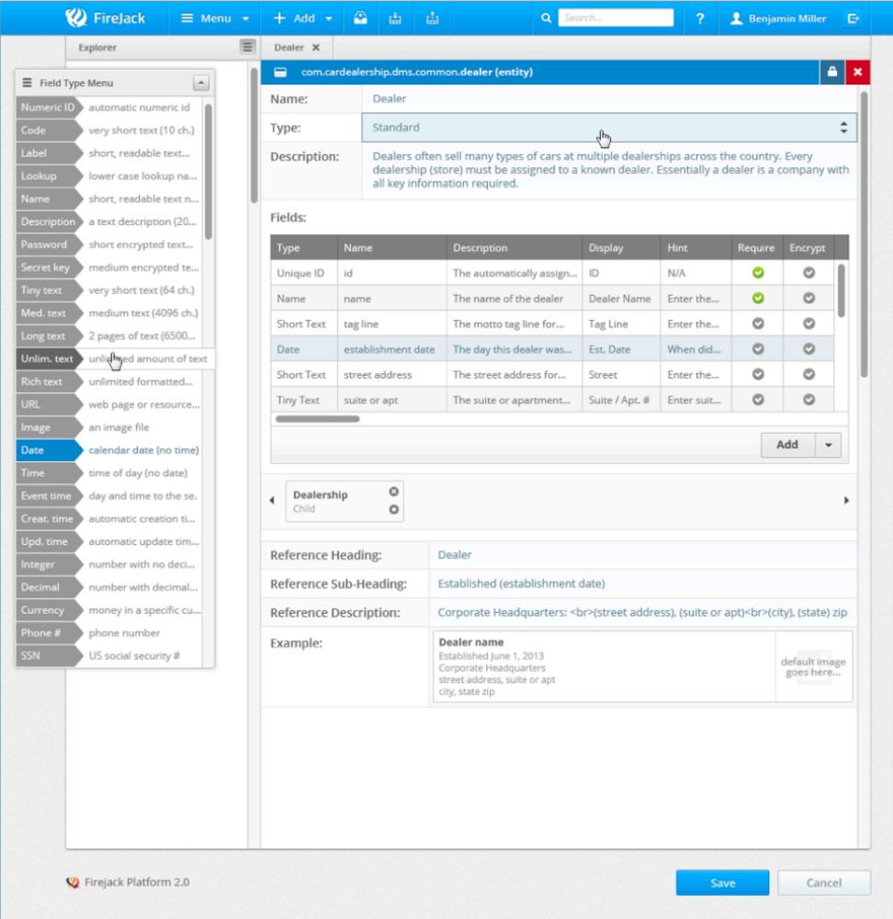

For companies with established databases, you can even discover and document what you already have quickly and begin enabling features from what is already in place.

Focus on Capabilities
First and foremost, the Platform creates documented APIs in SOAP and REST that drive every application solution. Enable integration with outside partners, other internal systems, and ensure the ability to tailor applications in any way required and in any technology.

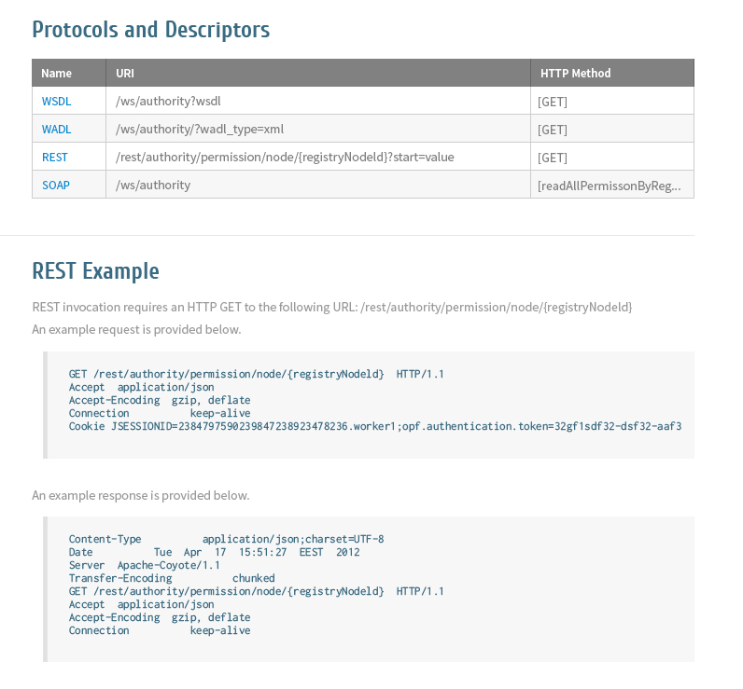

Instant Data Management Web Applications
Powerful web-based data-management applications with advanced data searching capabilities happen with no development required. Traditional development can be used to modify the code any way you see fit or to add customized user interfaces to applications in the standard ways you do today.

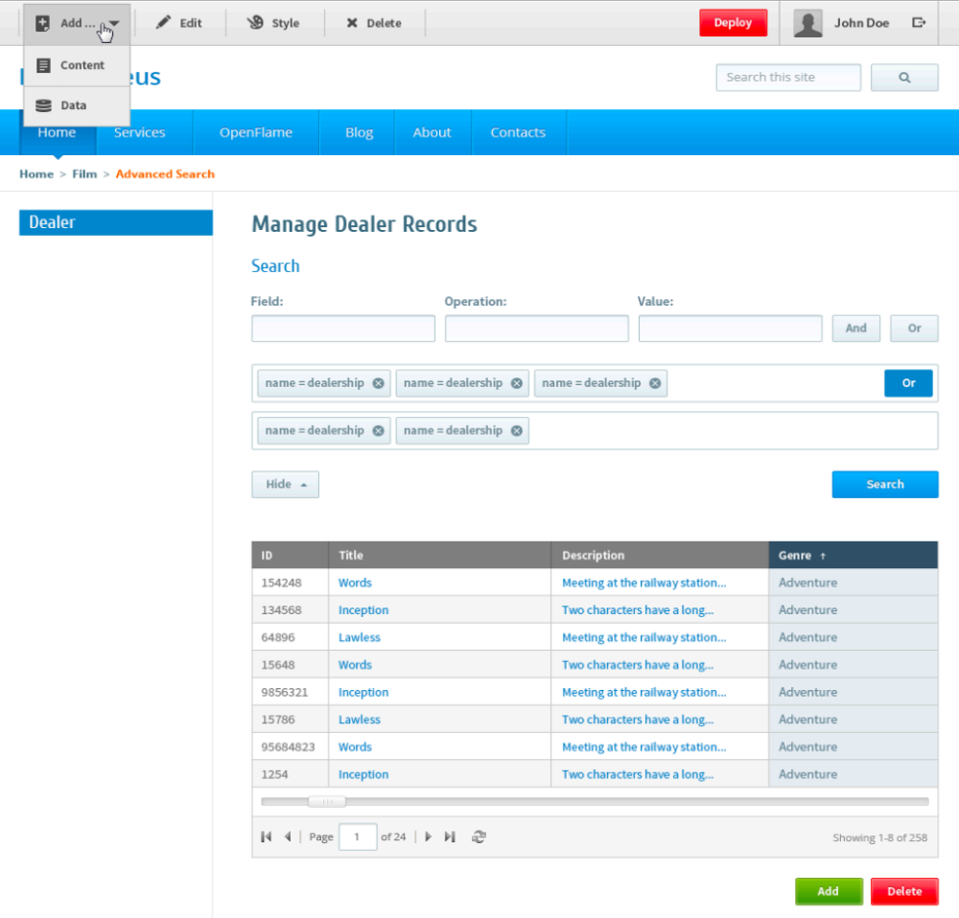

Data Entry and Validation
Manipulate data immediately and even mix documents and data into a single data-entry screen easily. Re-arrange forms as needed from the administrative view with drag and drop and / or tailor functionality with traditional custom development or both.

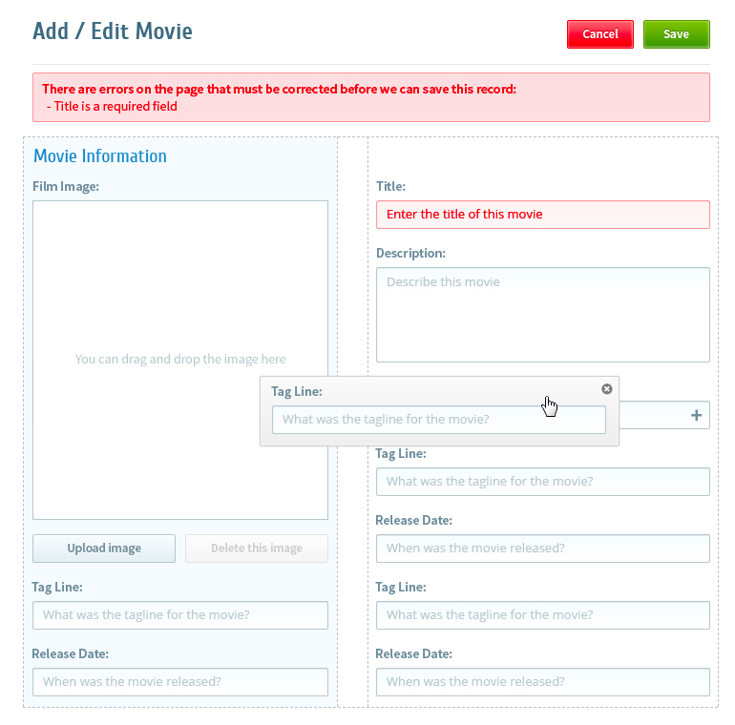

Track Performance and Utilization
See what parts of your system are really being used and how well they are performing at any level automatically.
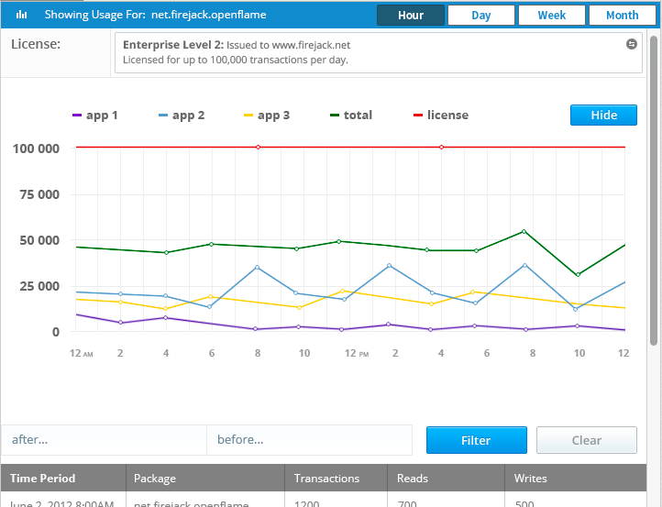

Instant Mobility
Work with your data securely from a tablet or mobile application as soon as its available via Platform-driven services.

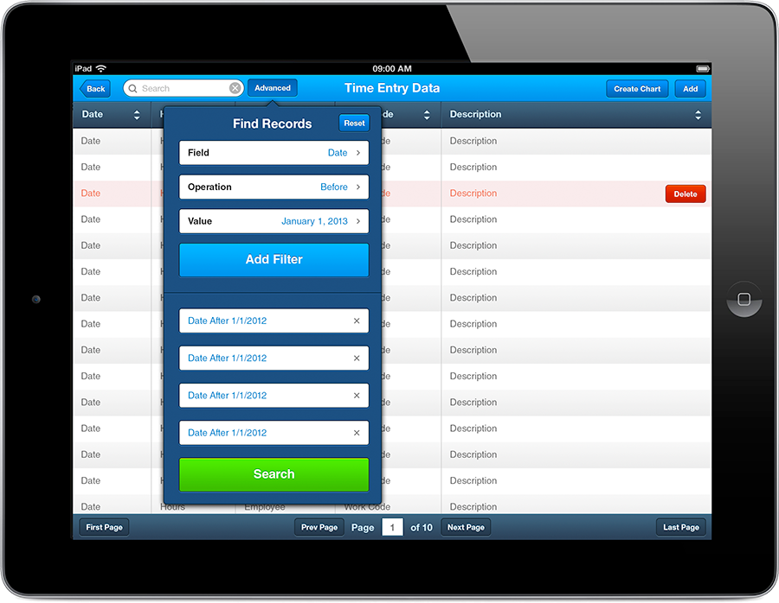

About Us
Firejack Technologies was founded in 2010 with the goal of enabling more people to create great custom software for the cloud than ever before possible. Since then, we’ve been embedding the intelligence of all the best consultants in our flagship product, the Firejack Platform and teaching it to help build great custom systems.

Our Mission
Enable almost anyone to translate great business ideas into superior technology solutions. Keep enabling developers to do what they are great at when the time comes. Take the risk out of custom software for the cloud.

Location
Firejack Technologies is headquartered in Columbia, MD at the Maryland Center for Entrepreneurship (MCE). We also have staff and locations in Italy, Ukraine, and Greece and customers worldwide.

Firejack Technologies
9250 Bendix Road, Suite 235
Columbia, MD 21045
sales@firejack.net

