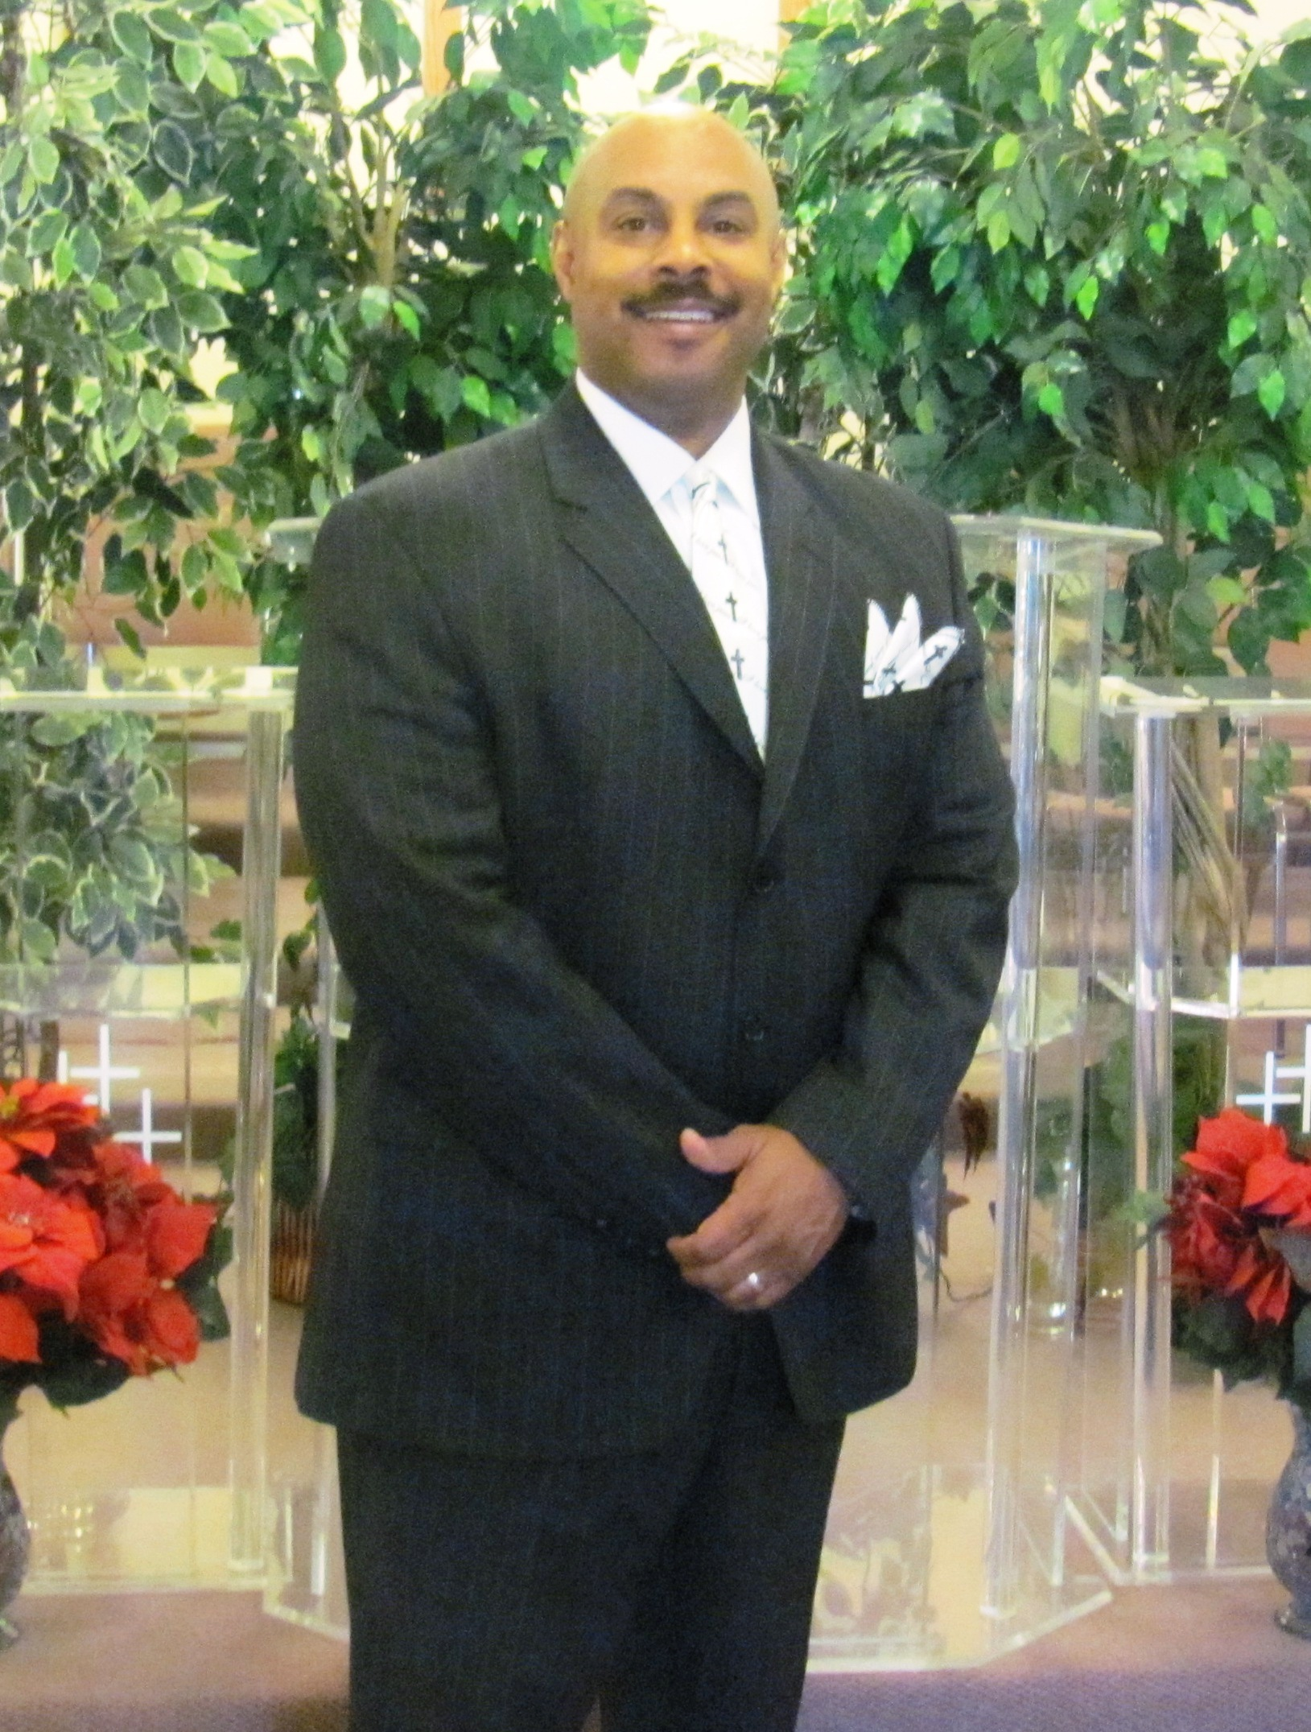
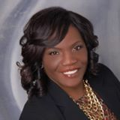
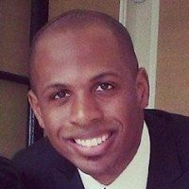
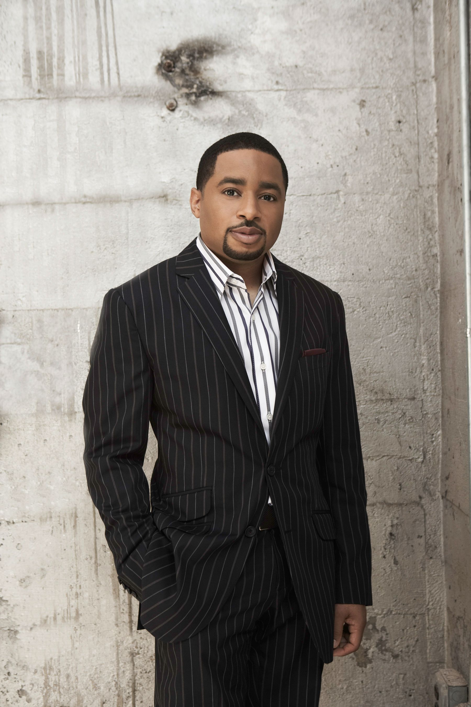

Pastor Terry Turrentine
Crusade Host
Recording Artist
Pastor Smokie Norful
Friday August 28
Services Wednesday-Friday 7:30pm
Metropolitan Baptist Church
2283 North Fair Oaks Ave Altadena

Community Prayer Service
Tuesday August 25@7pm
Deliverance Tabernacle
1299 Sunset Ave
Pasadena
Pastor Brandon Fisher
Thursday August 27
Evangelist Barbara Bryant Wednesday August 26
pecrusade.org
OUTPOUR!
EXPLOSION CRUSADE

