WA Foods Direct

Introduction
WA Foods Direct (WAFD) aims to supply high quality West Australian produce to the rest of the World. Western Australia is known for its high quality farming practices and environment, which produces meat, seafood, fruit and vegetable of a caliber that is respected globally.
With a management team and first class suppliers allows our organization to provide quality ingredients, straight from farm or ocean to purchaser, in a timely manner to the highest quality.
This document aims to outline both our management team and their back grounds, as well as the suppliers who will initially be supply our global customers.
The management team consists of:
Name | Role
John McLean | Management of operations, Chinese liaison, Quality processes and management.
Michael Lee | Procurement and liaison with suppliers.
Peter Howell | Logistics, transport, customs and tariffs
Dr Lifang Liao | Chinese Market Specialist, liaison between Australia and Chinese activities.

The suppliers WAFD will be using are:
Supplier | Produce Supplied
Total Food Distributors | High quality beef, lamb and pork
www.zimbulis.com.au | Fresh Fruit and Vegetables
www.kailisbros.com.au | Fresh Seafood

The Management Team

John McLean
John brings with him decades of experience in hospitality management, specializing in remote service and major city hospitality catering management. Whilst managing remote sites through Australia and off shore rigs, John’s management skills brings together supplier and logistical coordination to ensure the best outcomes for his clients.
Experience Summary
- Business Development – Remote catering
- General Manager – Major Catering Companies WA
- Consulting Management – Hospitality Companies, Catering Companies Developing Supply Opportunities

Michael Lee
Michael has been in the Sales, Retail & Procurement since 1972, after leaving Senior High School started Sales in the Tobacco industry before taking up Retail position in Supermarket management.
In 1986 moved into Food Procurement and Logistics management with major national and international Food Service companies in the Asia Pacific region. During the denture have managed sourcing of Food and Non-Food categories covering Meat, Seafood, Cold & Hot Beverage Fruit & Vegetable, Dry Grocery, Confectionery, Bakery, Dairy, Chemical & Cleaning materials and several other non-categorized products worth over $200 million which including logistics support, set up and mobilization service in remote and offshore locations.
In 2000 was appointed a team member of a consultation team working on a Concept Study in the design of services and facilitate of supply to enhance and add value to the businesses, in 2004 Michael lead the development of Pre-prepared Foods, designed and build Quarantine compliance Food Consolidation Facility to service Class a National Park locations.
Experience Summary
- General Manger – Supply Chain
- Coordinator IOM– 2004 Indian Ocean Tsunami temporary housing program
- Manager – Logistics and Operation Support – SHRM
- Team Director – “Australian National Culinary Team” Berlin 1996
- State Supply Manager – Spotless Services
- Purchasing Manager – Christmas Island – Spotless Services
- Supermarket Manager – Christmas Island – Nationwide Food

Peter Howell
Senior Executive with entrepreneurial experience in company building mainly in the transport and logistics field.
In excess of 30 years operational and strategic experience in running transport companies with national and international reach, over multiple sites, with various freight disciplines including refrigerated, ambient and specialized freight types.
Specialist in remote area work. Exposure to heavy industry, mining and oil & gas.
Particular emphasis on relationship building and management, always with the long game in mind.
Strong belief in leading from the front, team building, personnel development and creating the safety conscious but dynamic atmosphere required to promote the energy, enthusiasm and loyalty necessary to drive business performance and growth.
Experience Summary
- General Manger – Nexus Transport

Dr Lifang Liao
Well respected senior professional in the health and business community of Shunde Peoples Republic of China. Lifang has worked in the health sector in Shunde for many years and has progressed to a senior management position in a large hospital. During this time she has developed her medical skills but also senior management skills.
Lifang through her medical and community work in Shunde and adjoining cities has developed a wide network of community and business leaders.
Recently Lifang has retired from her medical and hospital practice and is now focusing on various business activities.

Suppliers

MEAT COMPANY

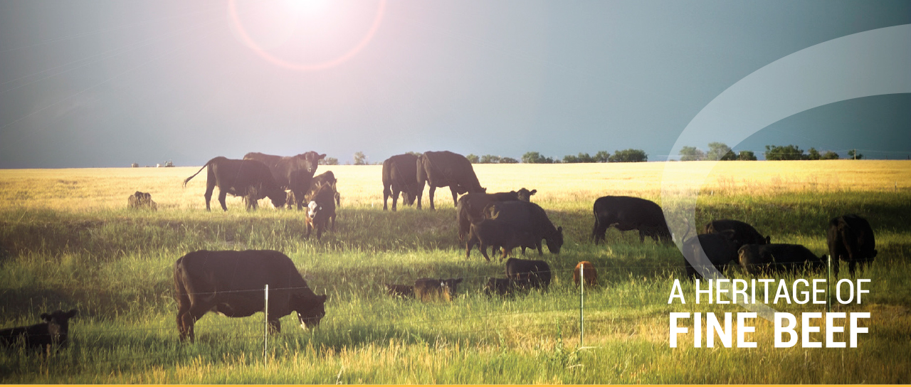

A family-owned Australian company with four generations of experience in producing and selling outstanding beef products, enjoyed by thousands of customers nationwide and around the world.
Since 1939, the family have established a reputation for quality and service in the beef processing industry. The brand has one hundred percent commitment to quality and consistency which has been the philosophy of the company since its establishment.  The processing plant is located in Warwick, Queensland, ideally situated on the Darling Downs, just two hours from the port of Brisbane with ready access to prime Southern Downs and New England Tableland cattle. Its operations are supported by the company's "Yarranbrook" feedlot situated on 13,200 hectares near Inglewood - one hour west of Warwick  With four generations of experience, we have operated for 75 years and are the longest running family owned meat processor & exporter in Australia under the one line of management. Experience in worldwide and domestic markets gives us the ability to understand customer requirements in all markets. | Our reliable and highly skilled workforce maintains our reputation for quality products. Staff training at is a top priority, ensuring skills and passed on to new generations who take pride in the name that stands for an Australian owned company that believes in producing and selling an outstanding product.  Four generations of experience in the beef industry means we are a trusted name in cattle husbandry, feed lotting and grain feed development. Coupled with a commitment to safety, the environment and compliance to DA (AQIS) and Halal requirements, we are a modern, internationally recognised brand that is shaping the next generation of global beef supply.  Truly a heritage of fine beef.

PRODUCTS
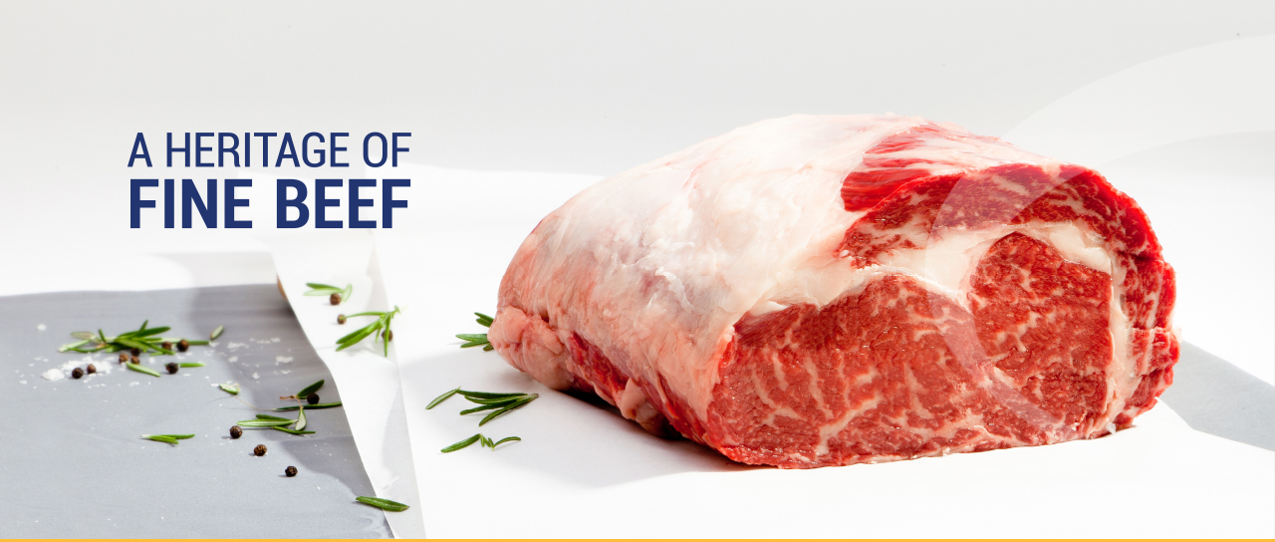

GOLD

Grain Fed (min 150 days)

150 day mid fed cattle with Marble Scores 1, 2, 3 that ensures you will have a grade of high quality beef to suit every sector of the market. Extremely well bred cattle of all breeds combined with a nutritional ration results in beef that delivers every time.

GOLD ANGUS

Grain Fed (min 150 days)
150 day mid fed cattle high quality Angus beef. Available in various marble scores this beef will simply deliver in all the areas that matter: texture, marbling, flavor and consistency. No doubt the best quality you can serve in markets where it matters. Medium to Long fed -Angus Bred cattle... it does not get any better. The choice of all the leading steak houses in Australia. Try it. Your customers will thank you for it.

BANKSIA BEEF

Grain Fed Young Beef (min 60 days)
For the last 10 years we have held pride and place in the Australian domestic market with its Yearling beef brand Banksia. Young sweet beef flavors flow through every cut available, and the quality is second to none. We only select the best quality cattle to produce this product range and it gives us the control needed to keep a wonderful product at the top of the market. Clean, fresh and pure flavors shine through, texture is always soft. Fantastic for retail, excellent for foodservice. YGGF MSA-YGGF categories available.

PLATINUM BLACK

Grain Fed (min 400 days)
You want the ultimate in Beef, we've got it. Wagyu F1 beef Wagyu is and without any challenge the most superior breed for beef excellence. Combined with our exacting standards, it delivers time and time again. Look no further if you're wanting the best of the best. Platinum Wagyu is "simply the best". Marbles scores range 2 to 9+.

Kailis Bros

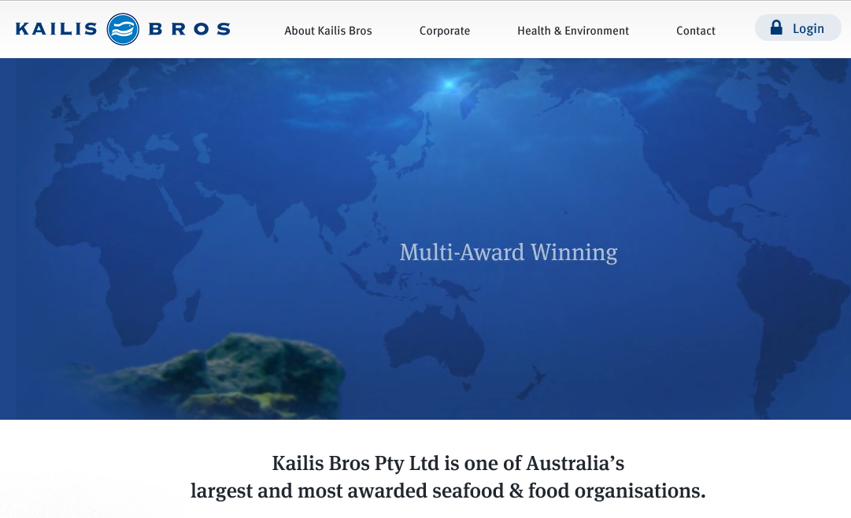

Kailis Bros Seafood
Kailis Bros Seafood, is involved in the catching, processing, manufacturing and marketing of fresh, frozen and value added seafood sourced from Australia and around the world. Whether they are marketed under the KB or Just Caught brands, Kailis Bros Seafood is the standard for the broadest range, the most innovative product development and the finest quality.
The Kailis Bros Group operates at all levels of the supply chain from catching, to processing, manufacturing, importing, exporting, wholesaling and retailing. With over 500 employees and a proud history of over 85 years, Kailis Bros is Australia’s leading food Group. Kailis Bros has partnered many of Australia’s leading corporations in developing solutions that deliver class leading value.

Zimbulis Fruit and Vegetables

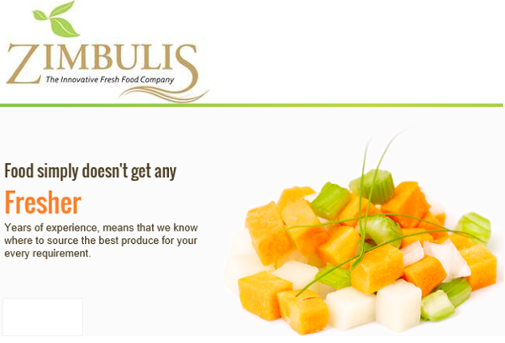

Our History
Zimbulis is an Australian family owned business established in 1929. We have a strong culture of equal employment opportunities and currently employ more than 200 staff. Integral to our vision is treating our customers with the utmost respect and integrity.
As one of Western Australia’s wholesalers of fresh fruit and vegetables we source all of our produce directly from approved growers. We are able to provide our customers with fresh fruit and vegetables throughout the year because we source from reliable suppliers in local regions throughout the state.

Leading the Way in Innovation
In 1991, we created new markets with the introduction of peeled and fresh cut fruit and vegetables, assisting retail, catering and hospitality industries to save time, money and eliminate possible OH&S incidents.
In 2014 we will be opening our new purpose built 10,000 square meter state-of-the-art warehouse, processing, development, packaging and administration facility in Forrestdale. This will enable us to expand our research and development, exploring new processes and approaches and meet the growing needs of the industry and retail sector.

We have been serving the needs of the retail, catering and hospitality industry in Australia since 1929. With the freshest produce cleaned, processed and packaged on-site we have been assisting businesses to save time, money, reduce waste and eliminate possible OH&S incidents.
Zimbulis innovation has brought new techniques, recipes, and flavor combinations to customers and chefs across Australia. We regularly deliver to quarantine zones, mine sites, large retail outlets, fast food chains, government organisations, aged care facilities, production kitchens and food manufacturers.

