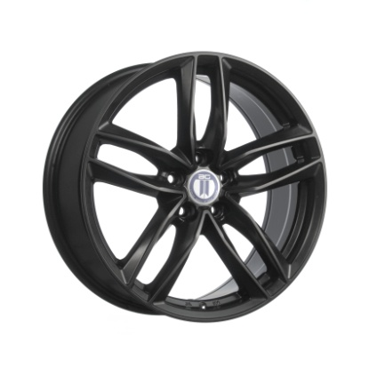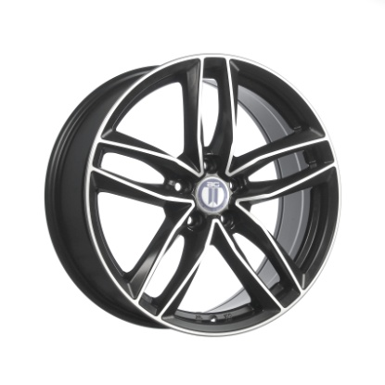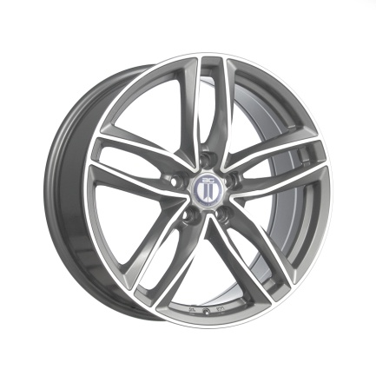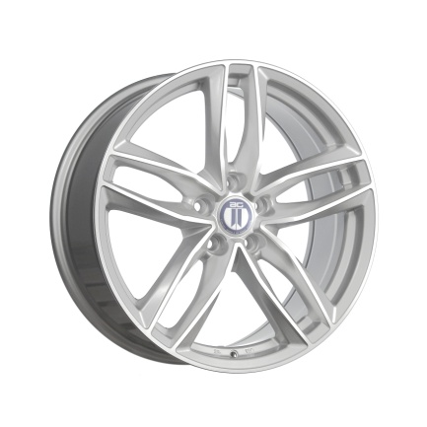
BLADE  SATIN BLACK  19x8, 20x9 | BLADE  SATIN BLACK/ MACHINED  19x8, 20x9 | BLADE  TITANIUM GREY / MACHINED  19x8, 20x9 | BLADE  SILVER / MACHINED  19x8, 20x9

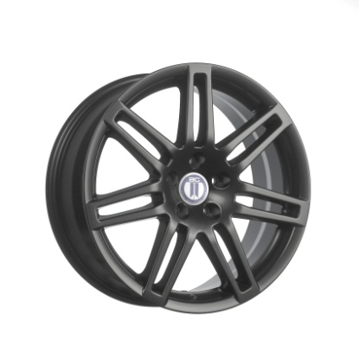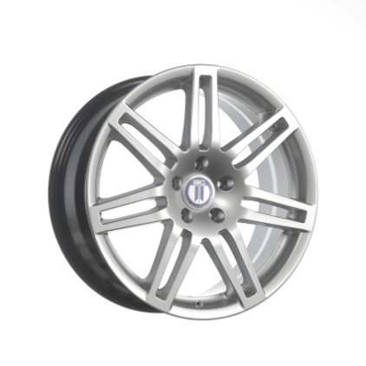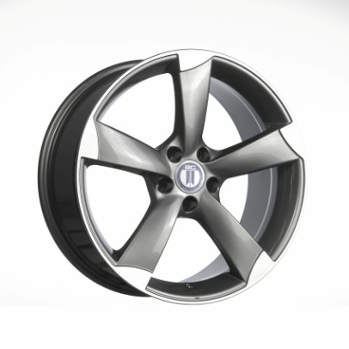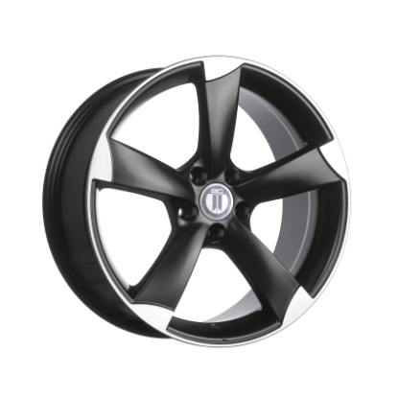
RS4  SATIN BLACK  18x8, 19x8 | RS4  HYPER SILVER  18x8, 19x8 | ROTOR  TITANIUM GREY / MACHINED  18x8, 19x8.5 | ROTOR  SATIN BLACK/ MACHINED  18x8, 19x8.5

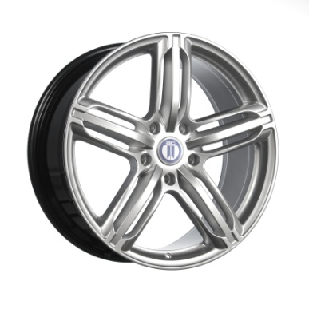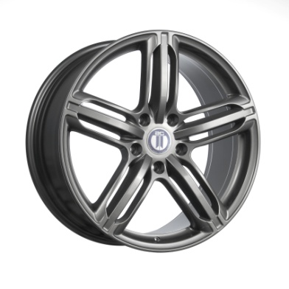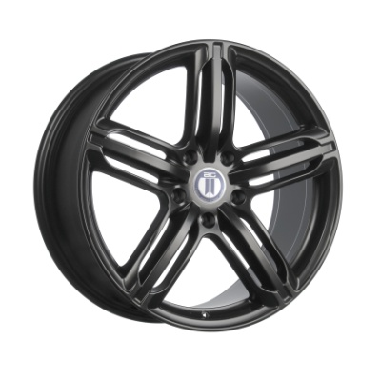
RS6  HYPER SILVER  20x9 | RS6  TITANIUM GREY  20x9 | RS6  SATIN BLACK  20x9

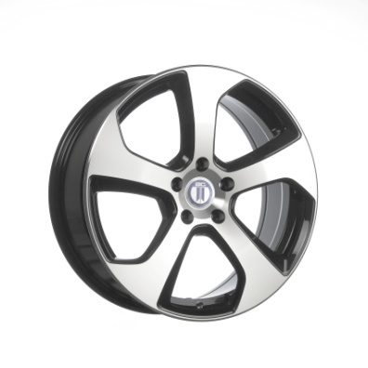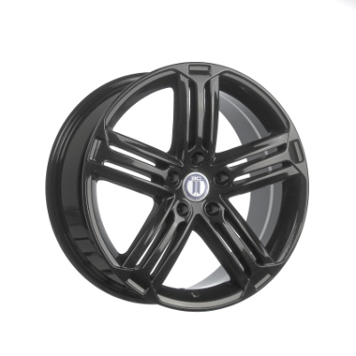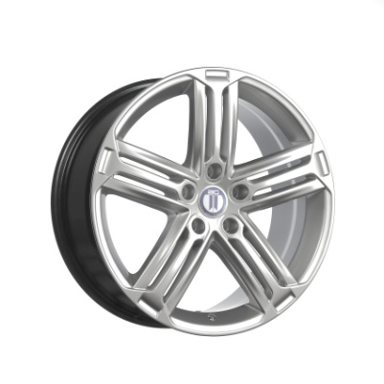
GT-I  BLACK / MACHINED  17x7.5, 18x7.5 | GT-R  TITANIUM GREY  18x8 | GT-R  HYPER SILVER  18x8

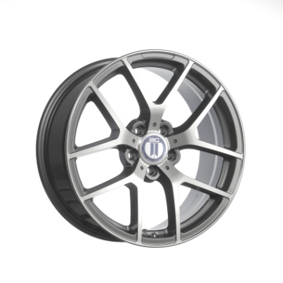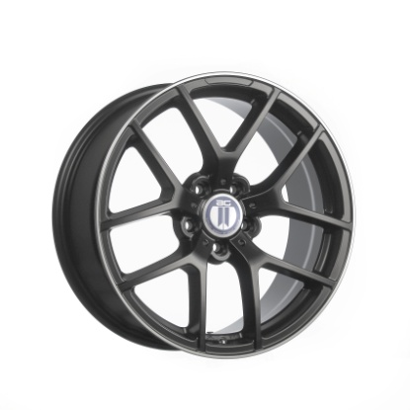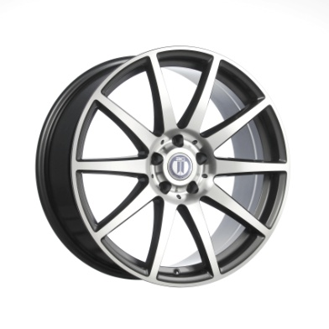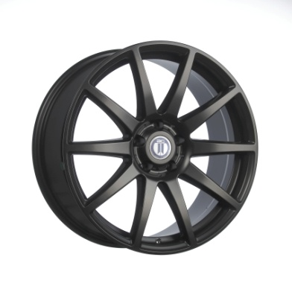
C655  TITANIUM GREY / MACHINED  18x8, 18x9 | C655  SATIN BLACK / MACHINED LIP  18x8, 18x9 | C688  TITANIUM GREY / MACHINED  19x8.5, 19x9.5 | C688  SATIN BLACK  19x8.5, 19x9.5
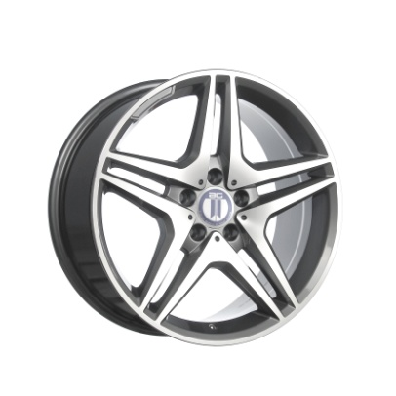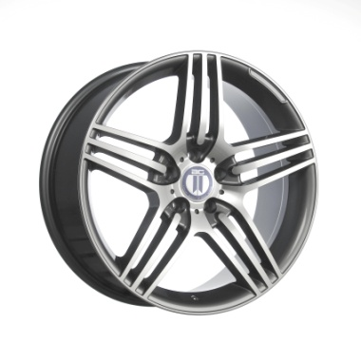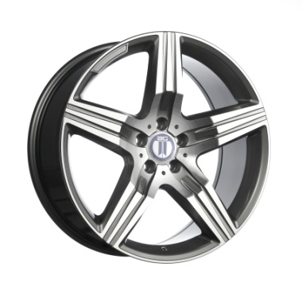
MB633  TITANIUM GREY / MACHINED  17x8, 18x8.5 | MB633  TITANIUM GREY / MACHINED  18x8.5, 19x8.5, 19x9.5 | MB600  TITANIUM GREY / MACHINED  20x8.5, 20x9.5

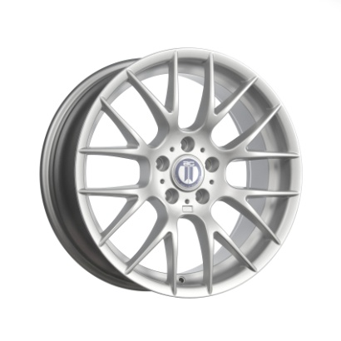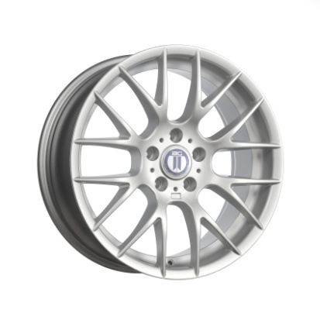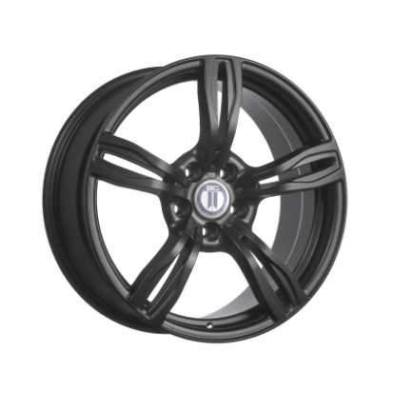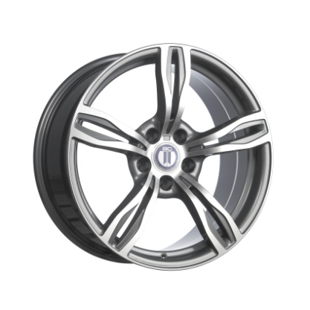
BM370  SATIN SILVER  18x8, 19x8, 19x9 | BM370  SATIN BLACK  18x8, 19x8, 19x9 | BM588  SATIN BLACK  19x8.5, 19x9.5 | BM588  TITANIUM GREY / MACHINED  19x8.5, 19x9.5

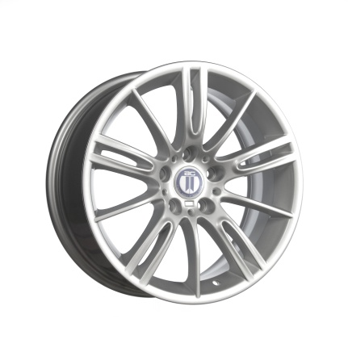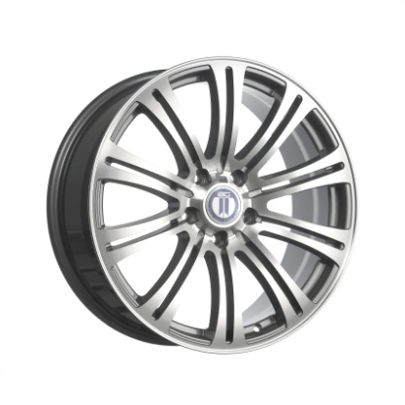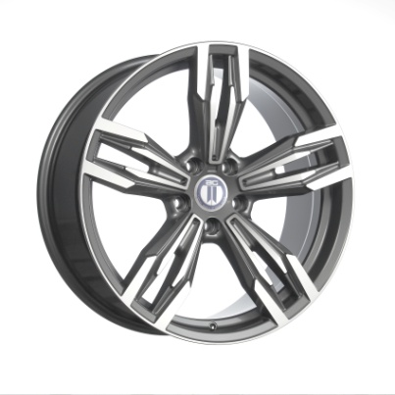
BM290  SILVER  18x8 | BM350  TITANIUM GREY / MACHINED  18x8, 19x8, 19x9 | BM750  TITANIUM GREY / MACHINED  20x8.5, 20x10

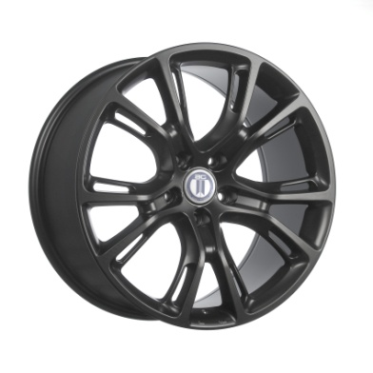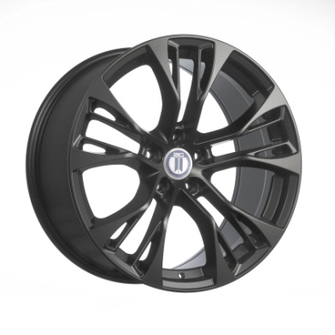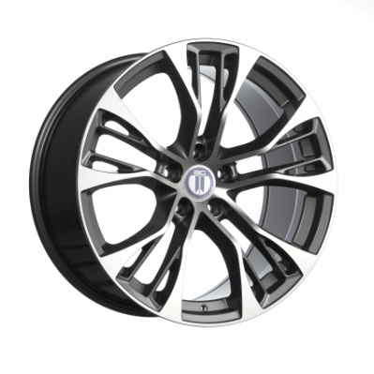
SR-T  SATIN BLACK  20x10 | SR-T  HYPER BLACK  20x10 | BM850  SATIN BLACK  20x10, 20x11 | BM850  TITANIUM GREY / MACHINED  20x10, 20x11

