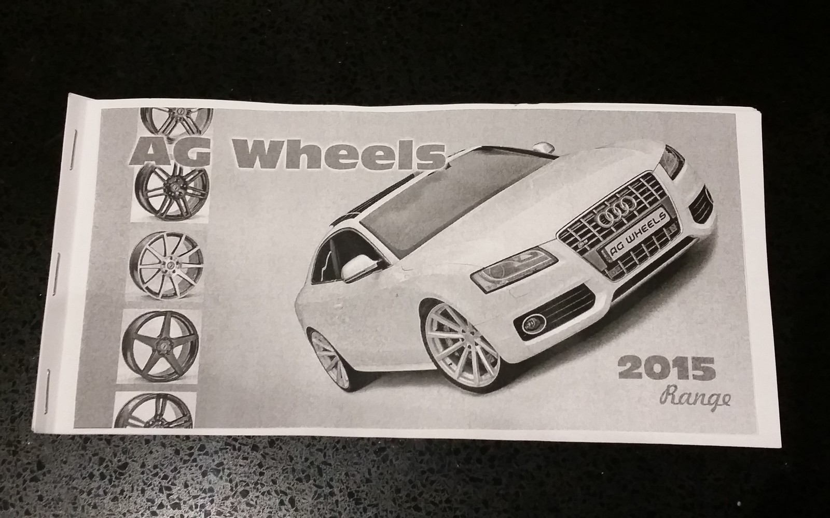
FRONT PAGE 1, SAMPLE LAYOUT , NOT FIRM
PICTURE OF VEHICLE, WILL BE SUPPLIED BUT UNEDITED.
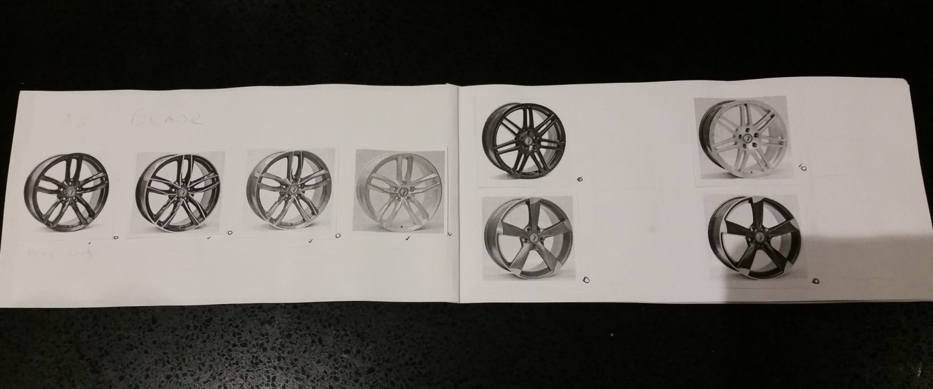
PAGE 2 and PAGE 3
LAY OUT NOT FIRM, BUT QUANTITY OF WHELS PER PAGE IS AS PER SAMPLE.
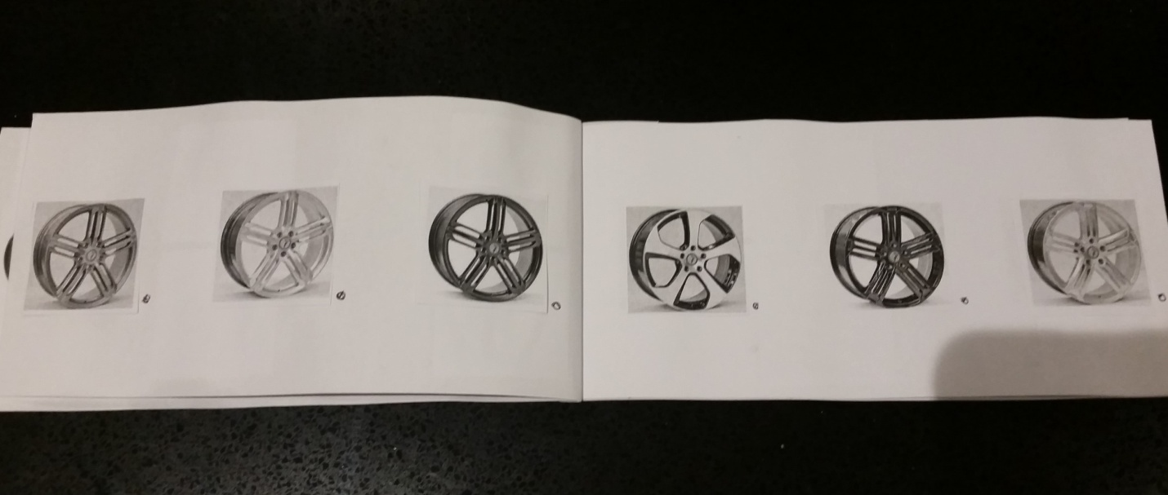
PAGE 4 and PAGE 5
LAY OUT NOT FIRM, BUT QUANTITY OF WHELS PER PAGE IS AS PER SAMPLE.
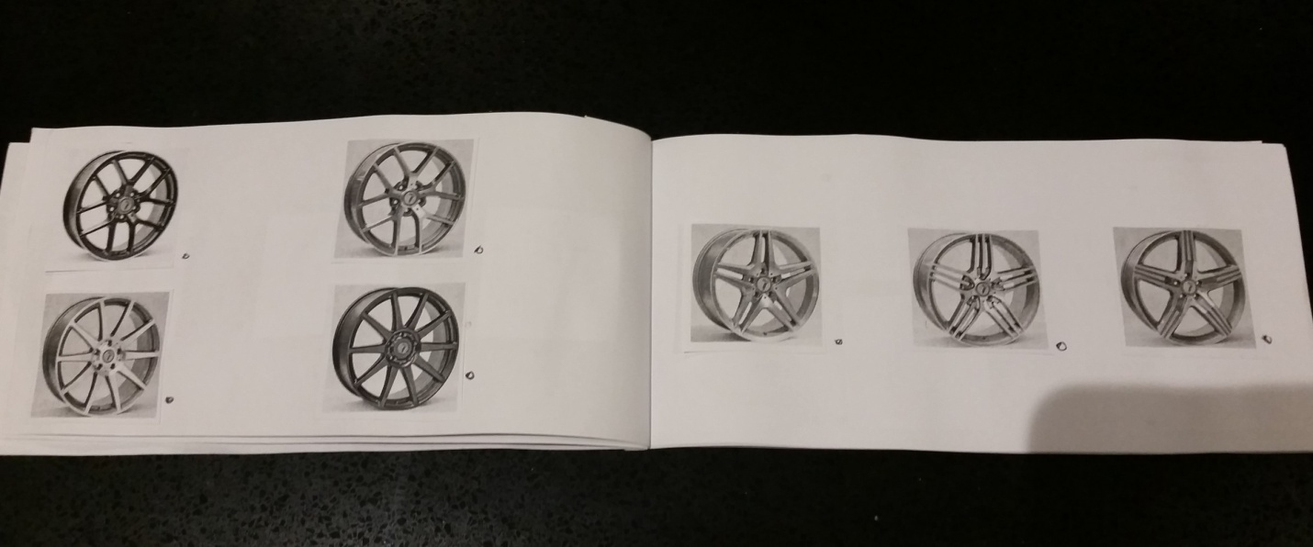
PAGE 6 and PAGE 7
LAY OUT NOT FIRM, BUT QUANTITY OF WHELS PER PAGE IS AS PER SAMPLE.
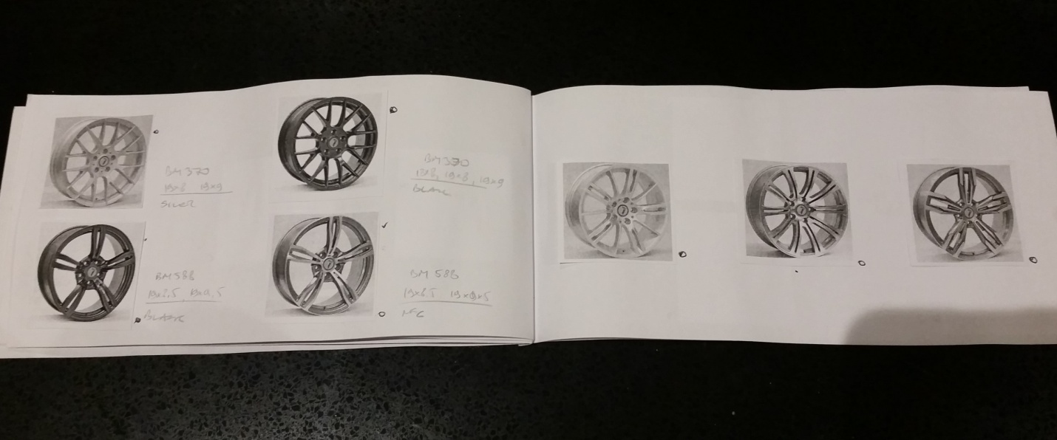

PAGE 8 and PAGE 9
LAY OUT NOT FIRM, BUT QUANTITY OF WHELS PER PAGE IS AS PER SAMPLE.
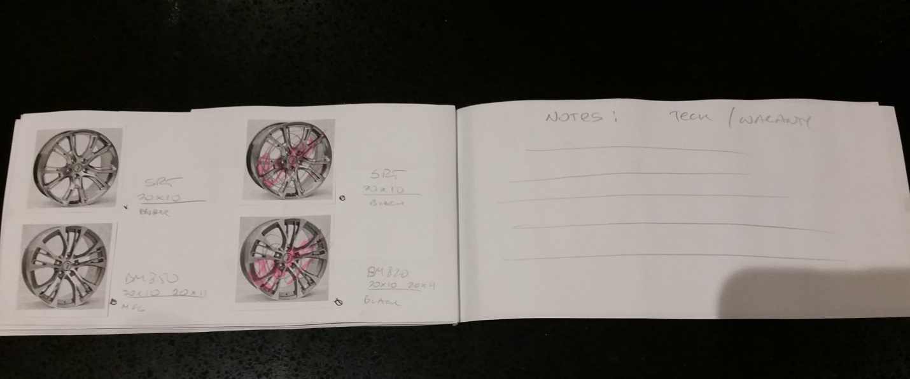
PAGE 10 and PAGE 11 ( This page will have warranty, and wheel care information, can have some watermark or wheel technical diagram on back ground so it doesn't look boring )
LAY OUT NOT FIRM, BUT QUANTITY OF WHELS PER PAGE IS AS PER SAMPLE.
TEXT WILL BE SUPPLIED.
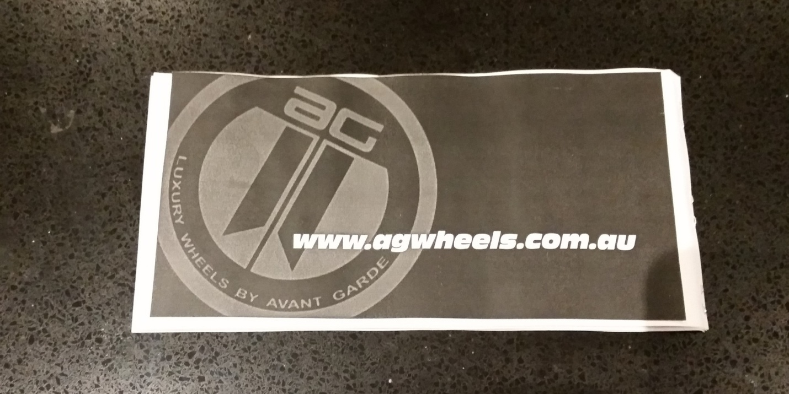
BACK PAGE
SAMPLE LAYOUT , NOT FIRM
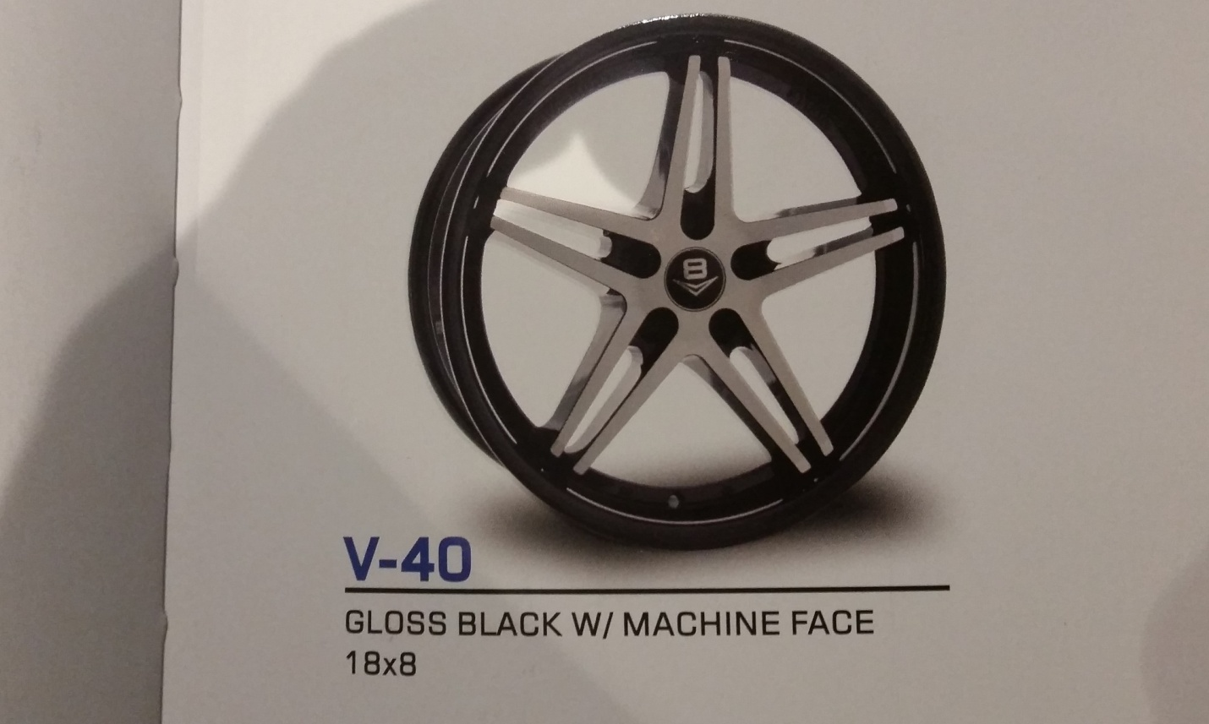

THATS HOW I WANT TO SEE TEXT LAY OUT UNDER WHEELS

