At the college level in the northeast, let's face it, there isn't a ton of big time athletics. You have a couple of football programs (UConn, Boston College, Syracuse, Army), some basketball programs (same schools), hockey (Yale, Quinnipiac, BC, BU) but that about does it.
As for college baseball there really are none. Yes there are very solid programs but none with facilities, weather, and resources that match the rest of the country. And if you haven't been outside of this area to see the best of college baseball you are really missing something.
College baseball is in fact alive and doing very well. Over my career I've been lucky enough to see the following places....Tulane, Houston, LSU, TCU, Louisiana Lafayette, Navy, Maryland, Mississippi State, Clemson, UNLV, Miami, Stanford, and Washington State.
Here is what many of these places have in common...excellent players, coaches, gear, fields, hitting areas, weight rooms, technology, loyal fans, and tradition. For those of you that go to minor league parks in the Northeast (New Britian, Pawtucket, Portland, Lowell, etc) imagine those types of facilities but ON a college campus!
They have full time ground crews, white balls for batting practice (and a boat load of them), pitching machines, branded team graphics on the stadium, great locker rooms, high tech video and scouting systems. They have fans that have special team cheers after runs, home runs, and team wins. Season ticket holders, vendors, and coaches shows. Fans dress in team colors and kids wear baseball face paint. Women know what a balk is.
At TCU they have a Player Development Center off the side of their stadium. It is a high tech batting cage worth over 2 million dollars. One the back wall they have two banners 20 feet tall by 20 feet wide. Both are images of a full stadium, packed with people. The first banner reads, “We will fight them until hell freezes over”. And the second one next to it says, “Then we will fight them on the ice.”.
At Mississippi State University, beyond the outfield fence they have flatbed areas with grills called the Junk Yard (see image). Hours prior to the game there are already thousands of fans with the grills going and they abuse your outfielders…but then feed them at the end of the game!
So if you’re seeing a lot of lacrosse sticks in your town and worrying about the future of our game, be at ease. College baseball is alive and well in many parts of the country. And if you are a player who is talented and thinks he can play down south, be forewarned, players in these areas were born into a baseball culture. They live, eat, and breath the sport and you can tell.
Coach Mazzoni’s Sacred Heart program has been to three of the last five NCAA Regionals. Follow him on Twitter @CoachMazz.
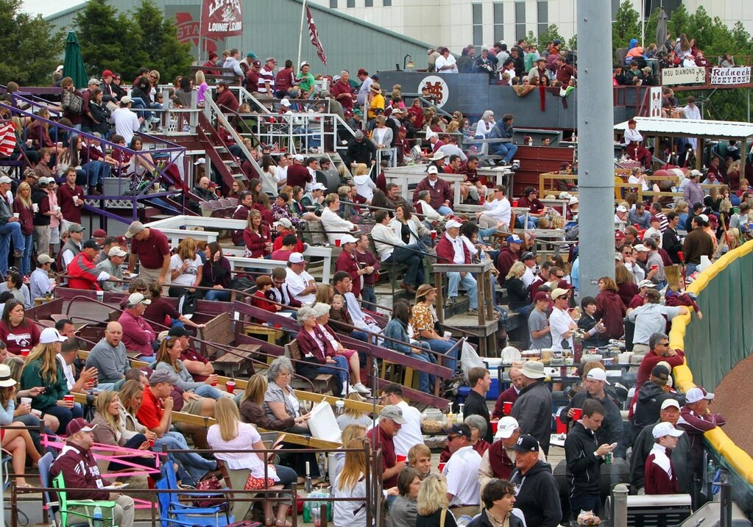
In 2011 my college team played in the NCAA regionals at Clemson. To a man we all thought it was the nicest stadium we had seen. Then 6 months later they announced a multi-million dollar renovation. None of us could figure out what needed to be renovated!

