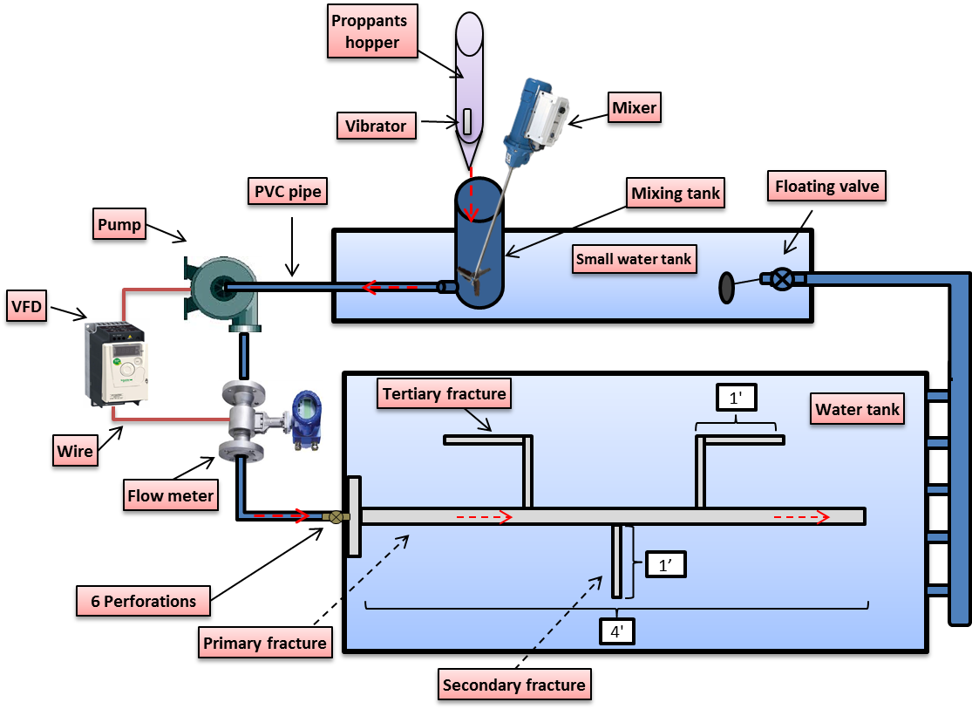
Figure-1: Schematic of the flow slot apparatus components and fracture slot dimensions in feet.

Dune
Stage-1
Figure-2: sand grains transport mechanism during stage-1 of dune development.

Dune
Stage-1
ϴ₁
ϴ₃
ϴ₂
ϴ₁ > ϴ₂ > ϴ₃
Figure-3: Larger proppants settle at larger angles and, hence, travels shorter distances during stage-1.

Decreasing diameter
Figure-4: Anticipated proppants size distribution at the bottom of the fracture slot during stage-1.

Dune
Stage-2

Settling + rolling
Figure-5: Proppants are transported to stage-2 dune by settling from moving fluid and rolling from preceding dune.

Time-0
Time-1
Time-2
Time-3
Figure-6: New dune surface developing with steeper slope during stage-2.

Dune
Stage-3
Rolling & suspension with vertical eddies forming
Figure-7: High turbulence flow creating vertical eddies during stage-3.

Dune
Dune
Dune
Time = 1
Time = 2
Time = 3
Figure-8: Dune shape transformation during stage-3, red line shows the new curved dune shape.

Stage-4
Figure-9: transport mechanism during stage-4 showing proppants rolling and saltation.

Stage-1
Stage-2
Stage-3
Stage-4
Figure-10: 30/70 Brown sand anticipated dune proppants size distribution.

Dune height increases with distance (slope of increase declines)
Slurry velocity increases with similar trend as dune height (77% increase in velocity)
Velocity
Dune height
The increasing slurry velocity reduces the friction effect and proppants settling by providing more drag force to transport proppants.
257 ft/min
145 ft/min
20.94 inches
21.94 inches
Dune
Dune
Figure-11: The inverse relationship between slurry velocity and friction effect.

