Redhand Logo brief
- Overview: Need an image of a hand with Index finger pointing in a gesture to guide / direct someone.
- Background
Redhand is a new technology that uses 2-way video to enable a remote expert to direct a local worker to undertake detailed engineering maintenance tasks. The local worker sees images of a red hand on his headup display to direct him how to do things
- Characteristics
Key words: Action, guide, direction, help, friendly
- Some visual guidance in the brief:
- This is what a worker might actually see in his display

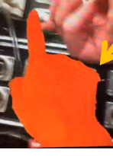
- This one is OK but not distinctive enough

- I do like this sort of look / feel / style but need to be pointing.


- Note that finger could be pointing in one of several directions , not necessary sideways





