  CAJUN BREAKERS
  Has been in the electrical supply business for over 15 years. We carry a wide variety of electrical products in stock. We have many obsolete and hard to find items as well as products used in today’s market.
  Specializing in:
  - COMMERCIAL
  - INDUSTRIAL
  - OILFIELD
  - MARINE
  - RESIDENTIAL
  Cajun Breakers, Inc.
  221 Railroad Ave
  Morgan City, LA. 70380
  Cajun Breakers Inc
    - 221 Railroad Avenue
  Morgan City, LA 70380
  PH : (985) 702-1004
  FAX: (985) 702-1006
  
  COMPLETE ELECTRICAL STORE

 |  |  | We offer 24 hr. service 365 days a year. We will deliver to you or your job site.  Breakers  Breaker Enclosures  Breaker Panels  Mounting Hardware  Shunt’s, UV’s, Auxiliary’s  Motor Starters  Coils  Contact Kits  Heaters  Auxiliary Contacts  Overload Relay’s  Fittings  Fuses  Disconnects  Residential/Commercial  Light Bulbs  Ballast  Wall Plates / Receptacles / Switches  Contact Us  Cajun Breakers, Inc.  221 Railroad Ave  Morgan City, LA. 70380  985-702-1004  sales@cajunbreakers.com
  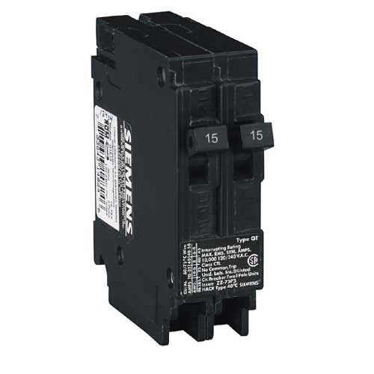
  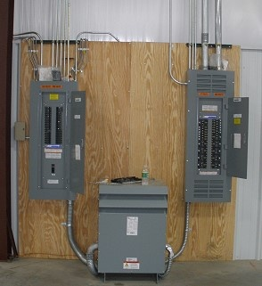
  We carry a wide range of residential and commercial breakers. We have many obsolete breakers in stock. Give us a call.
  