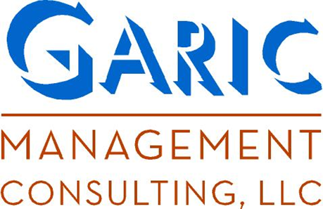

David Garic, Principal, Garic Consulting, leads a team of skilled and committed professionals who are wholly dedicated to meeting the needs of their clients. David has been developing leaders in organizations for nearly three decades. He is a retired Army officer, having focused on developing leaders while a Tactical Officer (Leader Developer) at the United States Military Academy and throughout his military and civilian careers. He holds a Master of Arts in Leadership Development from the United States Military Academy, West Point, and a B.S. in Management from the University of Maryland.
Garic Consulting has worked with thousands of governmental and corporate leaders since its inception in 2001. The firm is one of the very few in the field of leadership development that possesses an in-depth understanding of the scientific and research-based approaches to leadership development coupled with the experience of consultants and leader developers who have led small, large, and highly complex organizations and multi-disciplined matrix organizations.

For more information contact
Garic Consulting, LLC at
www.garicconsulting.com
3822 Octavia St., Ste. 1A
New Orleans, LA 70125
1-504-837-4577
DUNS: 026047295
VA Verified SDVOB
© 2011 Garic Consulting, LLC

Our Programs and Offerings
All of our programs are designed, from start to completion, to meet the specific needs of our clients. We believe this approach is unique and invaluable to our clients. With that in mind, some of our previous solutions for our clients have included:

Leadership Training Programs
Taking Charge (new supervisor training programs)
From Day One (leading and integrating new team members)
Manager as Leader, Leader as Coach (motivation at its best)
Leading the Team (strategies, techniques, and tactics for leading groups)
Leadership Development
Knowing the Leader (Oneself) Testing, interpretation, analysis, individual development planning
The Leading Edge Program (comprehensive, holistic, approach to leader development)
Listening for Leaders (the most important skill a leader can master)
Executive and Leadership Coaching
Coaching for Performance (focusing on breakthrough performance and increased responsibilities)
Coaching for Strength (focusing on reassessment and realignment with a goal of measured improvement)
Performance Consulting
Performance management systems based on client need
Change leadership and management strategies

We Grow Leaders

Capabilities

Garic Consulting has a broad bandwidth capability, able to apply leadership and organizational development professionals possessing a multitude of disciplines in fulfillment of its contractual requirements. In this vein, we are able to deploy facilitators, instructors and trainers and leader developers across the breadth of large organizations simultaneously. We are able to deploy certified leadership coaches on a broad scale, able to meet the needs of clients with significant and multiple simultaneous coaching requirements.

In addition, we are certified to administer and interpret numerous diagnostic and developmental instruments including the Meyers-Briggs Type Indicator, BarOn EQi, FIRO B, the California Psychological Indicator (CPI), and many other vital measures for leader development.

Why Choose
Garic Consulting?

Companies and organizations that are serious and committed to the development of leaders and leadership skills seek out Garic Consulting. Here’s why they choose us:

- Expertise. We’re experts in an area where guessing can result in failure.
- Availability. We’re never off duty when it comes to meeting our clients’ needs.
- Each client’s needs are unique and we approach them that way. In our business, we know that while solutions may be similar, they are never identical.
- Our clients are our credentials. We are wholly and completely committed to our clients and see our relationship with them as of paramount importance.
- We’re systematic. Leadership is a process, a collection of related activities, the purpose of which is to get the job done. We never lose sight of this primary purpose.
00
Name of Flyer Here
Month

