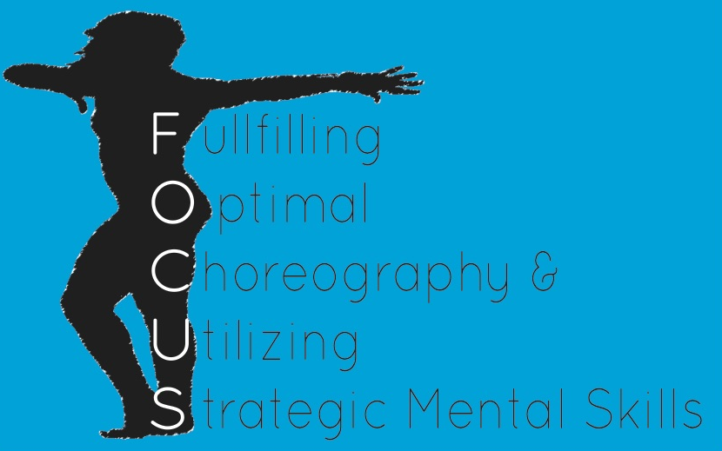

Chantel Serita Is:

The founder of FOCUS

A former Gymnast for the University of Illinois at Chicago

A Choreographer of Gymnastic Floor and Beam Routines

A Graduate of the University of Illinois at Chicago
Bachelor of Arts in Liberal Arts and Sciences

A Graduate of Adler University
Masters in Counseling with Specialization in Sport and Health

A member of Boom Crack! Dance Company founded in the Chicago-land area

Why Will You Benefit from Mental Skills Training?

- Consider all athletic successes that you’ve had. What percentage of time were you mentally focused?
- Consider your athletic performance. What percentage of mistakes were considered to be mental errors?
- Consider your preparation. What percentage of time do you spend on mental training?

What does FOCUS have to offer?

Mental Block Interventions
Mental block interventions are designed specifically to develop mental toughness required to perform skills otherwise avoided due to fear.

Imagery Workshops
Imagery Utilizes the Powerful Dynamics of the Mind. This technique provides athletes with the proper way to visualize successful performances prior to competition, improving the level of consistent and quality performances.

Goal Setting Workshops
Goal setting is one of the most important mental skill techniques providing guidance, motivation and ultimately increasing performance levels. These workshops will allow athletes to create team long-term goals as well as individual goals.

Motivation Workshops
Motivation is essential to optimal performance for any athlete. These specific workshops provide motivating scripts, personal mantras as well as supportive team slogans.

Team Cohesion Activities
team cohesion is another element required for peak performances. Team cohesion workshops incorporate activities attached to learning objectives that assist in uniting a team in a fun and innovative manner.

Individual Sessions
Individual sessions are developed specifically for an athlete’s particular needs.

Choreography
Choreography can stand alone or be implemented into individual sessions. Dance lessons can also be incorporated into choreography sessions.

Packages

Service Price
Team Workshops | $250 per contact/hour
Coach Workshops | $250 per contact hour

Individual Sessions | $100 per contact hour
Floor Routines  Beam Routines | $400 per gymnast  $150 per gymnast
Dance Lessons | $25 per contact hour

