
August / 2015 / 70 mins / Drama / Singapore
Dir. Angeline Tay, Iskandar Ramli and Kelvin Ke

August follows the parallel stories of three Singaporeans dealing with familial love and loss: a young girl copes with her mother’s death by living in an imaginary world, a father struggles to reconcile with his estranged daughter before her wedding and a woman fails to convince her family of her desire to become a Getai singer. Staring Shanice Koh, Esther Low with veterans Zaliha Hamid, Khalid Baboo and Simon Ho and Jason Sim.
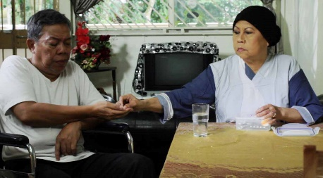

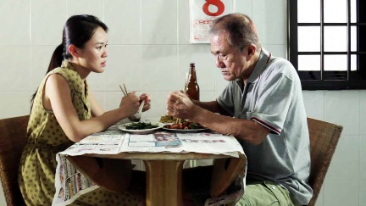
Cast: Zaliha Hamid, Khalid Baboo Simon Ho, Esther Low, Shanice Koh
Producer: Kelvin Ke
Co Directors: Iskandar Ramli and Angeline Tay,Kelvin Ke
Director of Photography: Ernest Ang
Camera Assistant: Adisatrya Johari
Sound: Shafina Subari
Editor: John Edward Gamell
Production Designer: Joey Chia
Production Art Assistant: Azhar Noor & Jaron Tay
Music Composer: Lu Heng and Ng Chee Yao
Production Assistant: Nadiah Osman
Assistant Producer: Chin Wing Yan
Production Company: Imago Films

