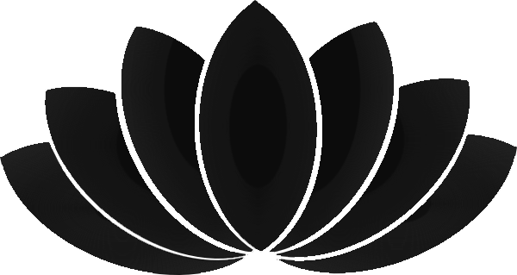
Every First and Second Friday of the month 7:30pm - 8:30pm
Recurring Event

All are welcome to come to a guided Mediation. Meditation on Twin Hearts is one of most powerful meditations, practiced worldwide as a global healing technique.

Please arrive by 7.15 pm for a brief introduction.

During the session we will:
Do gentle yoga exercises to open up the energy centres
Do a guided mediation on Twin Hearts to draw in tremendous amounts of energy
Perform energising exercises to fully absorb the energy generated.

We do not charge for the evening but ask for a donation.

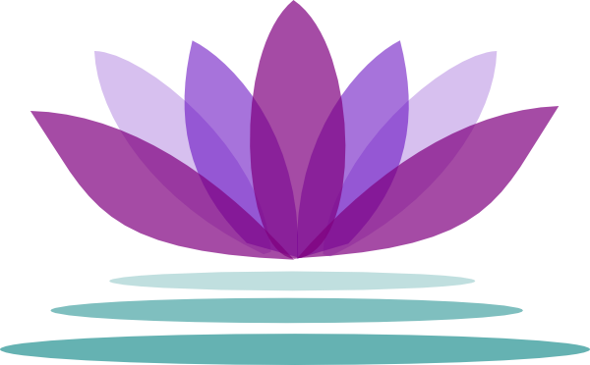
“Mediation on Twin Hearts is one of the most powerful mediation tools for spiritual development. It is true gift from the Great Ones” Master Choa Kok Sui

Where:
New Crayford Library
Meeting Room
176 Town Hall Square, Crayford, DA1 4FN
E: kent.pranichealing@gmail.com

