Request for the design of a donors sign:
To design a wall sign to give recognition to donors who have made significant financial contributions to CHANCES, which is a non-profit, charitable organization, that exists to provide a range of early childhood and family support services to children from 0-11 years and their families, particularly those experiencing additional life challenges and risks.
The allowable space for the sign is up to 6 ft wide and 3 ft high, although the sign may be smaller then this if necessary to have it proportional to the space. We offer a family friendly, welcoming environment and so the sign would have to be reflective of the environment, but also be very high end and respectful of the significant financial contributions made by donors. We would like to incorporate into the design of the sign, the key elements of the CHANCES logo, which is in color below. I have also included at the bottom of the page, a sample that might be a place to start for the design as it outlines a tree which is consistent with the CHANCES logo. The following statement must also be on the sign and space for 15 names:

Catherine Callbeck Family Centre
This facility was inaugurated, October 16th 2014.
Thank-you to generous supporters:

CHANCES Logo: Previous sign design submitted but not accepted:

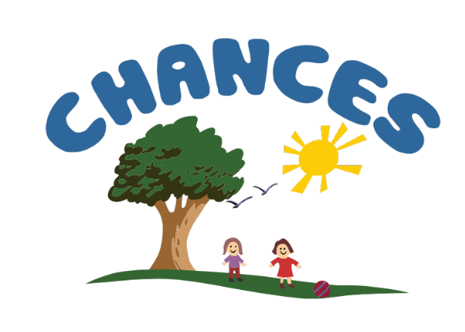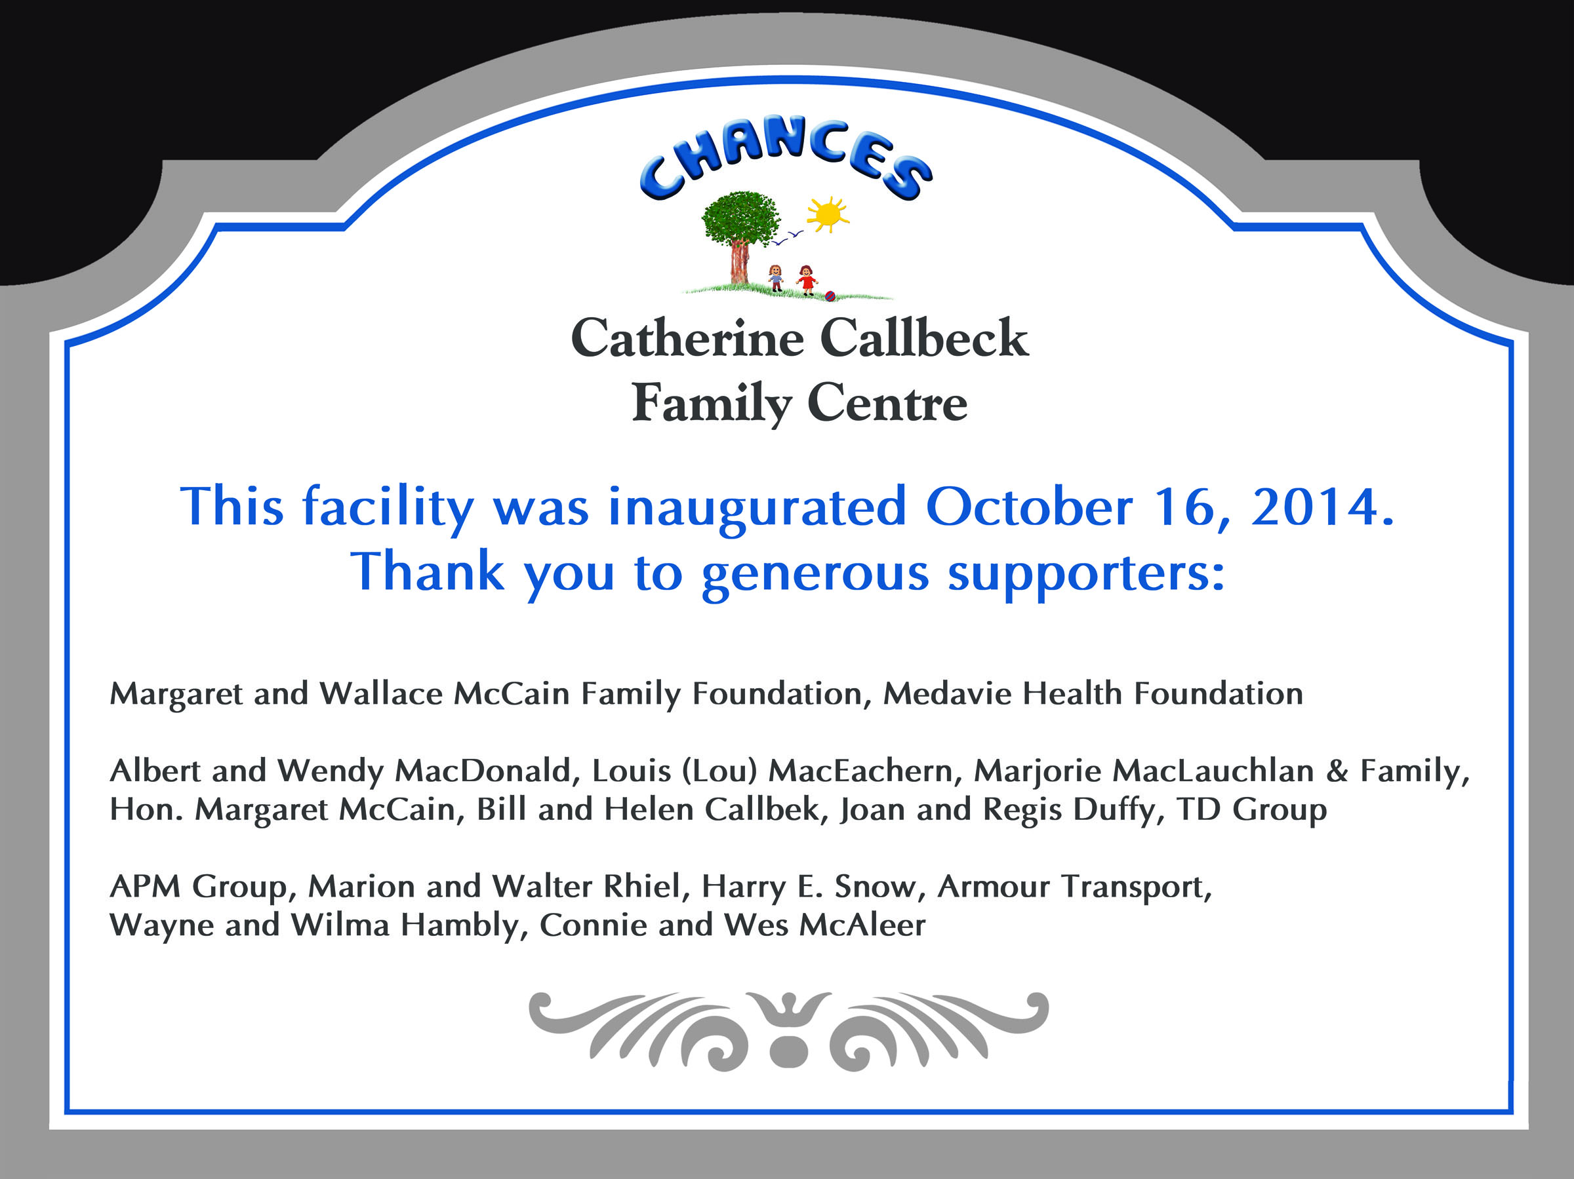

Sample of sign design that we liked but is missing some required key elements:


