CREATED GIF PAGE
For the Designer - with UI/UX background
MakeaGif is a GIF creation and sharing site. We are upgrading one of our main responsive website pages. [Please see: http://makeagif.com/P-8UQu for an example] Need design versions for Desktop, tablet & mobile.
Also need frontend development to implement page. Currently on Foundation framework.
There are many functions/nav elements that need to be on this page in an uncluttered and clear manner. Not all of functions need to be shown at all times. Need a designer with UI/UX background to incorporate these and make it easy to navigate for the user.
The designer needs to be familiar with the site to understand each function. Color scheme will remain the same as current site.
If there are Dropdowns/collapsed or hidden features - need to know how they look when opened.

This page is developed with sharing in mind. Our top 3 actions are highlighted below. Be creative & think about user experience as our #1 priority

Desktop
- SOCIAL SHARE BUTTONS Facebook/Twitter/Reddit/Instagram
- Download Button
- Create a GIF Button
OTHER FEATURES THAT MUST BE INCLUDED
Share This With Friends pop up
Title of GIF
Added XX days ago by XXXX in XXX
Source
Thumbs up votes showing numerically (no down vote thumb)
Total Views
Embed Links: direct, website, message board, markdown
NSFW Flag
MP4 to GIF toggle
Next arrows to scroll through GIFs
Scroll thumbnail bar for like GIFs at the bottom of the page
NEW FEATURES TO IMPLEMENT
Twitter Upload GIF to Twitter (not just the link, uploads full image)
Favorite (bookmark Option)

LOGGED IN USERS:
Logged in users also have Private Button & Delete Button
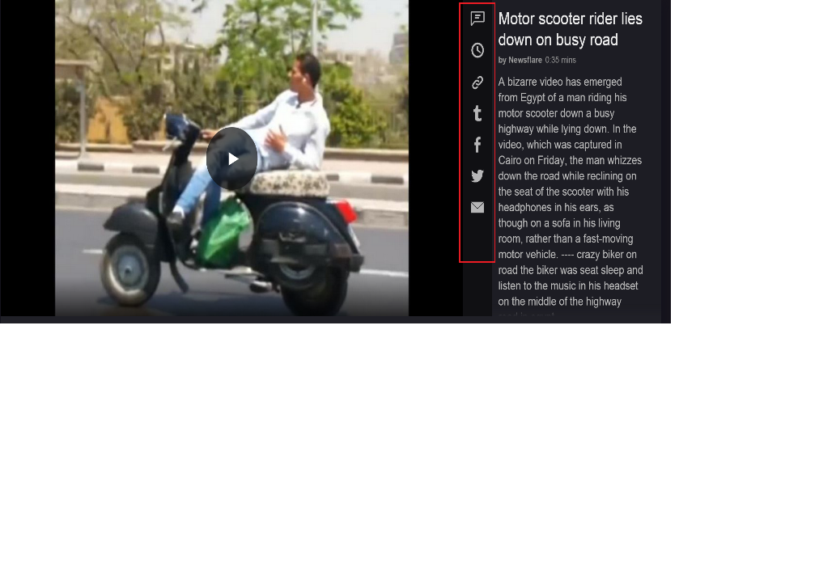

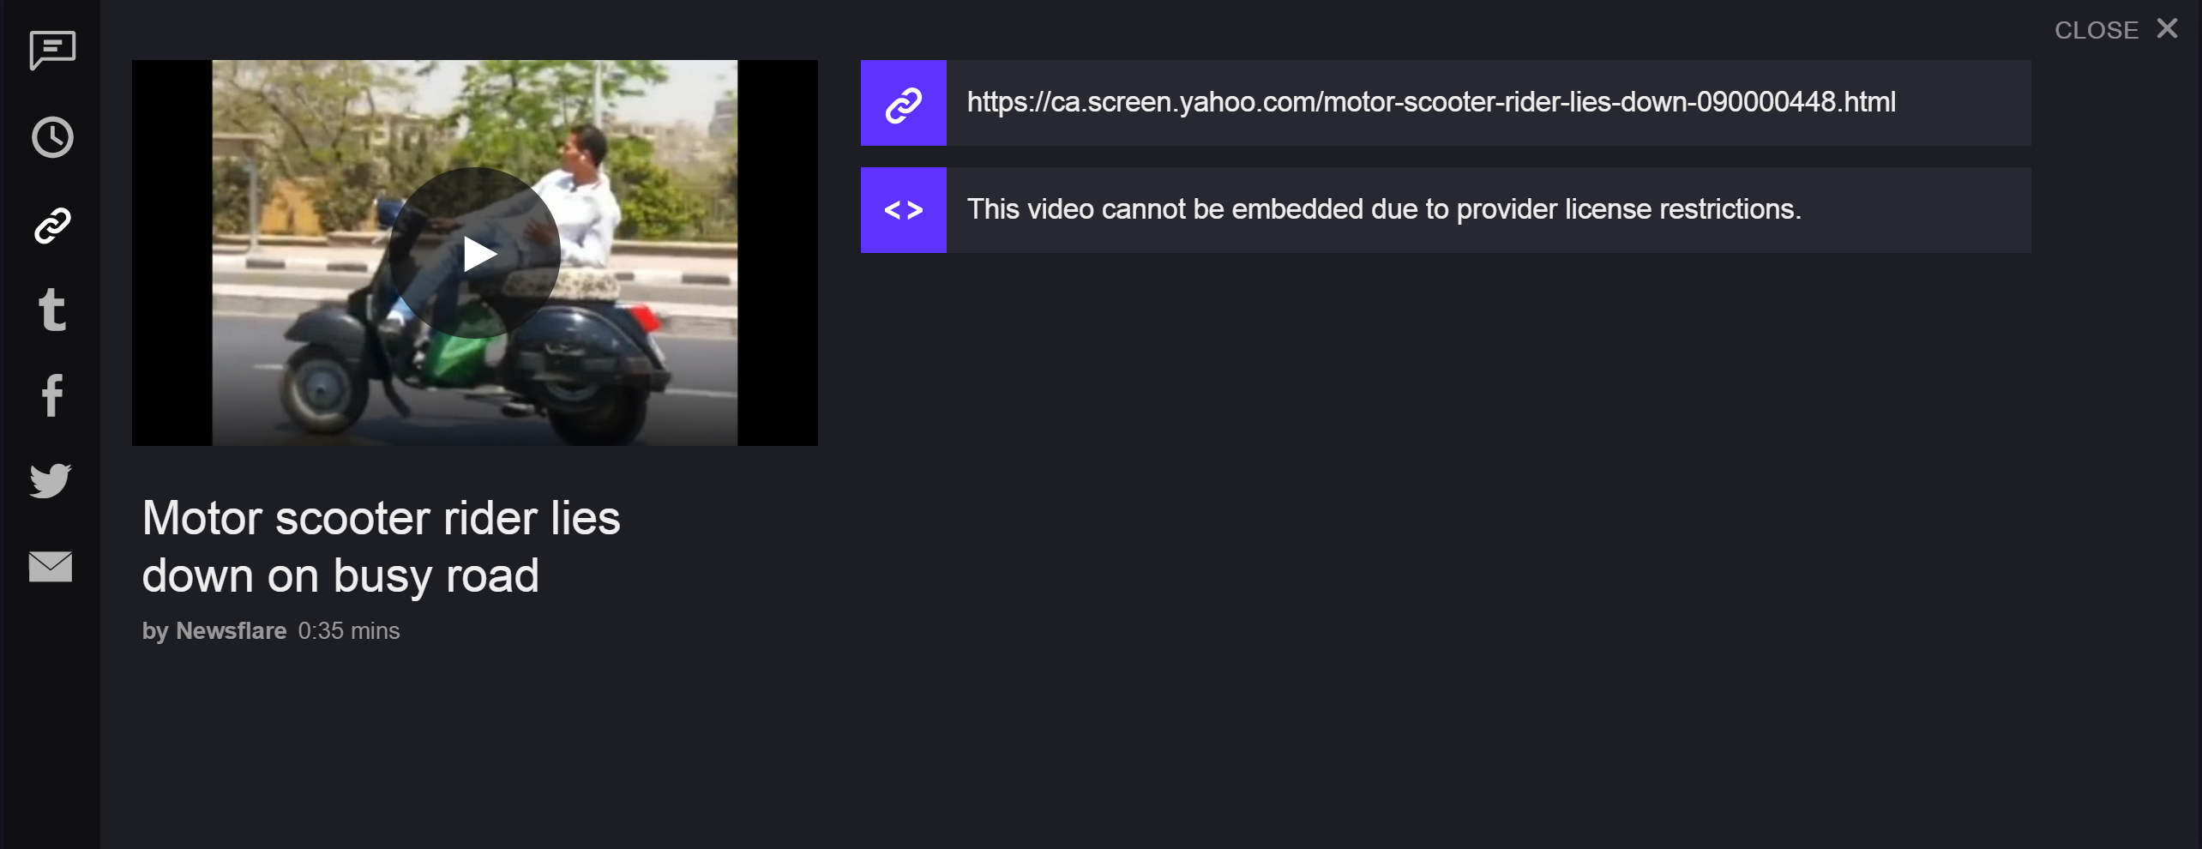
Interesting Idea for nav bar. What it looks like when opened to embed link.
This does not have to be used! Just a visual concept that we think is interesting.

Mobile
We would like to keep the mobile page as minimalist as possible. We could have hidden content but the most important features are:

Download button
Create a GIF button
Sharing button: Instagram, Facebook, Twitter, Reddit,
Share Via SMS or Email
Thumbnail scroll at bottom for GIFs in the same category

Secondary Features, could be hidden:
Tags
Added XX hours ago by XXX in Funny GIFs

