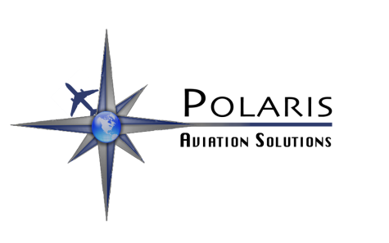
Don't Forget the Paperwork!
Polaris excellence goes beyond the aircraft. Our clear and detailed expense reporting, available in print and electronic formats and also accessible in real time on-line, is everything your accounting department could ask for. We use zero-based budgeting techniques to provide an annual budget for each client's aviation operations and update these budgets quarterly with actual operational data.
• Each year, Polaris manages more than 820 flights into 232 different airports across 33 countries, logging a total of more than 7,800 flight hours since opening in 2007.
• Through a carefully developed process Polaris selects, trains and mentors crew to deliver service tailored to each client.
• Polaris assigns a specific dispatcher to each client, so that when you talk to Polaris you are speaking with someone who thoroughly understands your needs.
Budget
Expense Report
Service
Cost
DRIVE
+
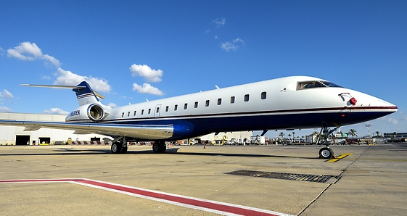

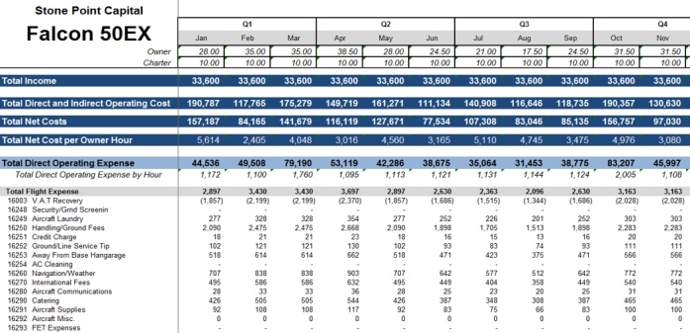
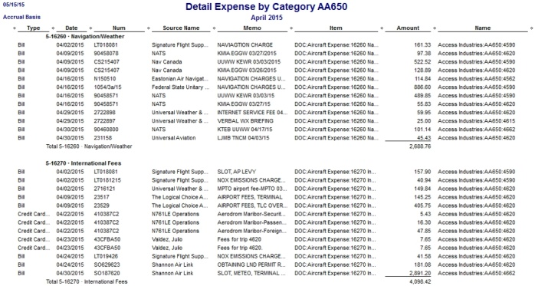
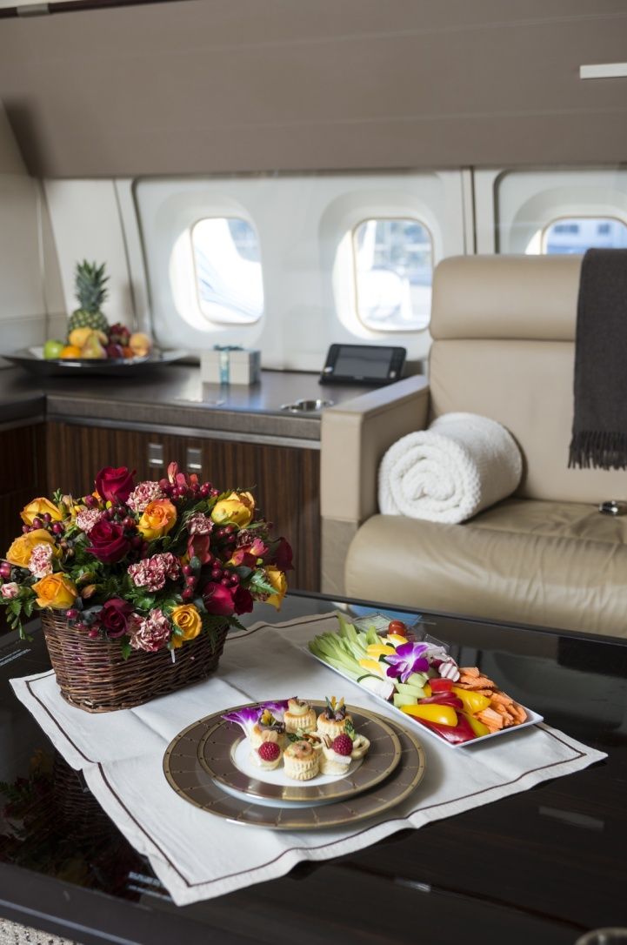
Polaris Aviation Solutions
6700 Highway 53, Braselton, GA 30517
(706) 645-2685
233 Industrial Avenue Teterboro, NJ 07608
(201) 288-1455
sales@polarisaviation.com
www.polarisaviation.com
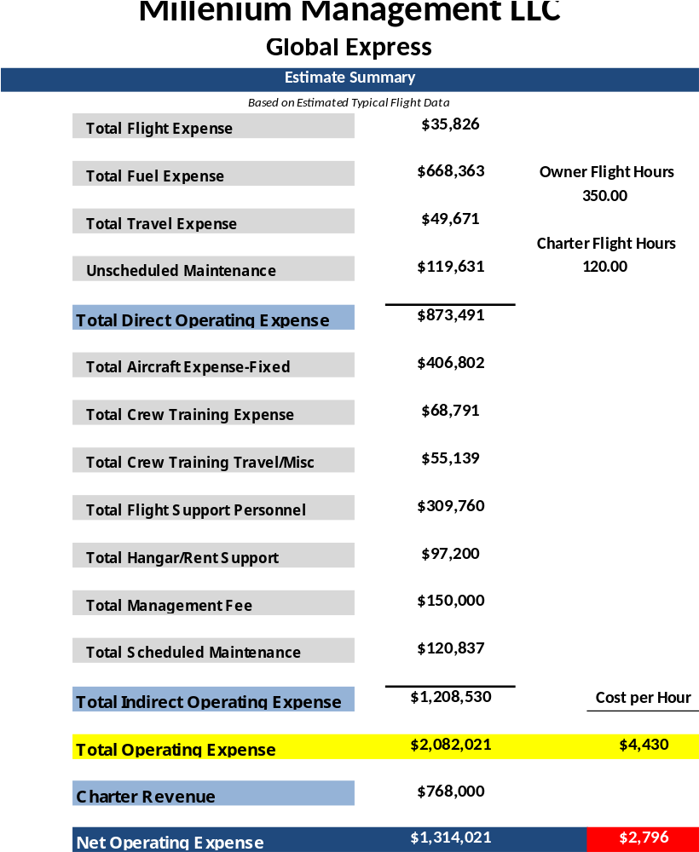
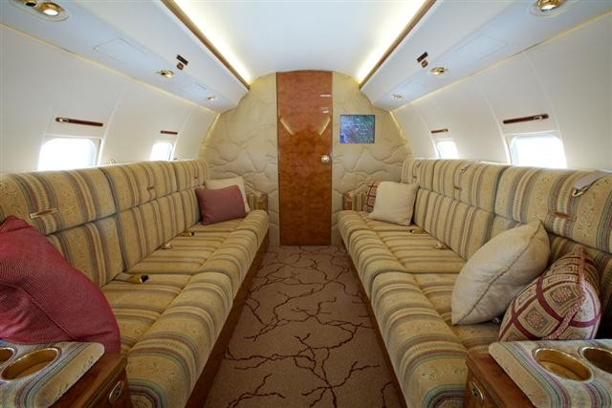
Polaris Aviation Solutions: Fast Facts
• Polaris manages globally operated fixed wing and rotary aircraft under FAR Parts 91, 135, and 125.
• At over 1,000,000 gallons of fuel purchased globally on an annual basis, our average domestic price per gallon sits below $3.00, with a global average that consistently remains below $4.00.
• The longstanding relationships Polaris maintains with its insurance partners combined with its impeccable safety record and meticulous attention to detail, allow us to offer the most competitive premiums in the industry with ZERO dollar deductibles.
• Our exemplary safety record allows Polaris to return an average of 13.5% of the premium back to each client for incident-free operations.
• Polaris is proud to offer a highly accomplished team of maintenance staff averaging more than 20 years experience across more than 30 aircraft types, making the Polaris Maintenance Team second-to none.
• The team of Polaris pilots offer an average of more than 20 years experience and 12,000 incident-free flight hours, making our flight deck one of the safest in the industry.

